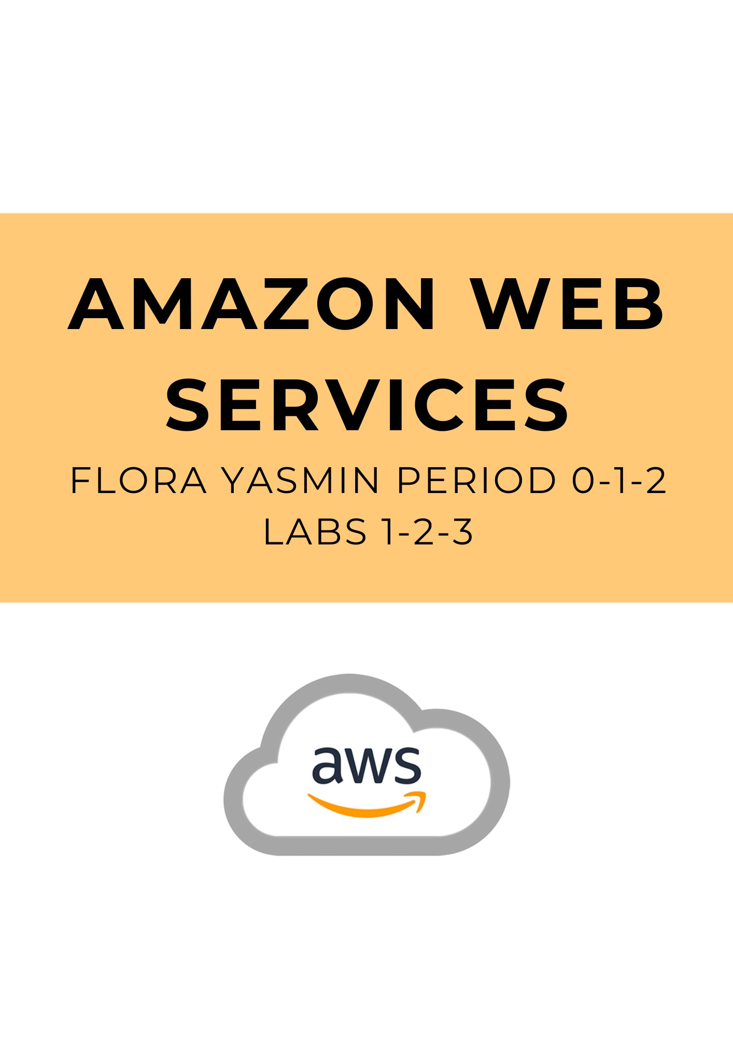

**Lab 1: Introduction to AWS IAM**  
  
**Purpose**

This lab demonstrates the uses of the AWS Identity and Access Management (IAM) web service. Through this lab we explored pre-created IAM users and groups and all the IAM policies applied to these pre-created groups. We were also able to experiment with the different kinds of policies and see what effect they had on accessing services. The lab gives exposure to a real-world scenario where Amazon Web Services come into play, by adding users to groups and granting each user specific capabilities and signing in with IAM.

**Background Information**

The AWS Identity and Access Management (IAM) web service allows you to securely manage users, user roles, and user permissions using AWS. IAM helps manage user control access and security credentials like access keys and permissions controlling which AWS resources can be accessed by users.

The key aspect of AWS IAM is its ability to create and manage AWS users within an account. Esach user consists of a username and password or access key and is given specific controls provided by IAM. The individual users can also be grouped up to simplify the IAM configuration, which is especially useful for large organizations where the same access needs to be distributed to multiple users. IAM also helps continue manage existing federated users without having to create a new IAM user each time.

Role-Based Access Control (RBAC) in IAM helps delegate access by assigning roles to different users, AWS services, or AWS resources. Roles are given to define the scope of authorization given to one user. Some kinds of IAM roles are user roles, group roles, service roles and federated roles, and all of them grant different levels of access to the user they are assigned to. IAM also allows policy management to define permissions, allowing and denying types of actions performed by users, groups, or roles.

Aside from managing control access, AWS IAM also offers security such as multi-factor authentication, which requires users to verify their identity when signing in. IAM provides detailed logs of all activity on your account which also provides an extra level of security as you can use CloudTrail to monitor changes to your IAM resources. Similarly, IAM Access Advisor helps track user permissions over time which gives you information about what services and resources users were able to access with the control access granted to them. Overall, AWS IAM is crucial to securing your AWS environment.

**Lab Summary**

1. Explore pre-existing users and groups in the AWS management console, under the IAM service tab.
   1. Clicking on each user provides a summary page of all permissions, groups, and security credentials designated to the user.
   2. You can also view the different user groups and policies defined in each group.
2. Then, following the real-world scenario provided in the lab, add user-1 into the S3-Support group so that they have the permissions of the *AmazonS3ReadOnlyAccess* policy.
3. Follow the same steps to add user-2 to the EC2-Support group and user-3 to the EC2-Admin group.
4. Using the IAM users sign-in link provided in the dashboard, you can sign using each user’s credentials and view the contents in each of the existing buckets (ex. S3 Bucket, EC2 Bucket) and analyze which users have which permissions.
   1. Each user will be allowed and denied access to buckets depending on the configuration in steps 2 and 3.

**Lab Procedures**

Task 1: Explore pre-established IAM users and groups in the lab

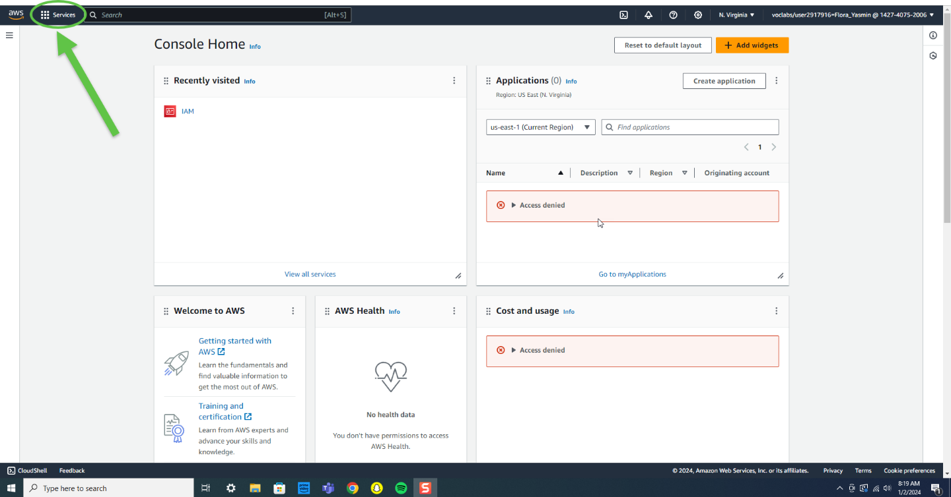

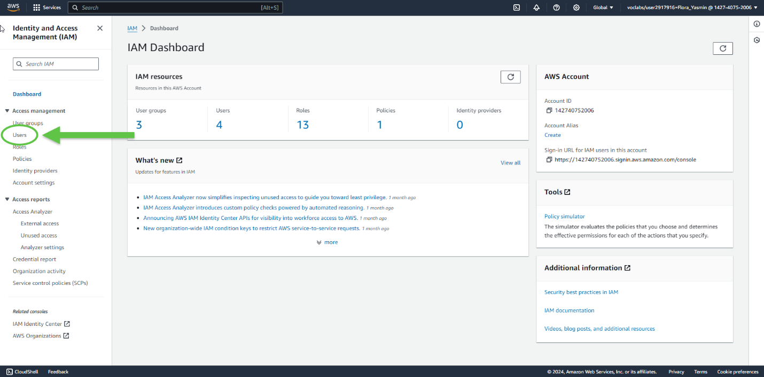

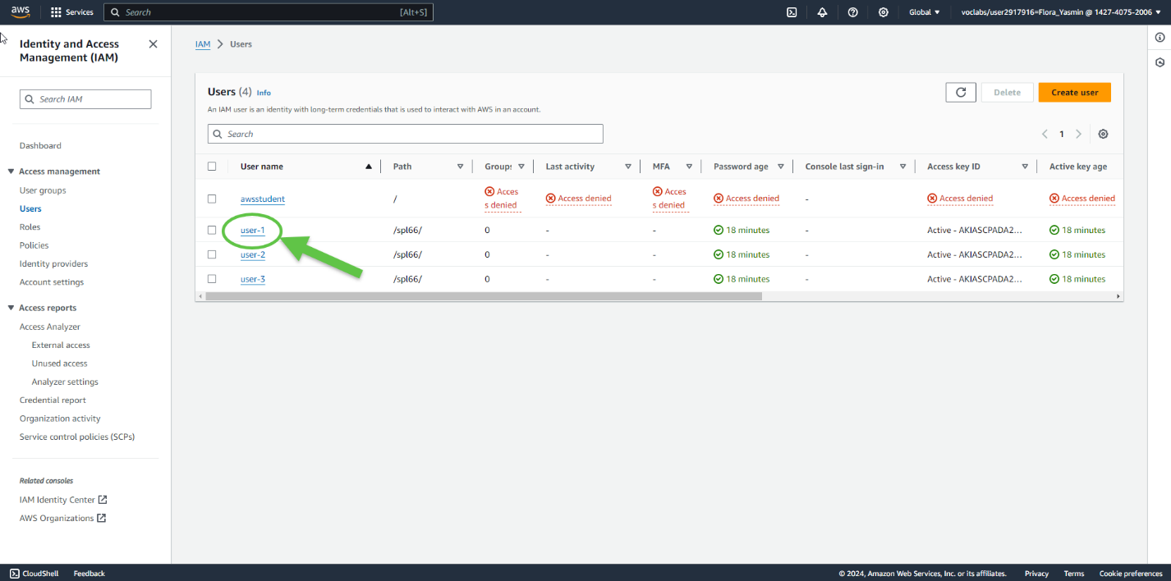

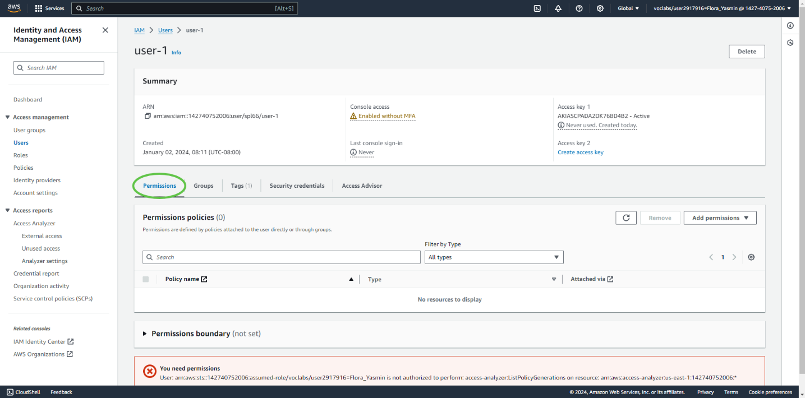

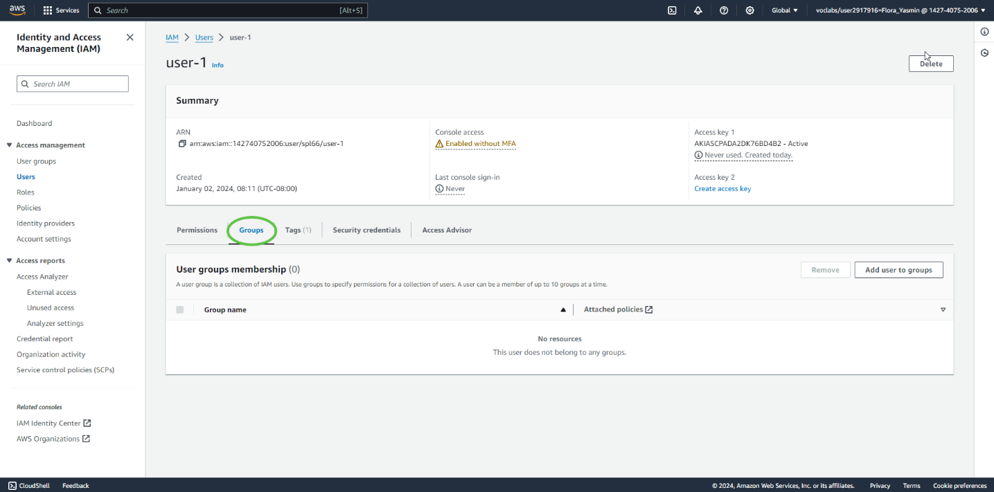

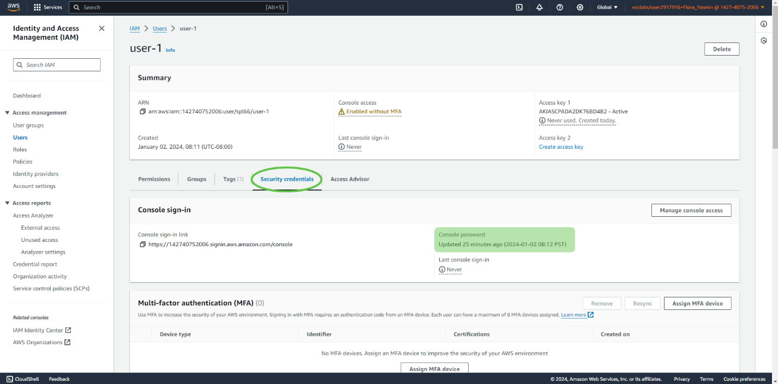

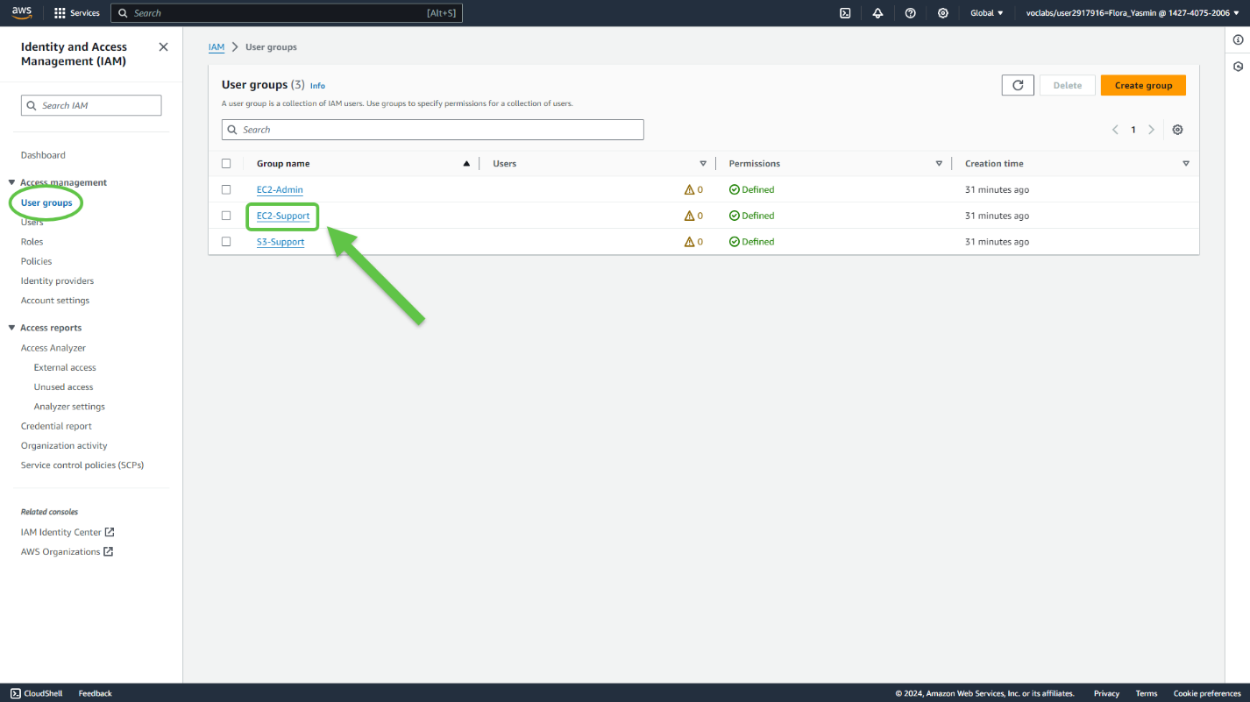

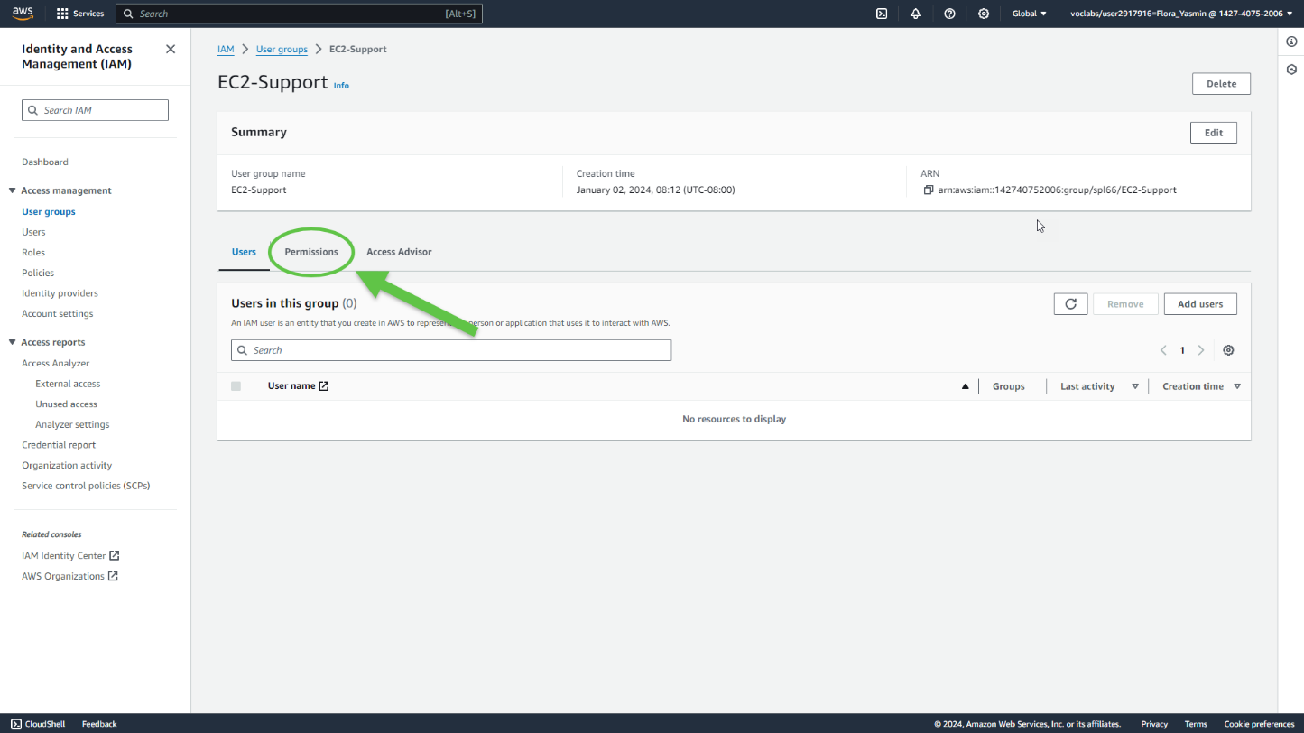

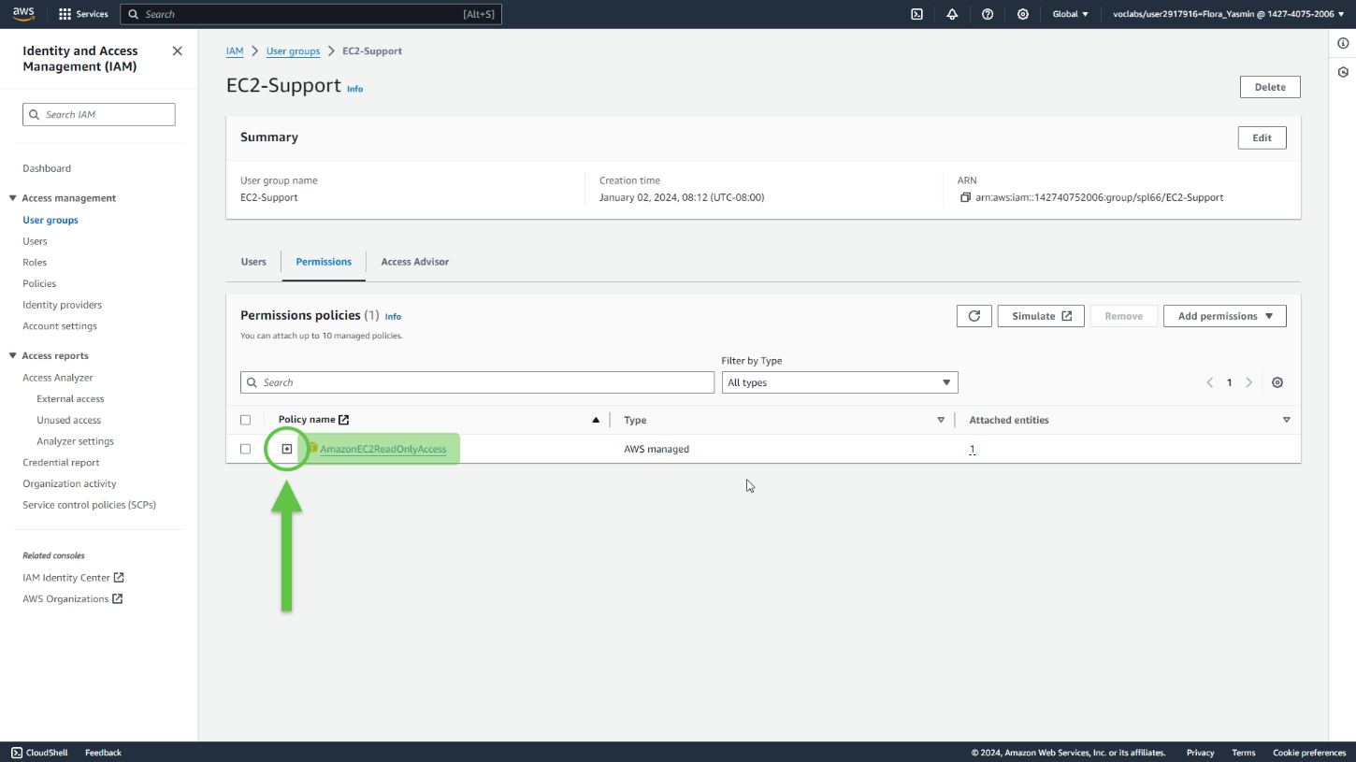

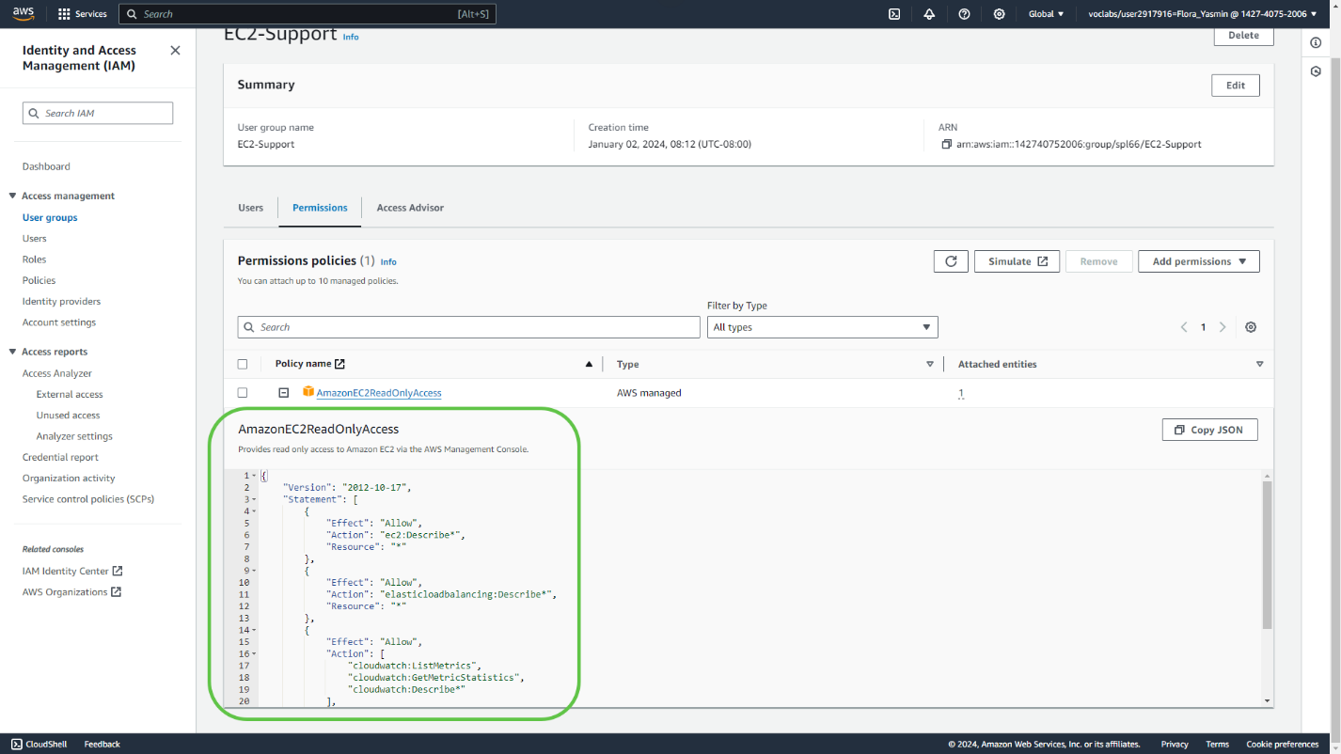

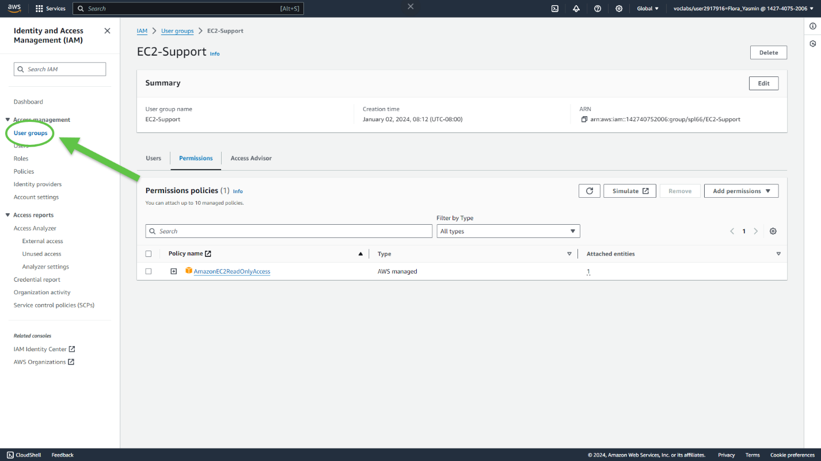

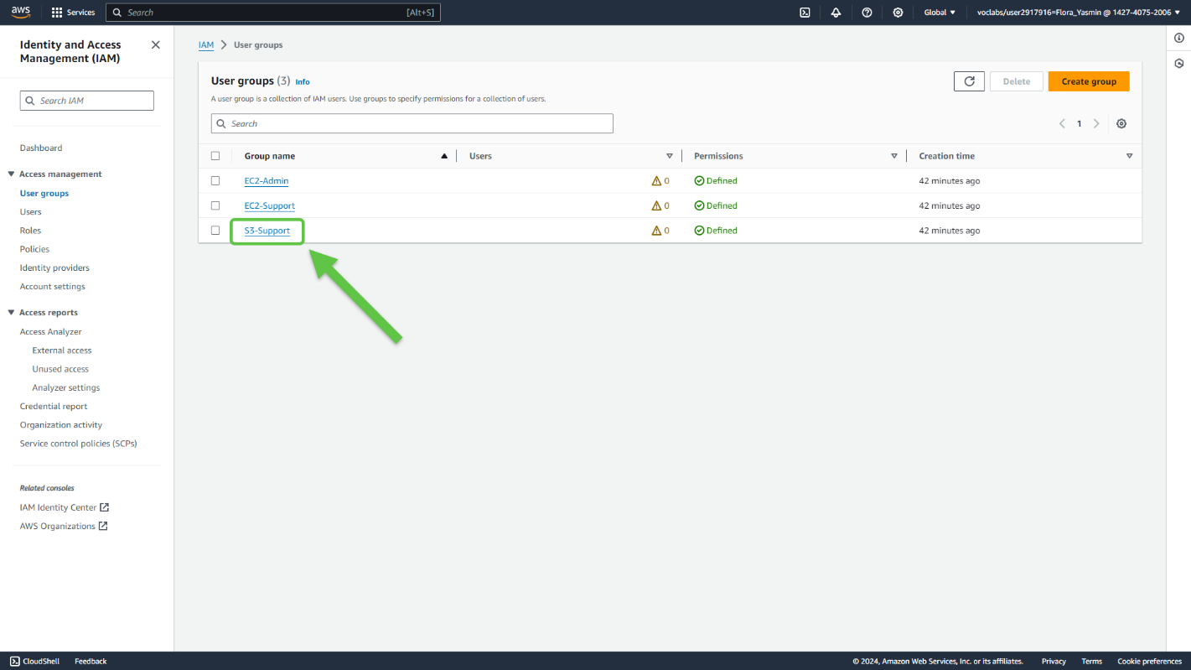

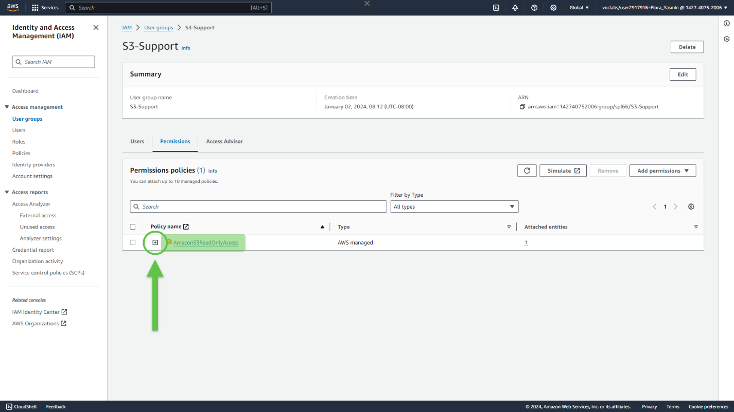

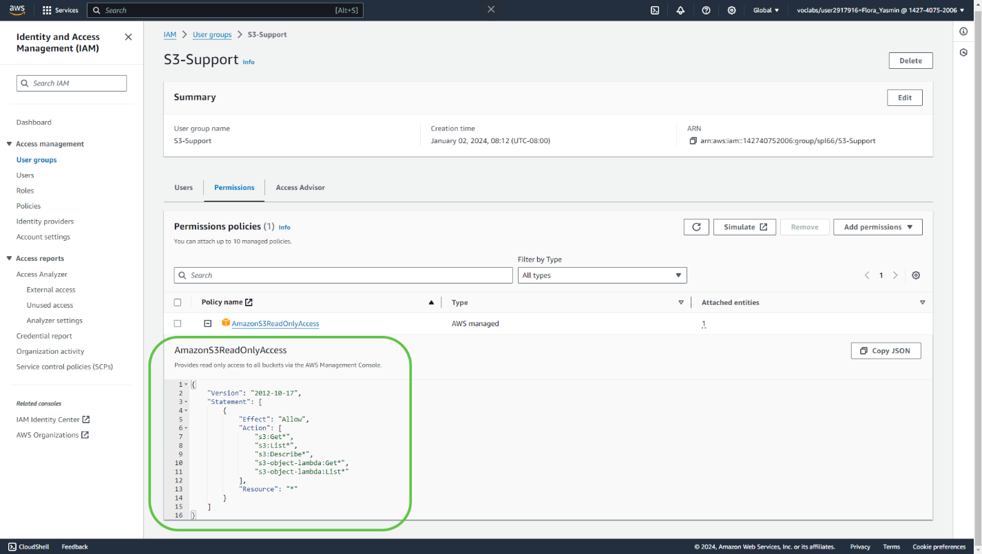

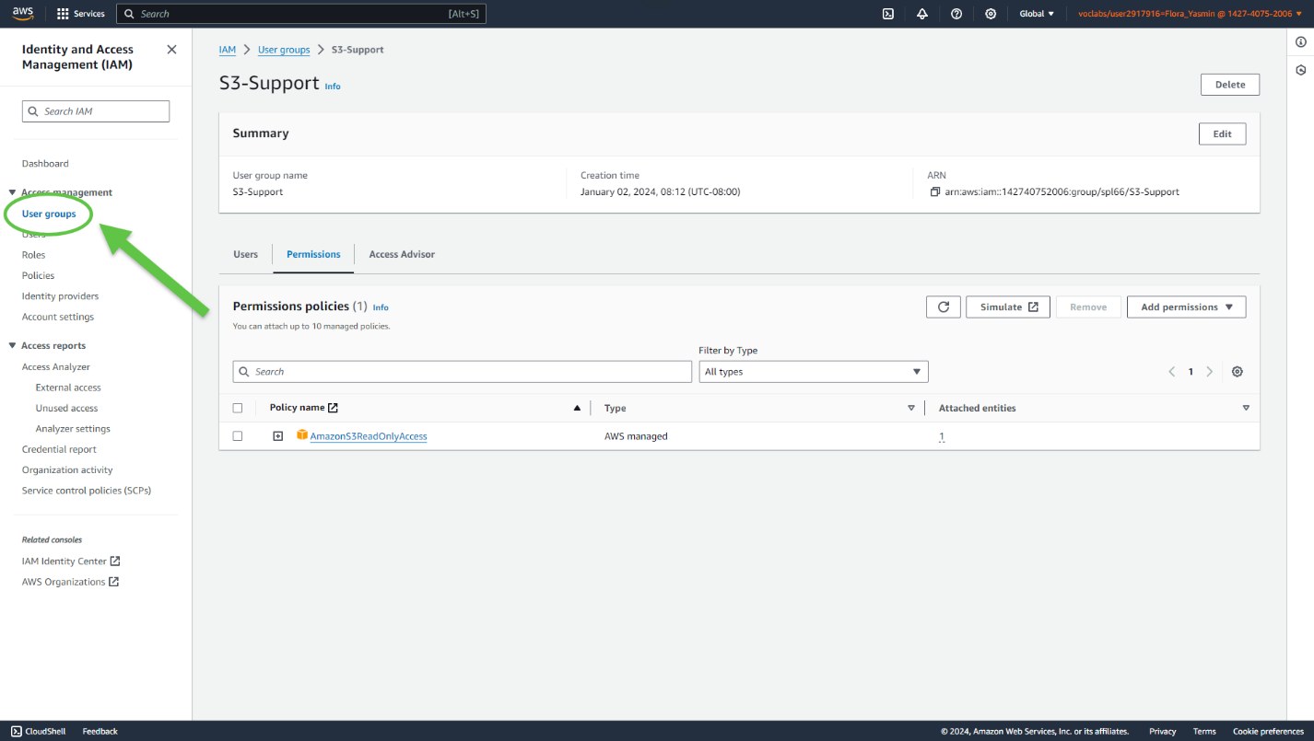

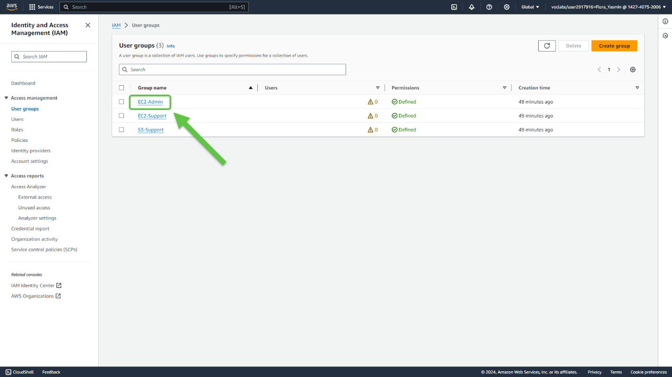

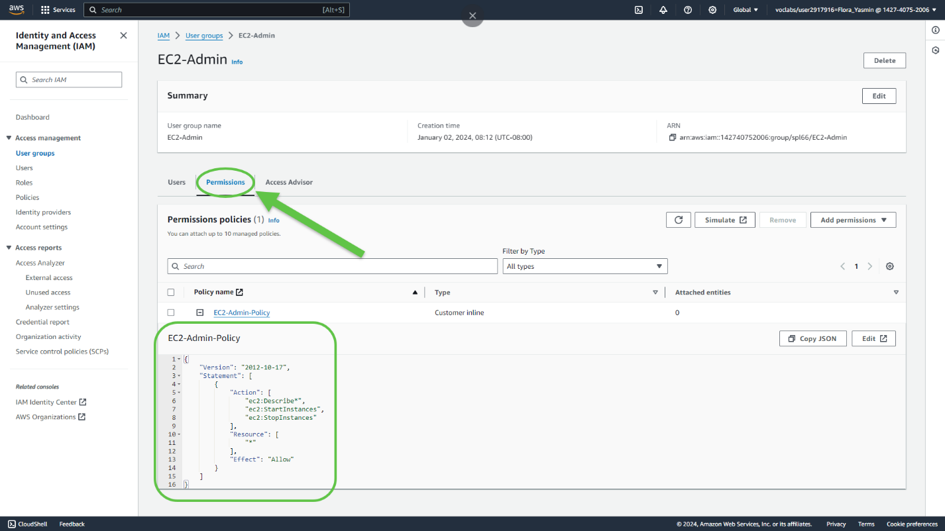

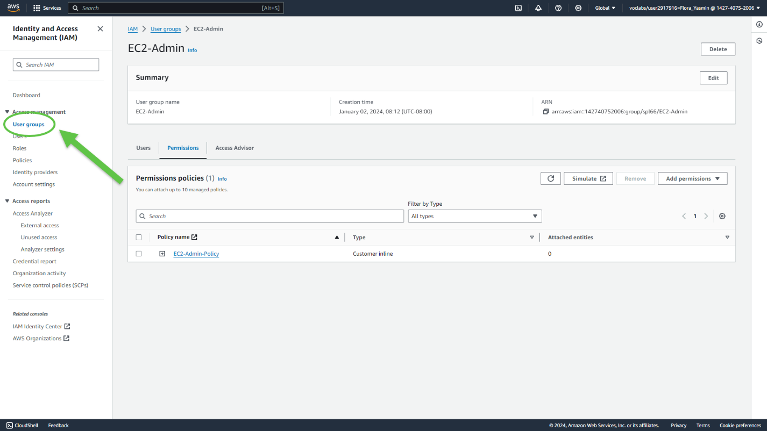

Task 2: Add users to groups

1. Add user-1 to the S3-Support group

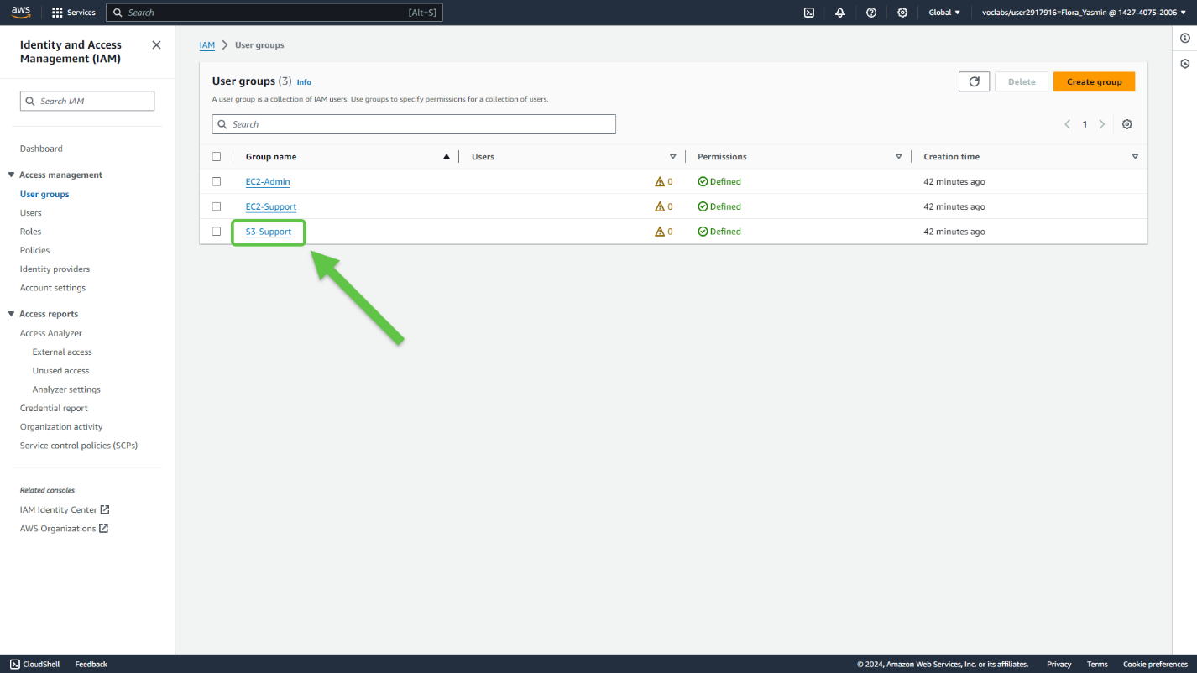

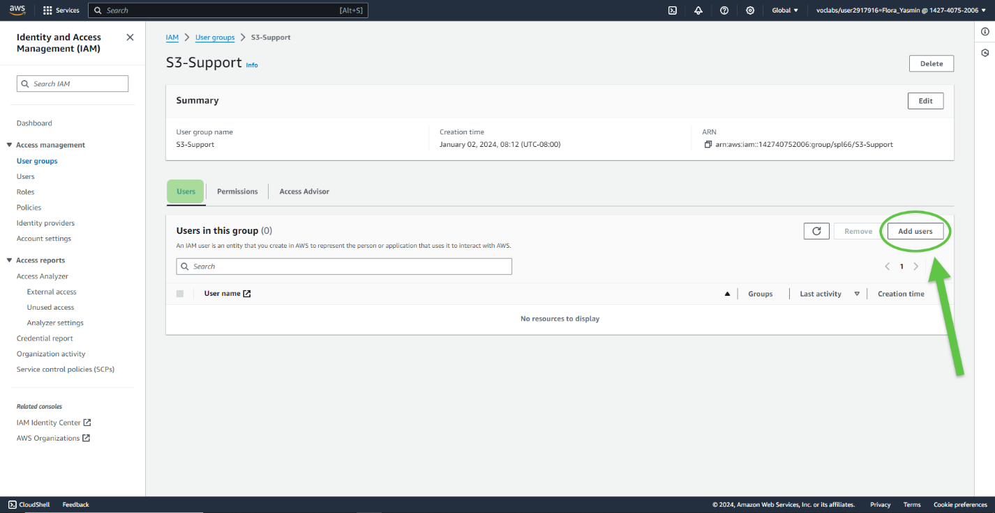

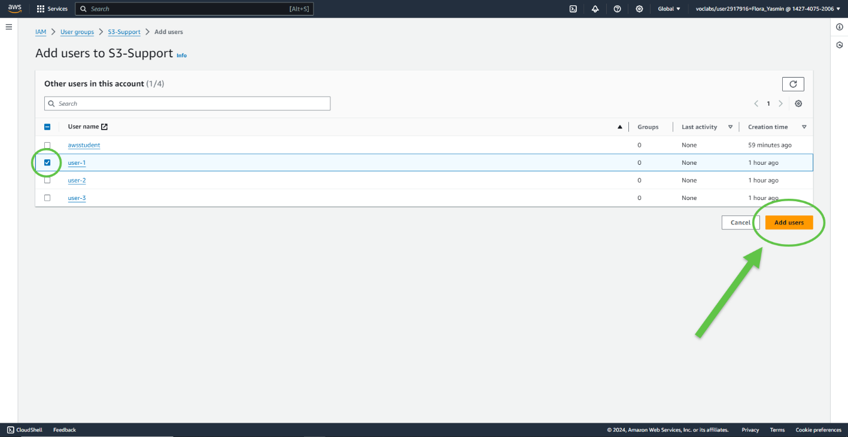

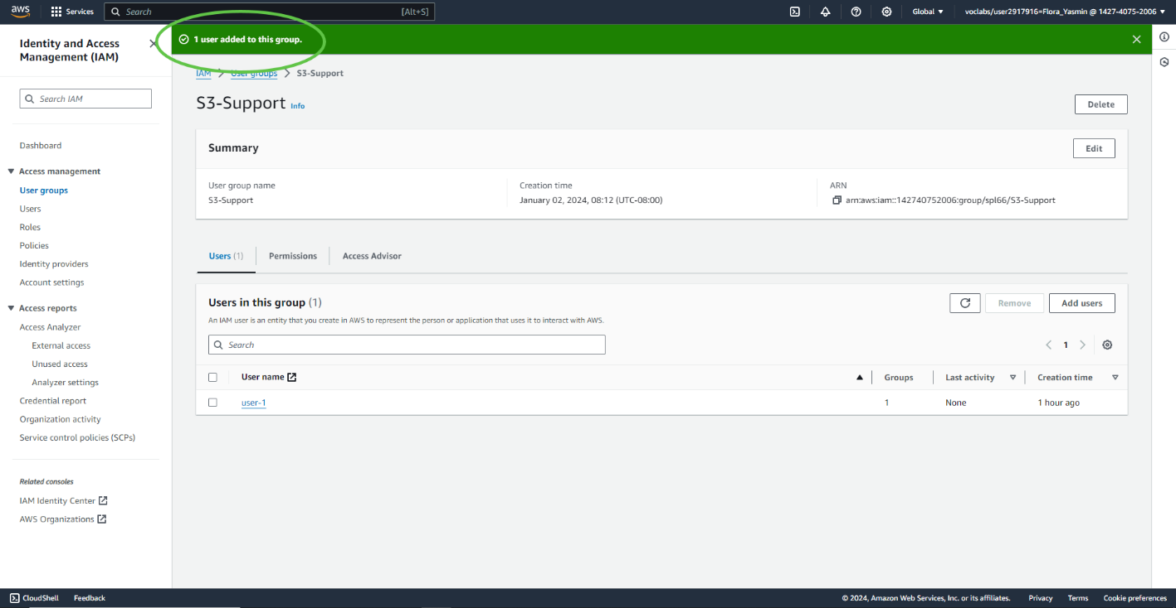

1. Add user-2 to the EC2-Support group

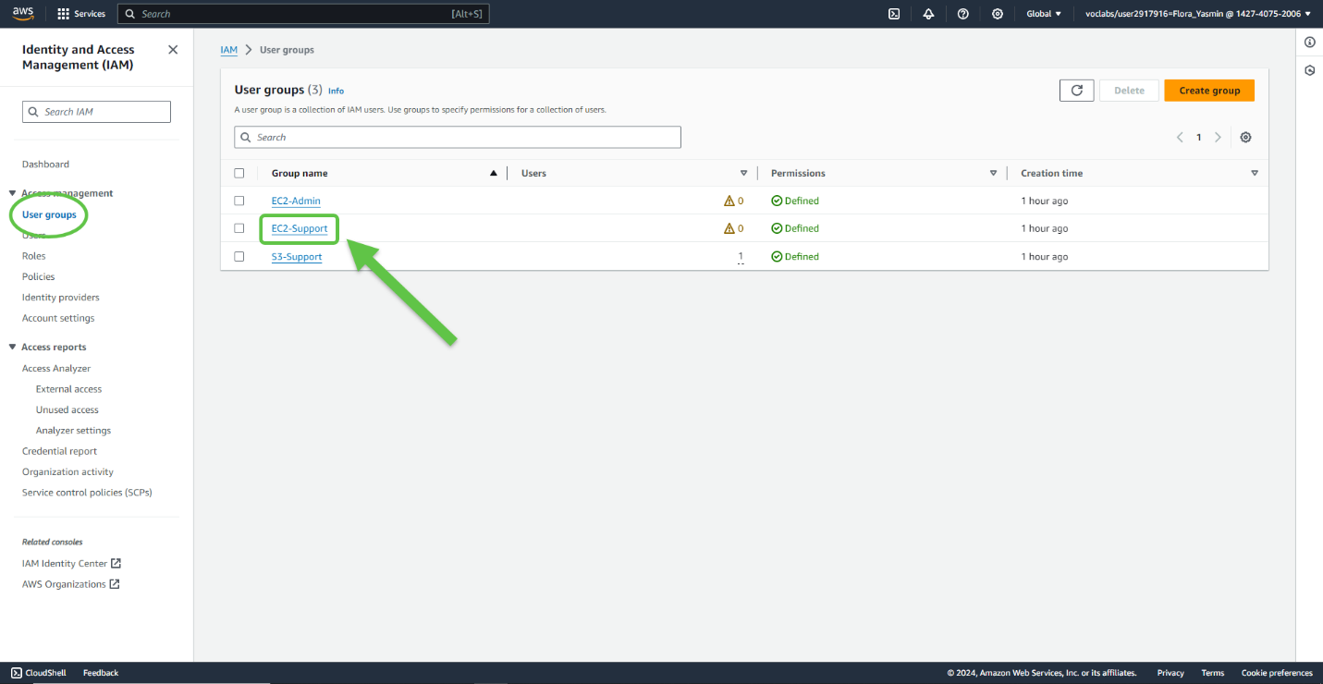

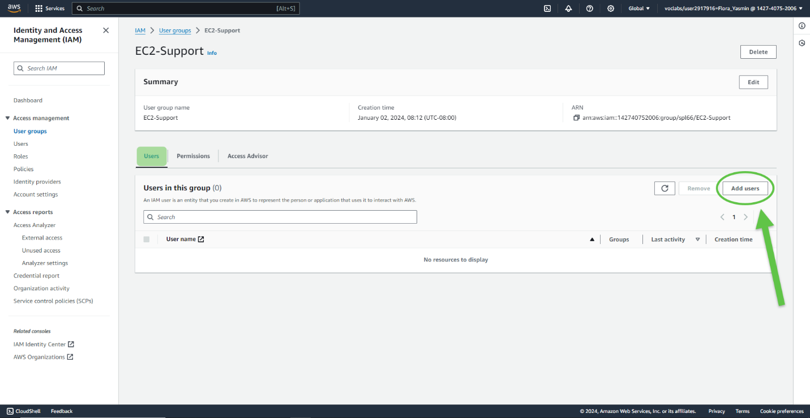

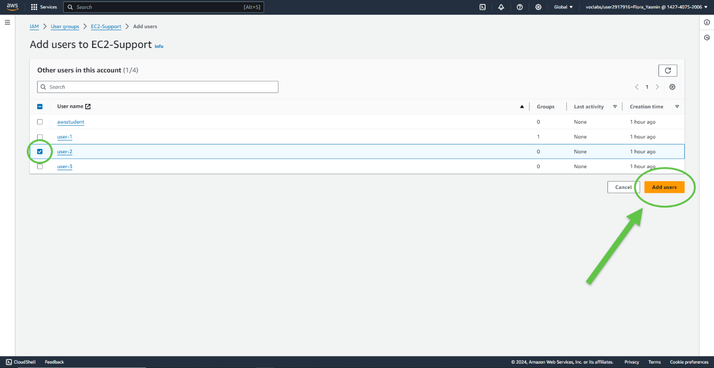

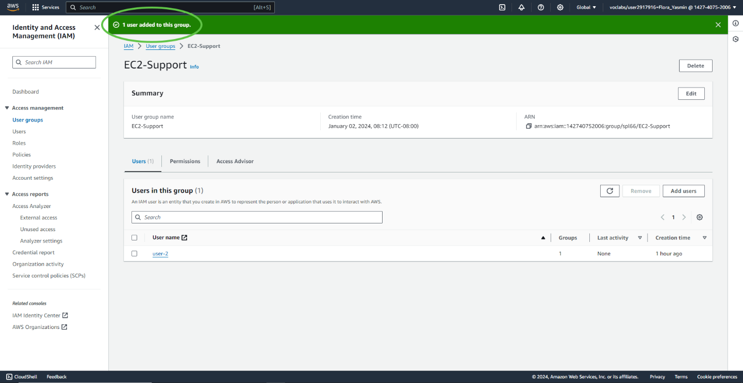

1. Add user-3 to the EC2- Admin group

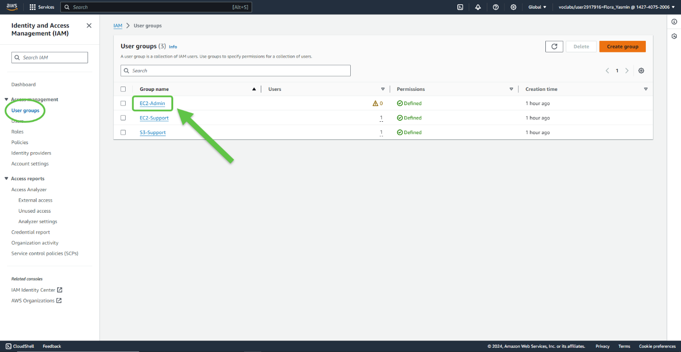

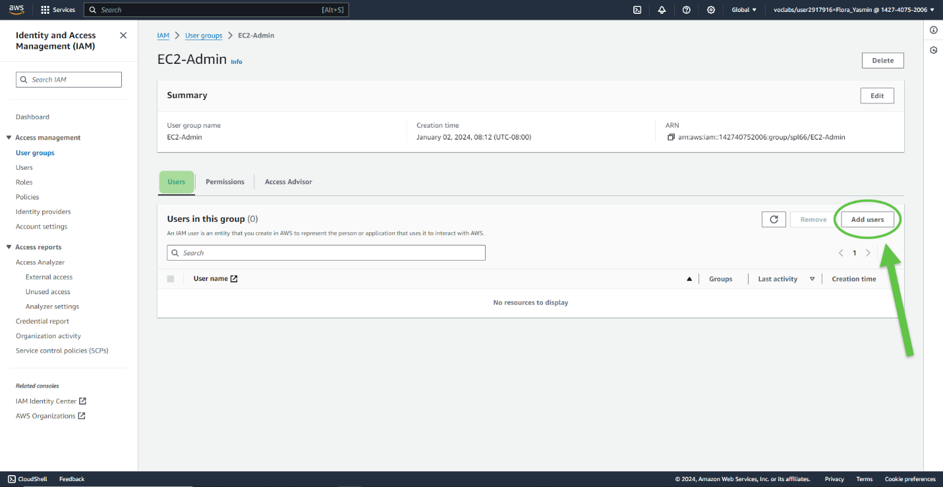

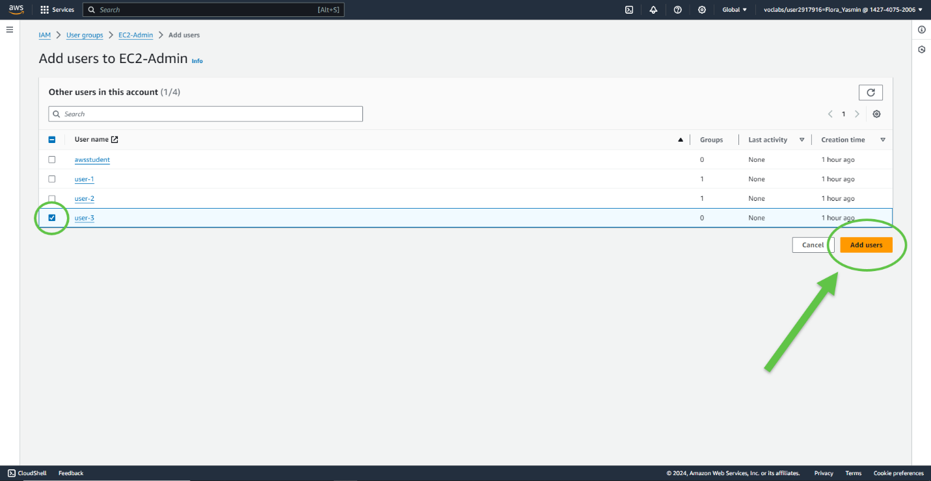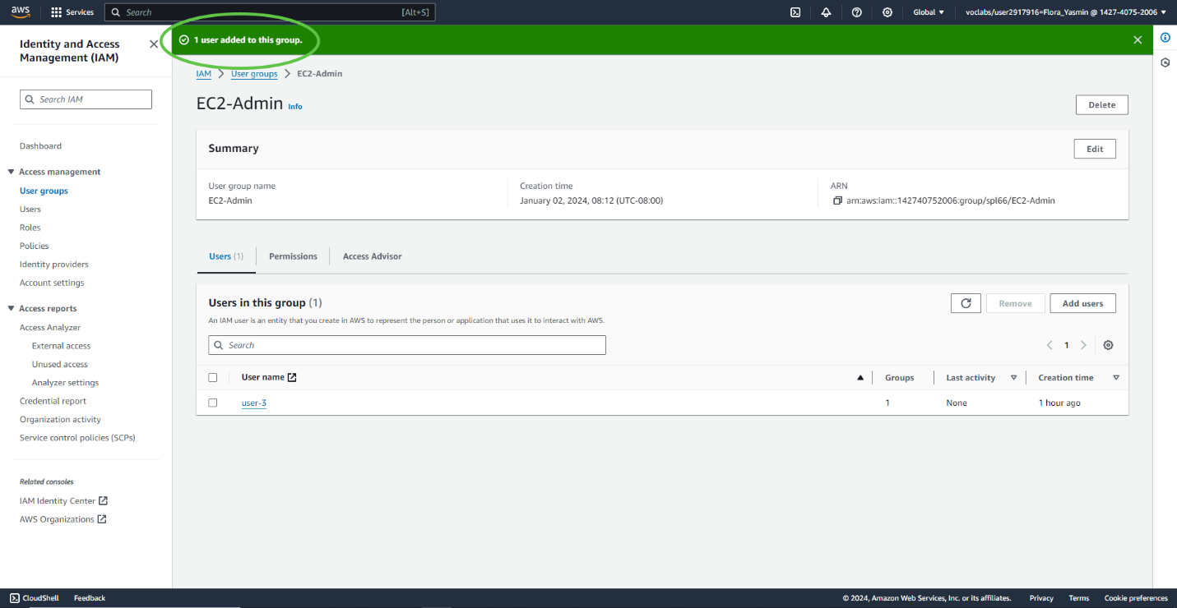

Task 3: Sign in and test users

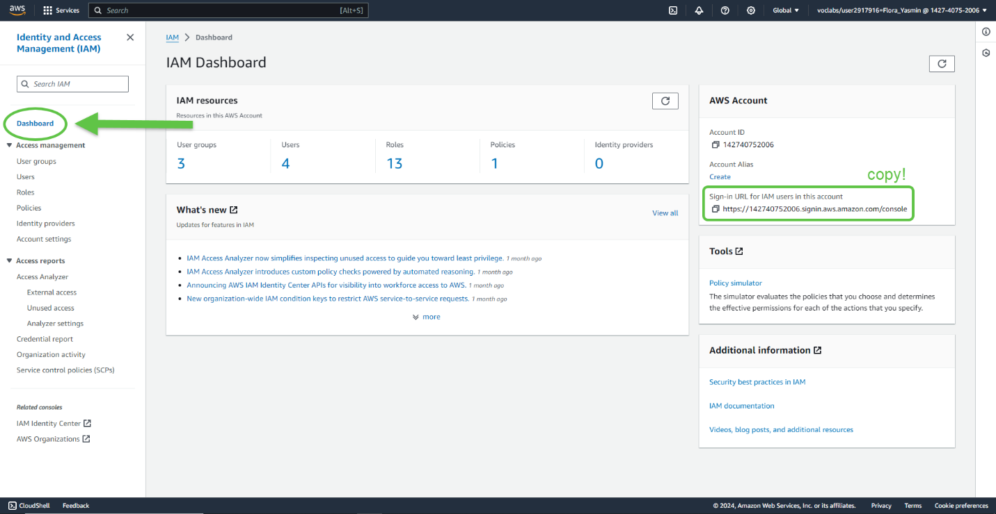

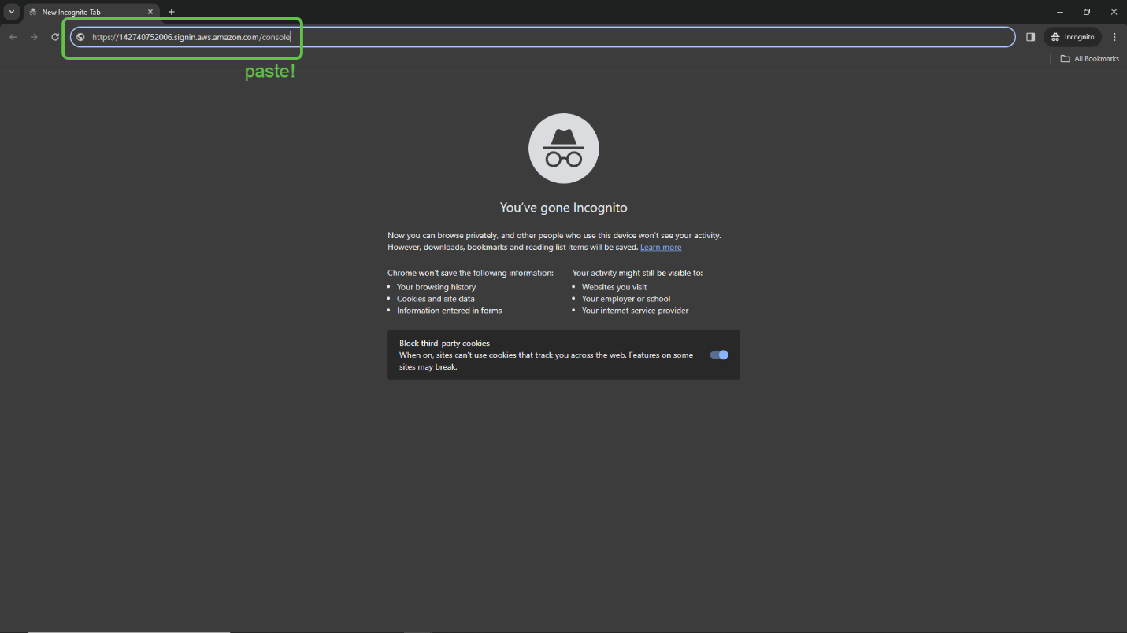

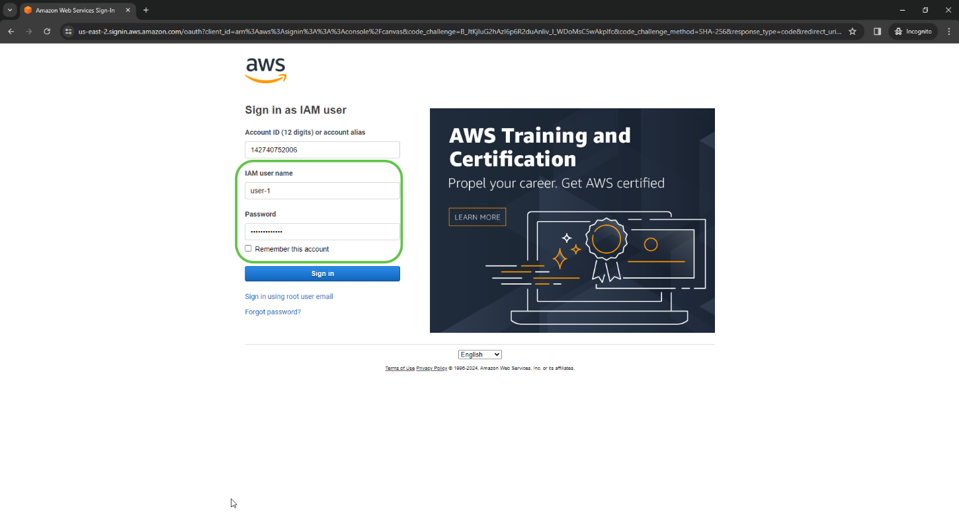

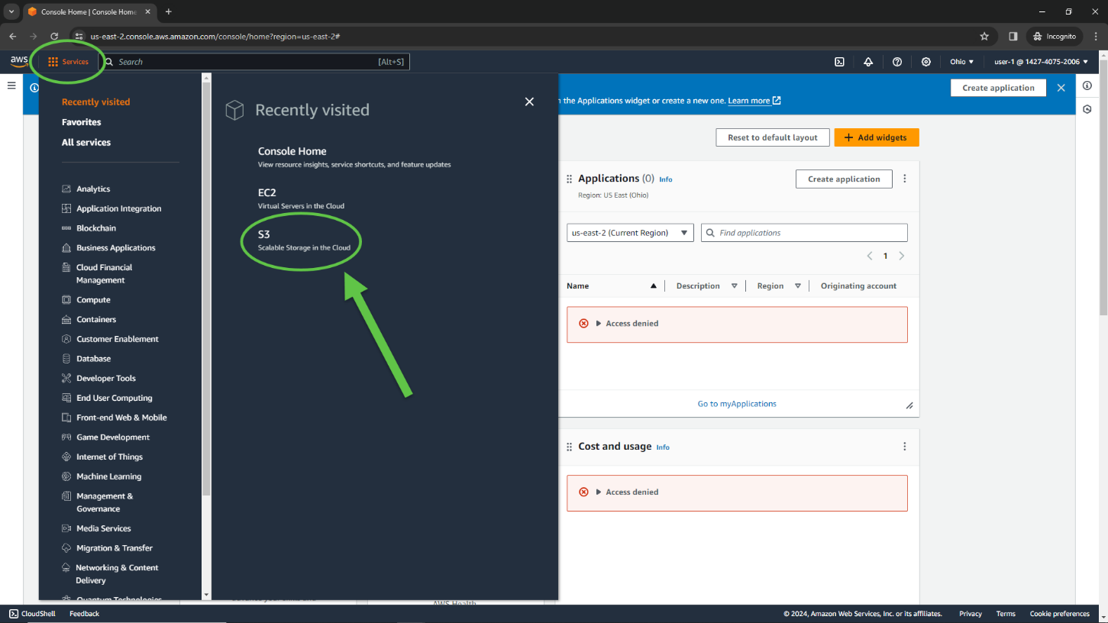

Since user-1 is part of the **S3-Support**group, they have permissions to view the S3 buckets and the contents. You won’t be able to see EC2 instances when logged in as user-1, since these permissions have not been specifically granted.

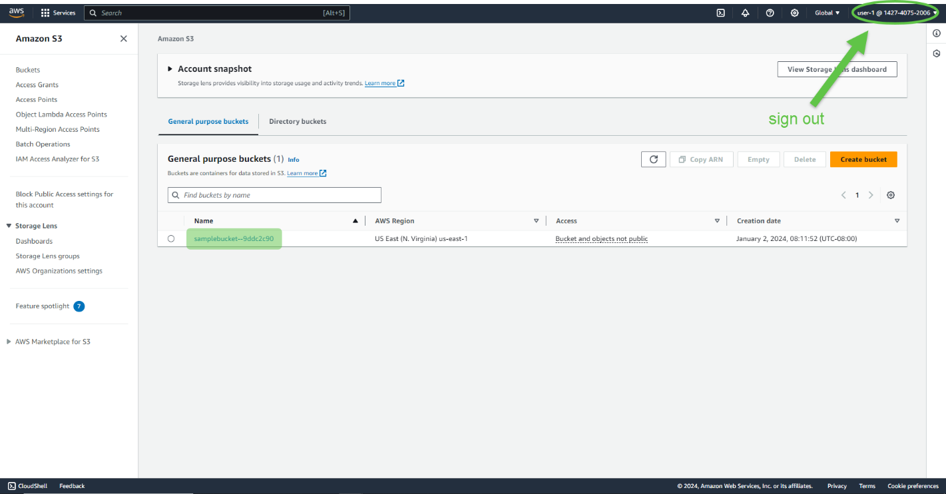

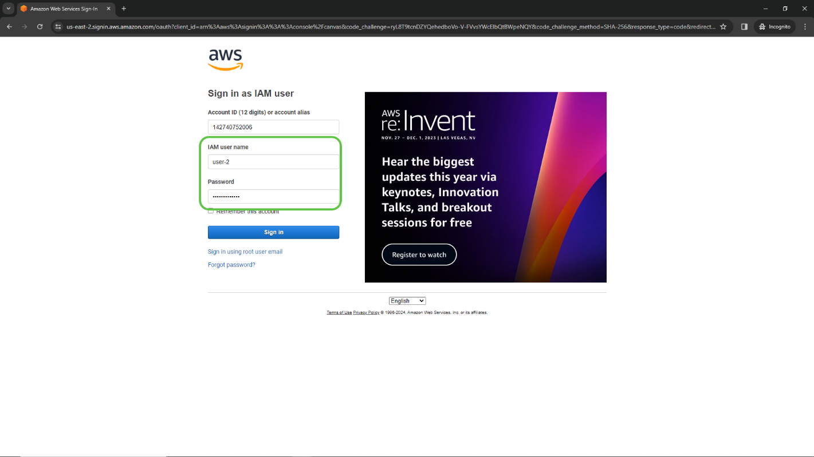

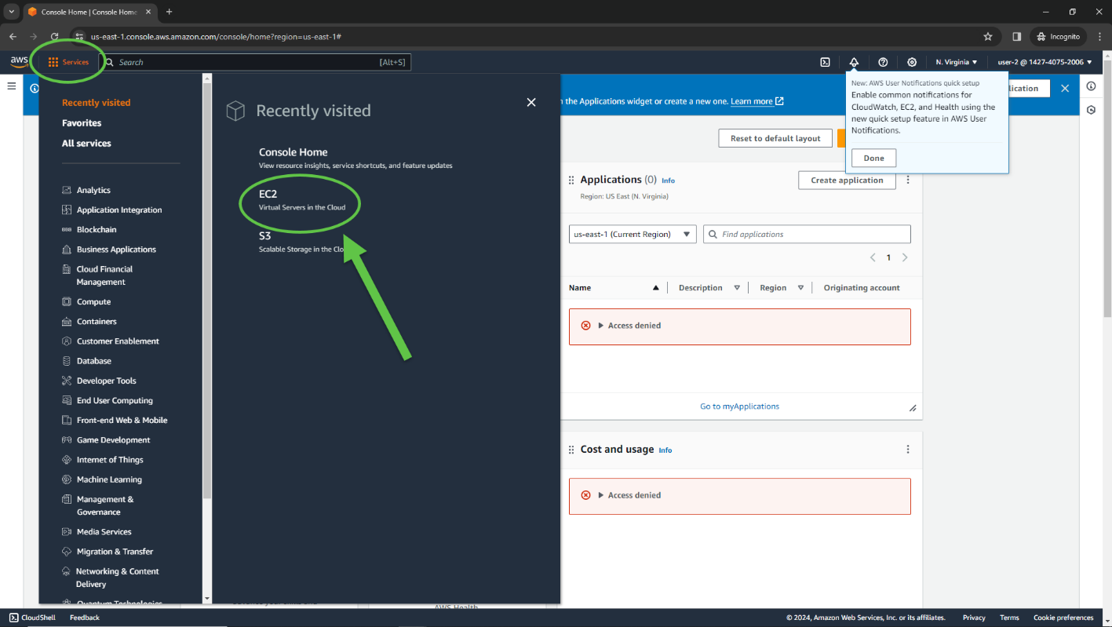

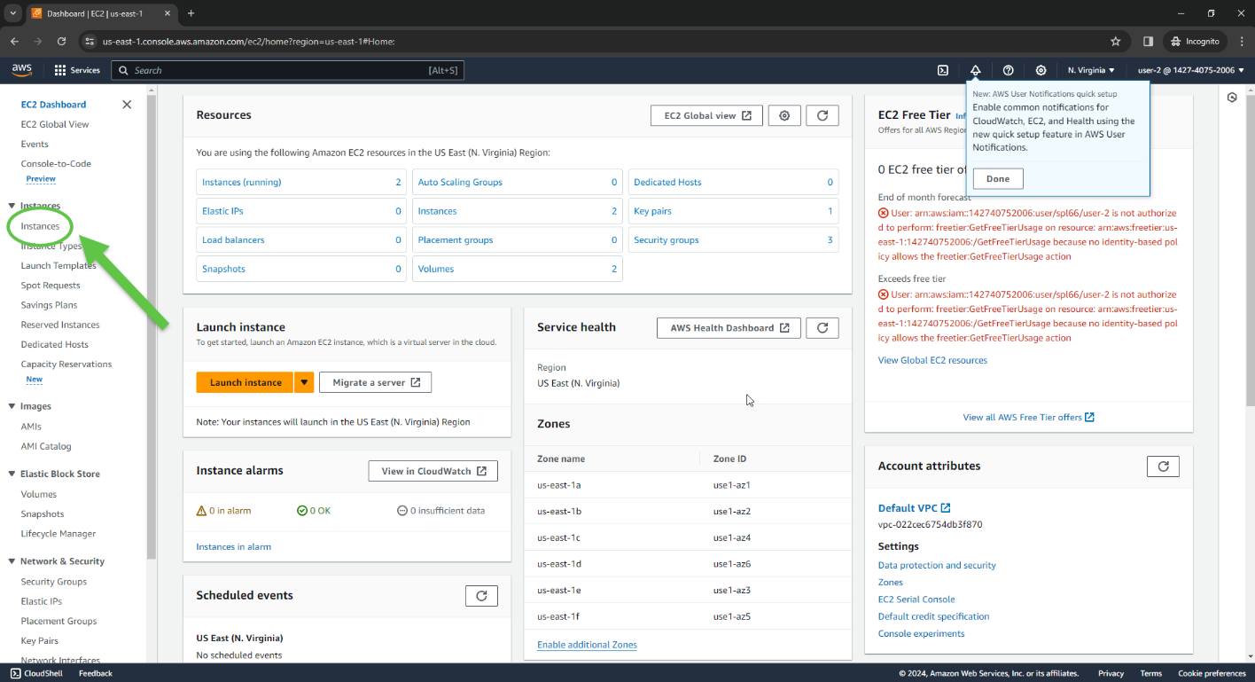

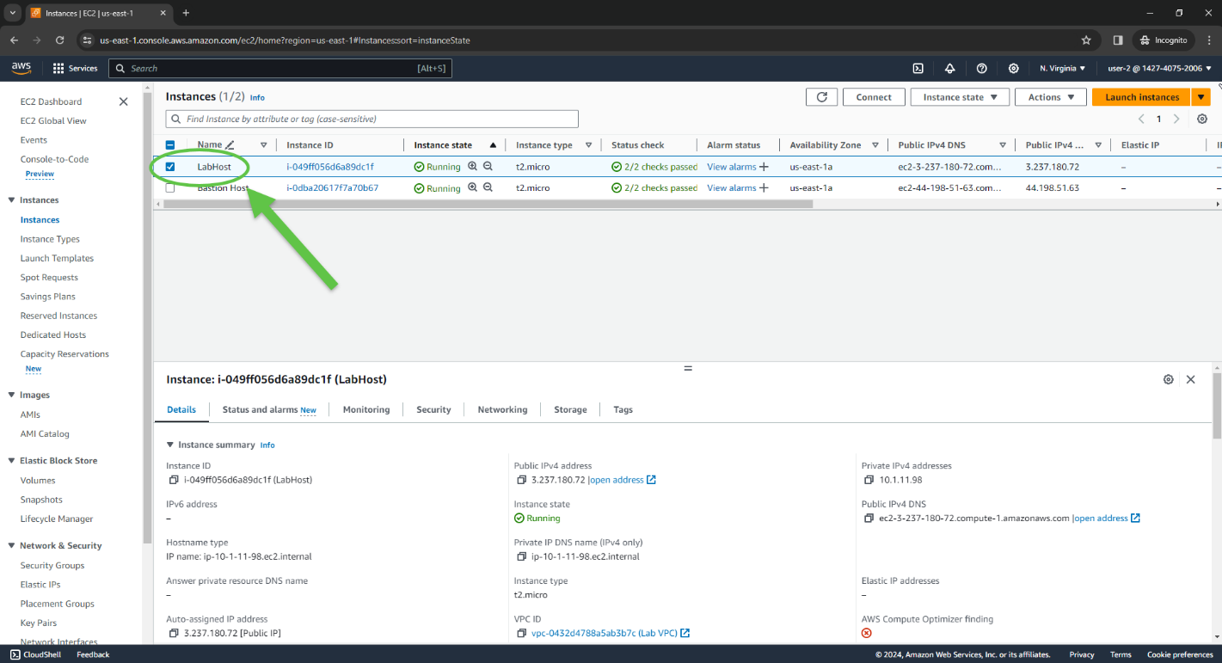

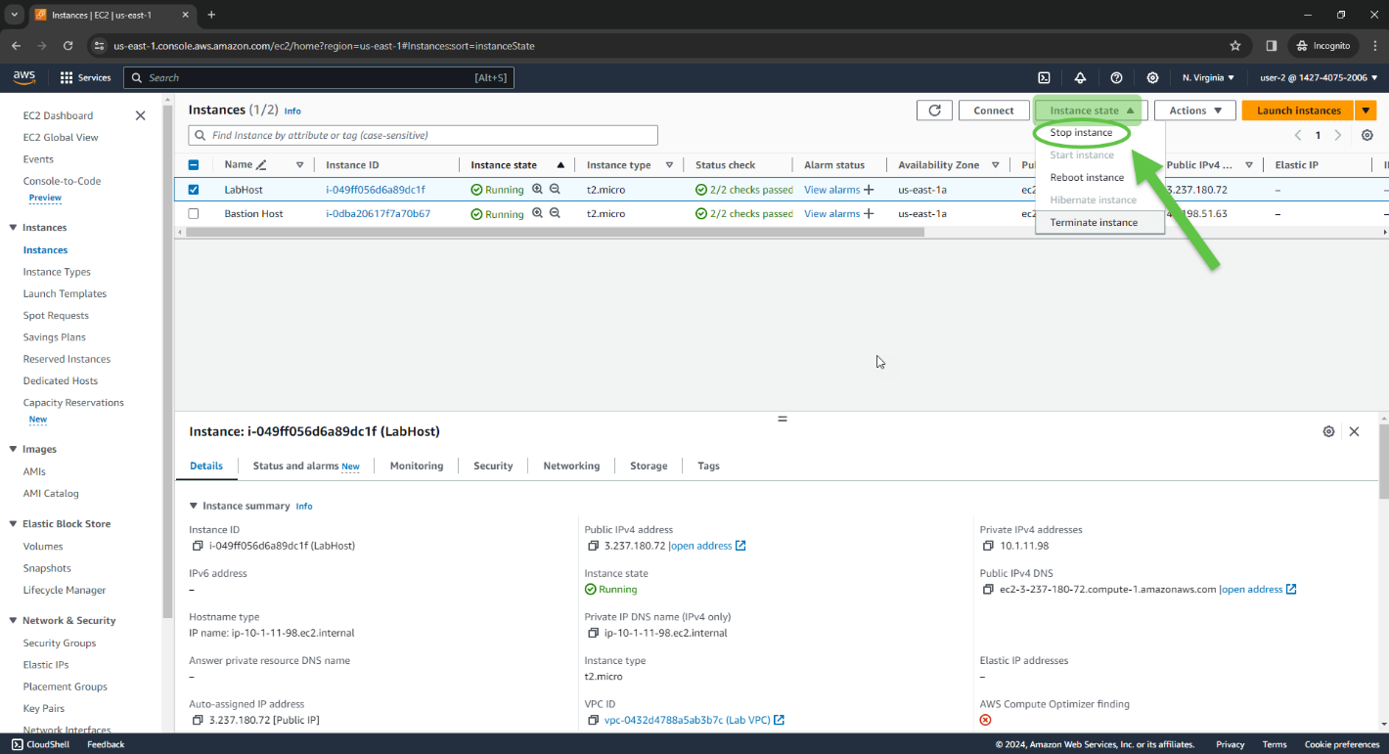

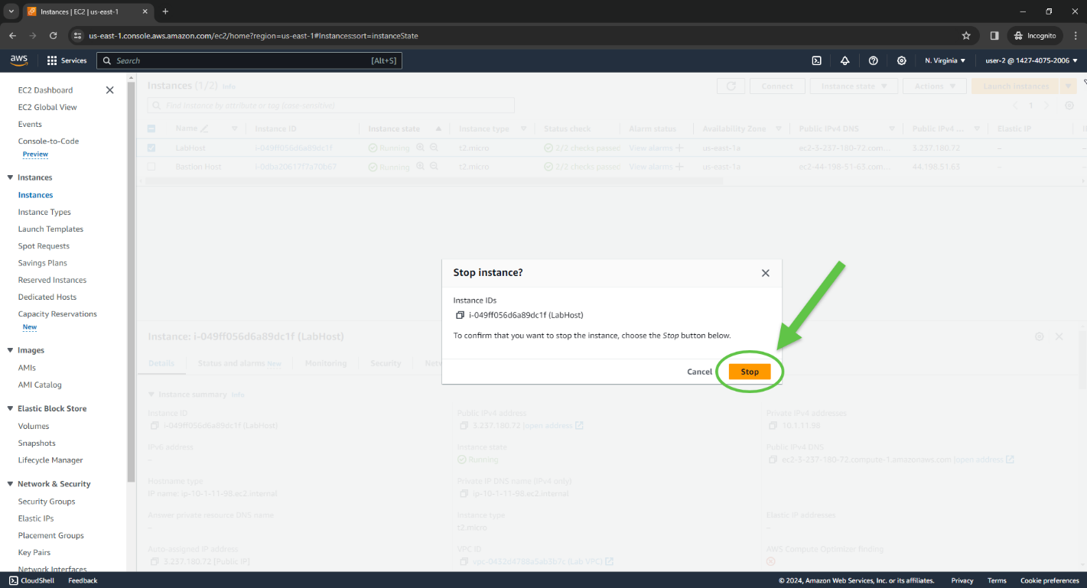

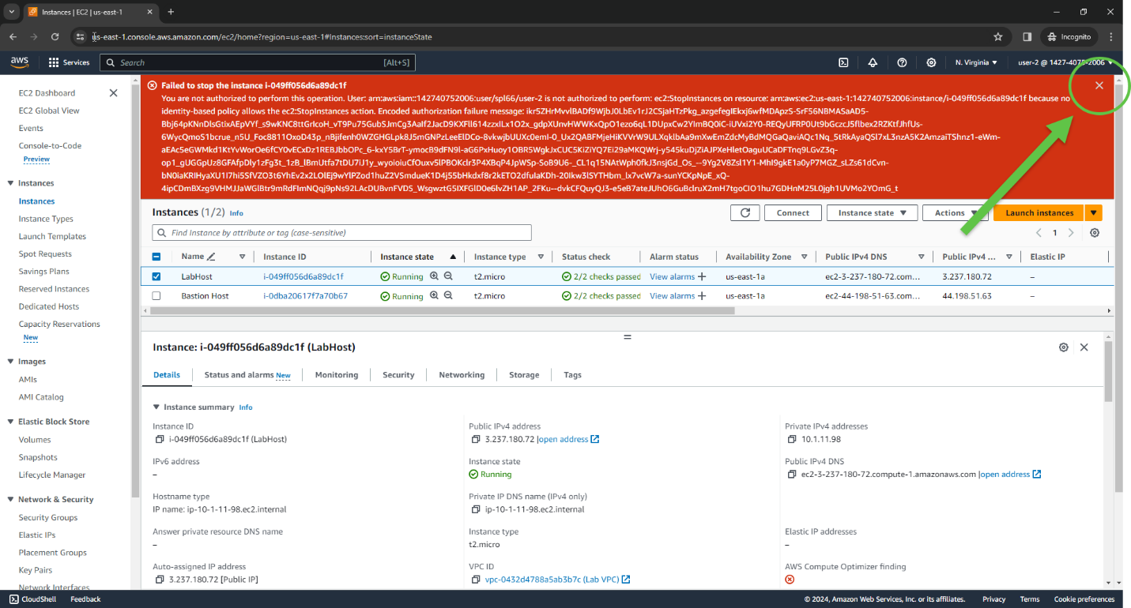

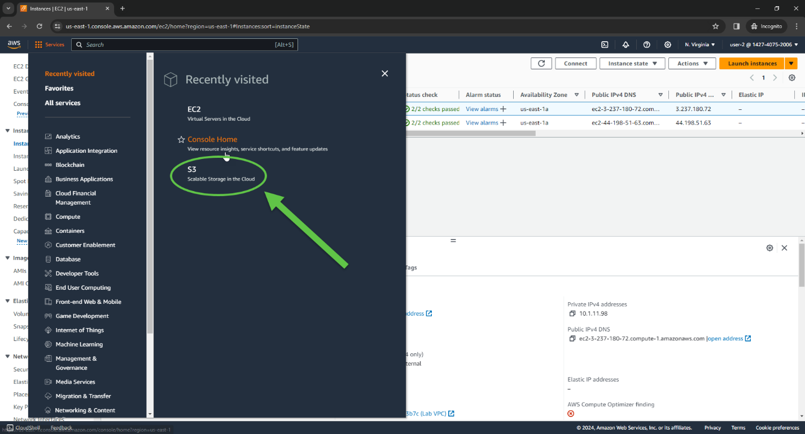

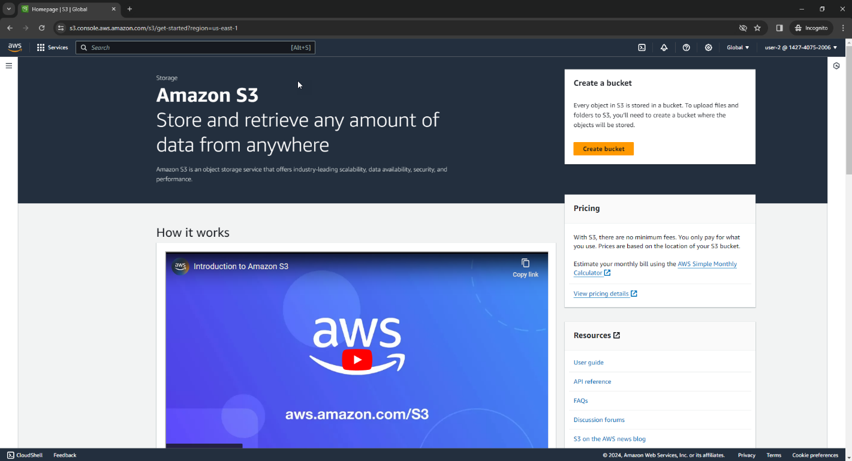

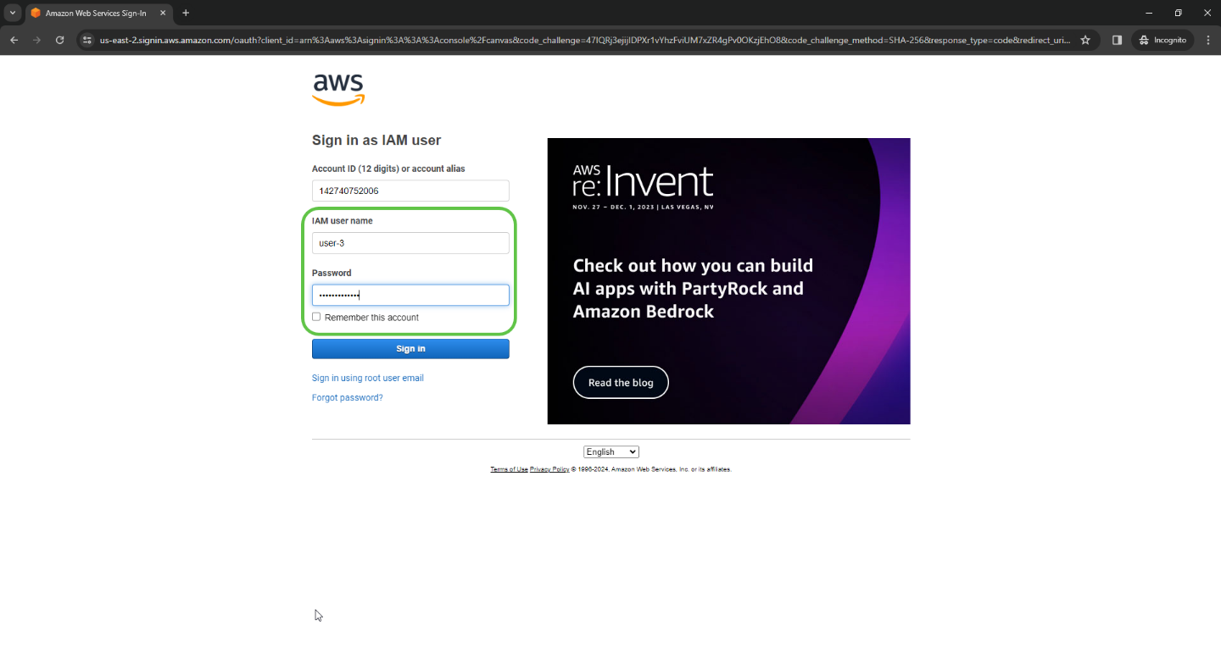

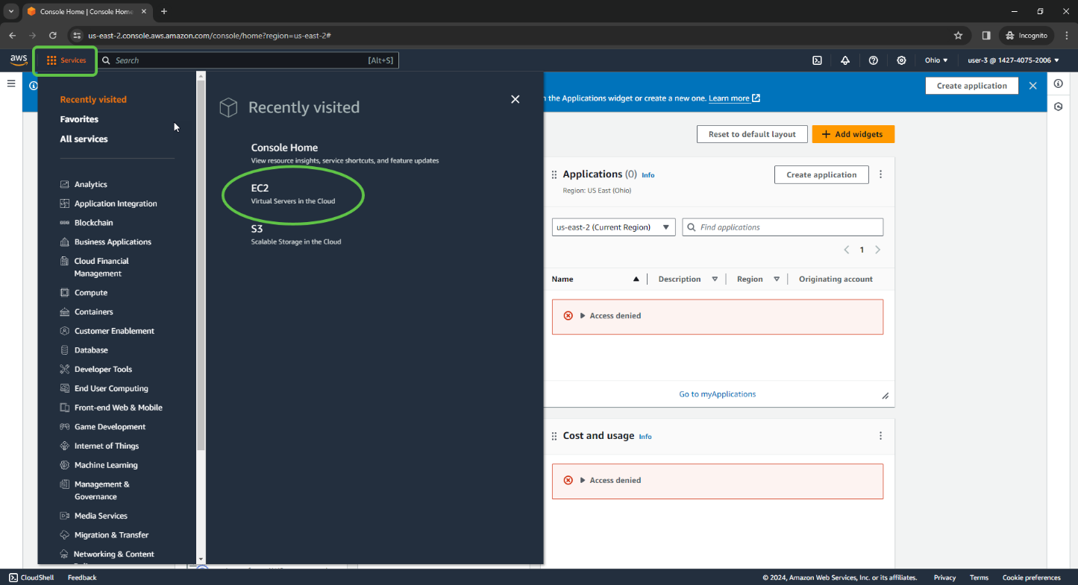

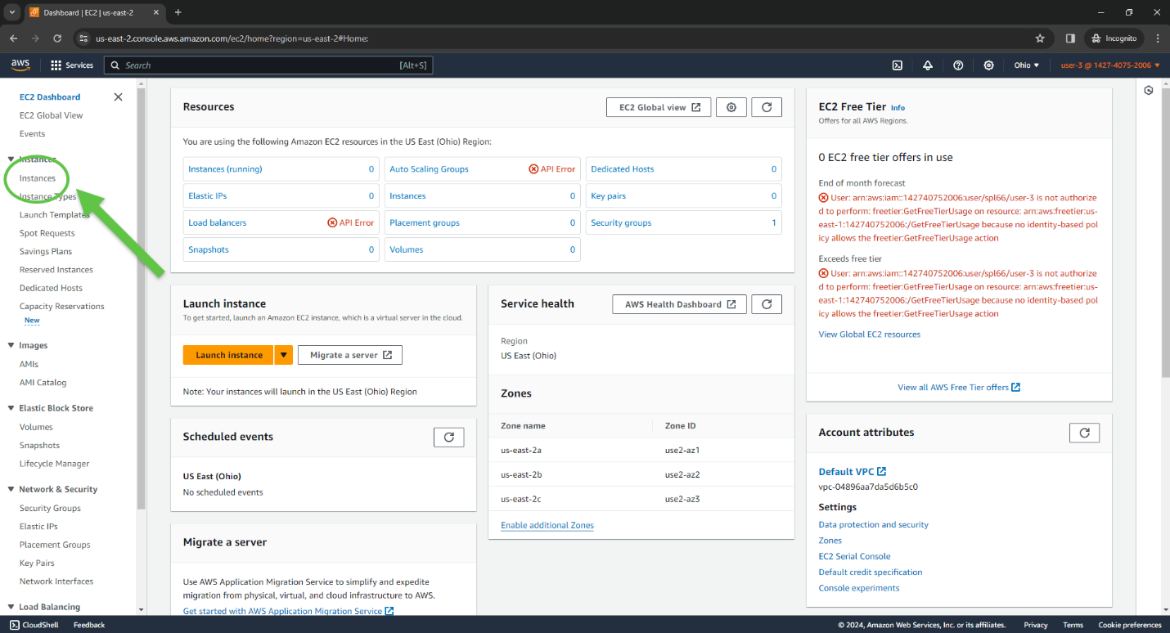

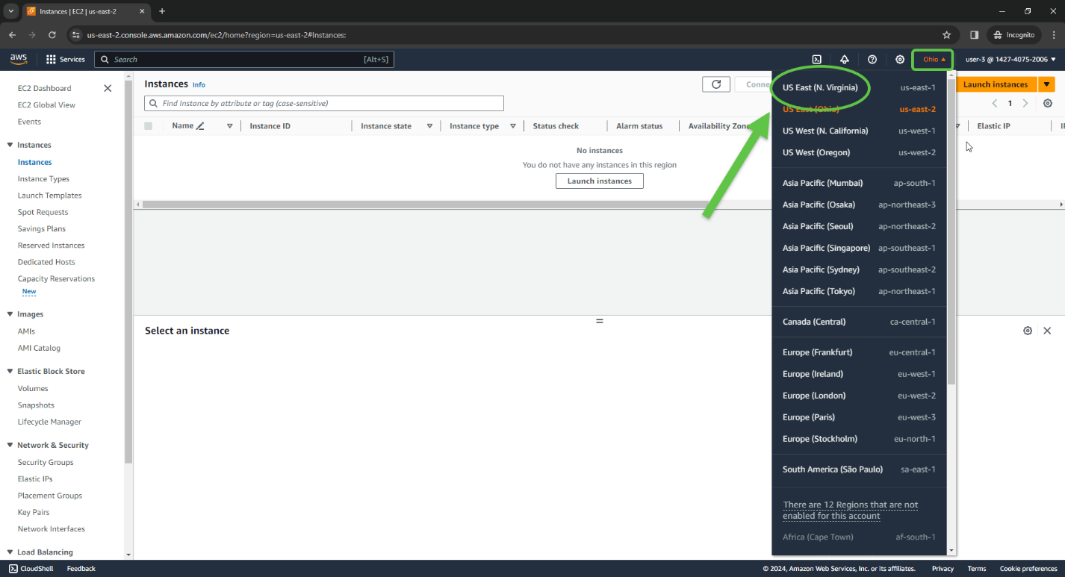

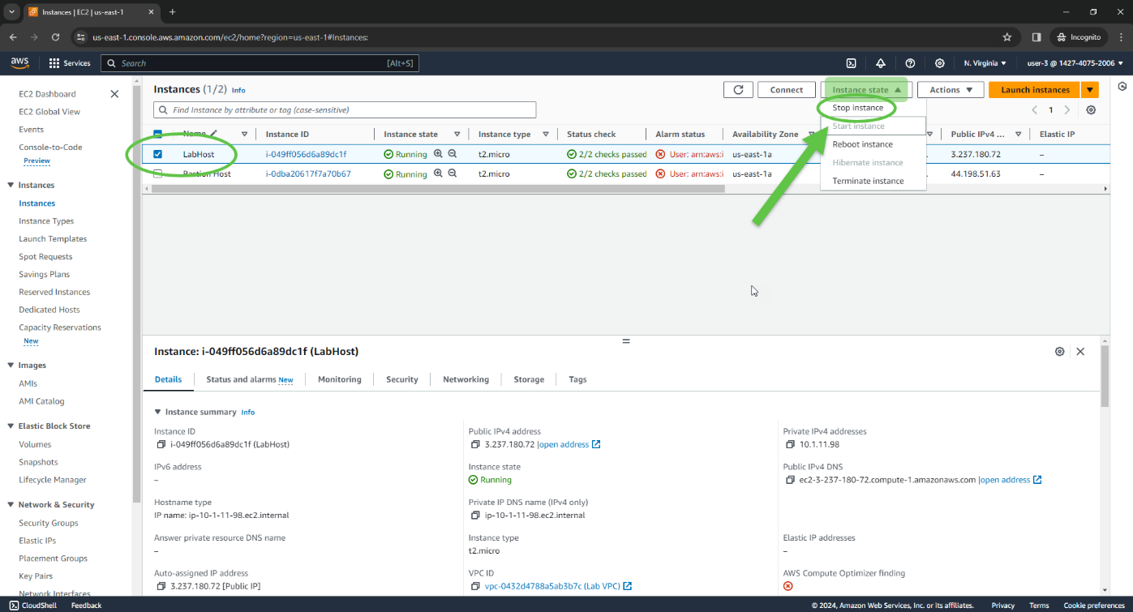

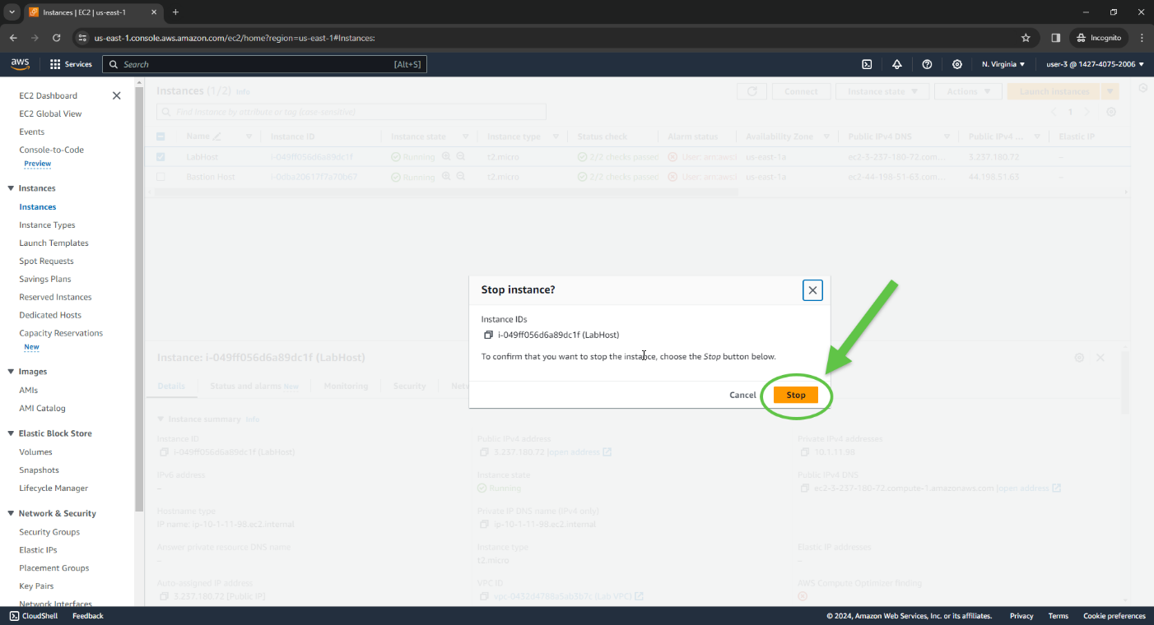

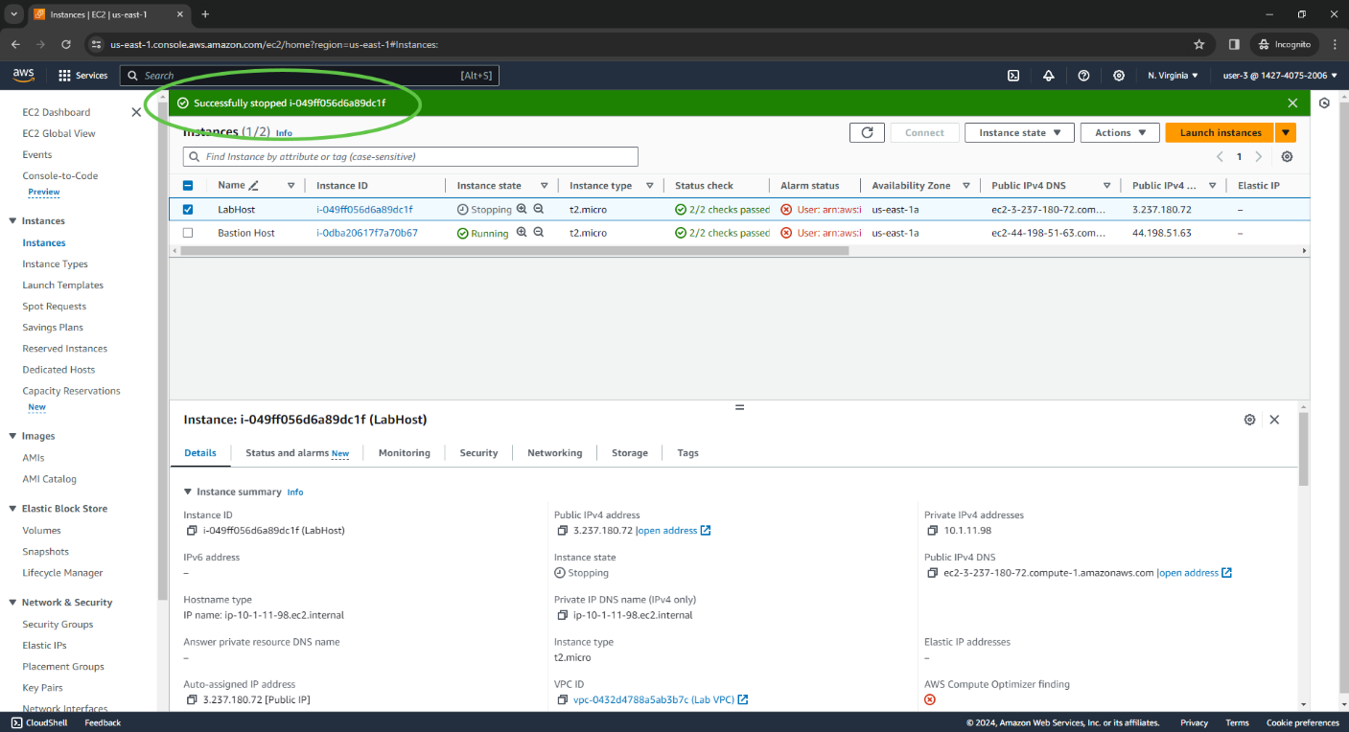

**Problems**

On Task 3, instances for user 3 did not show up because I was set in Ohio, not N. Virginia. To fix this problem, I clicked my location in the top right corner and changed it to make my instances visible.

**Conclusion**

This lab showed how to view and create IAM users and groups and sign in to see the policies assigned to each. Following a real-world scenario, it allowed us to analyze the effects of policies taken on each user’s access by viewing their service buckets.

**Lab 2: Build your VPC and Launch a Web Server**

**Purpose**

The purpose of this lab is to use the Amazon Virtual Private Cloud (VPC) to create a new, customized VPC and network. This lab also creates a security group and an EC2 instance to run a web server and create subnets in the VPC.

**Background Information**

The Amazon Virtual Private Cloud (VPC) is a web service provided by AWS enabling users to launch resources into a new virtual network—a network which resembles a traditional data center network, except includes the benefits of AWS scalability. A VPC is an isolated section of the AWS cloud and can span multiple Availability Zones. Its three main components include control over networking resources, network configuration customization, and security.

The IP addresses for a VPC are represented in Classless Inter-Domain Routing (CIDR) notation. A IPv4 or IPv6 CIDR block is assigned to the AWS region, and subnets from this block are assigned to separate Availability Zones. AN IPv4 CIDR block can range from a /28 subnet, or 16 addresses, up to a /16 subnet, or 65,536 address. In a CIDR block, 5 IP addresses are reserved for the network address, broadcast address, VPC local router, DNS resolution, and future use.

For each VPC instance, there is a default private IP address, and you can easily receive a public one as well. But instead of CIDR blocks, VPCs can also use elastic IP addresses, which is a static, public IPv4 address designed for dynamic cloud computing. Failed instances’ resources can be restored and deployed into a new instance this way. Elastic network interfaces are also easy to re-map from instance to instance.

The VPC console can be used to create additional resources beyond just a VPC, including an *internet gateway,* a *public subnet,* a *private subnet,* route tables, and a *NAT gateway;* which you will notice in this lab*.* An internet gateway is a VPC resource that allows communication between the internet and EC2 instances established through your VPC. Similarly, a NAT gateway is a VPC resource that is used to provide internet connectivity to any EC2 instances in *private* VPC subnets without establishing any direct connections with an internet gateway. When a route table is associated with public subnet routes with network traffic traveling to the internet gateway, the subnet is public.

**Lab Procedures**

Task 1: Create your VPC

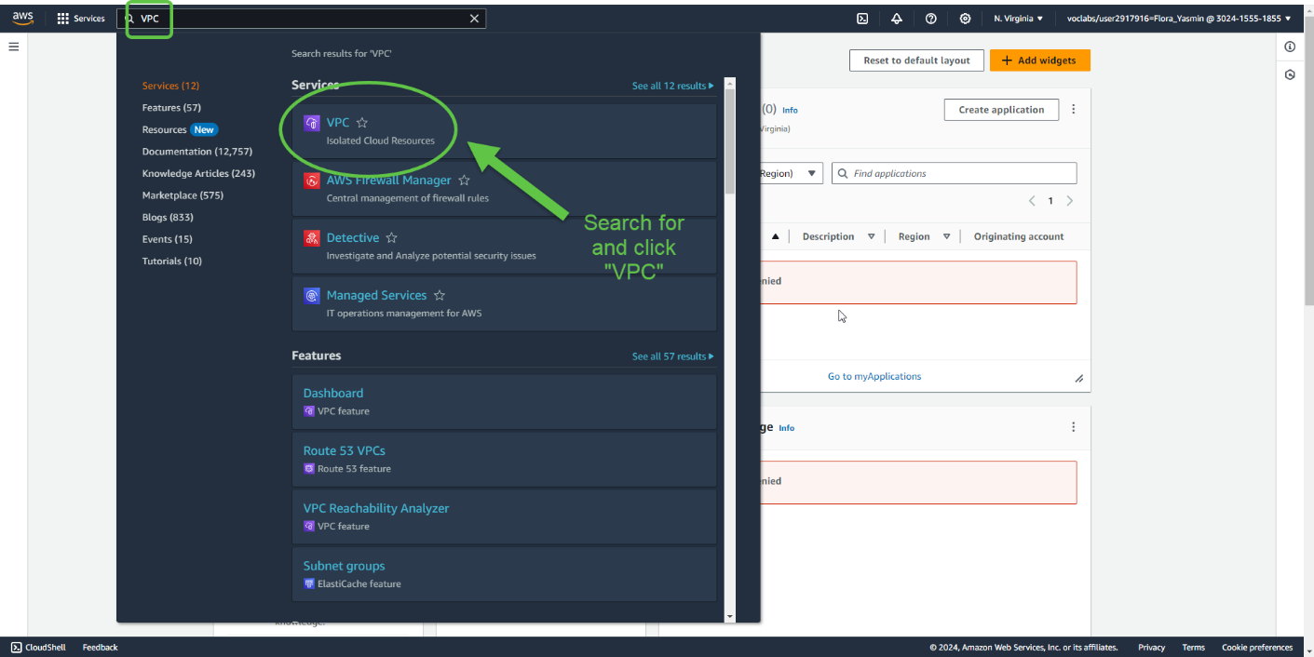

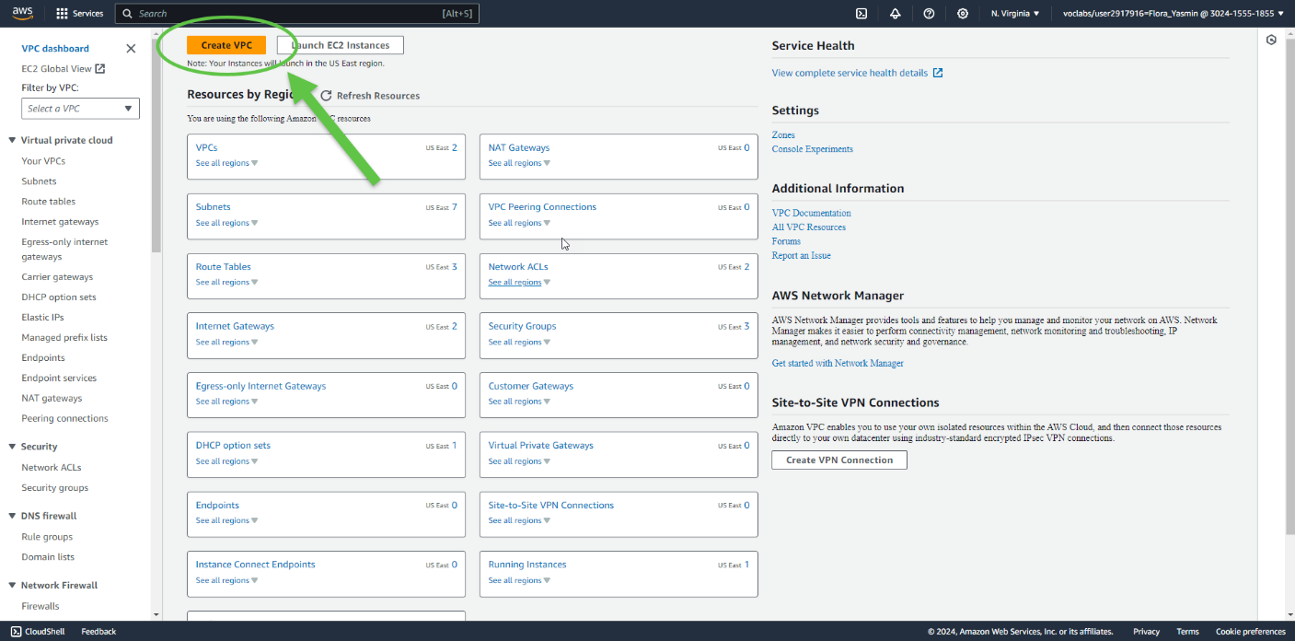

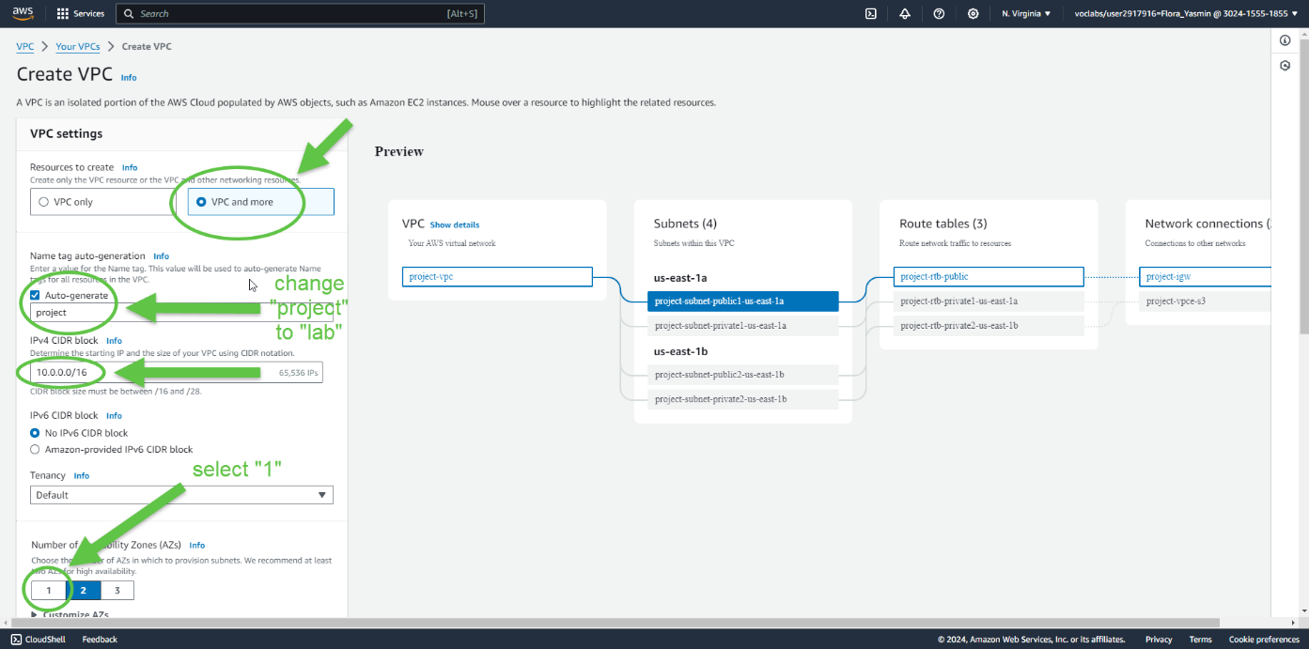

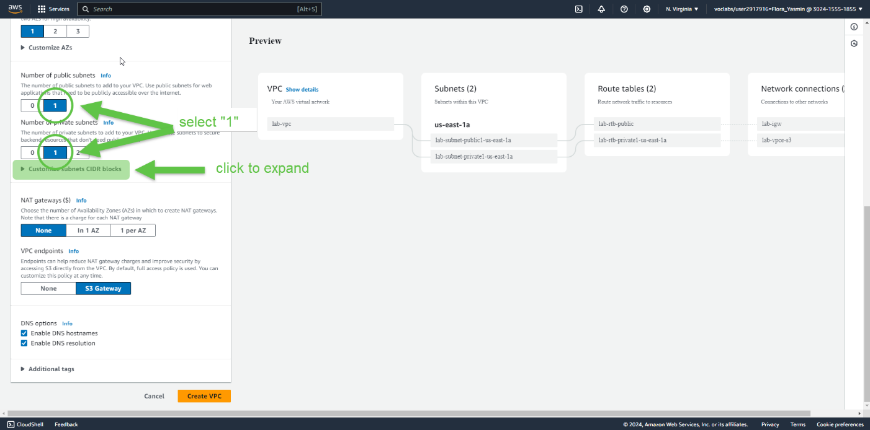

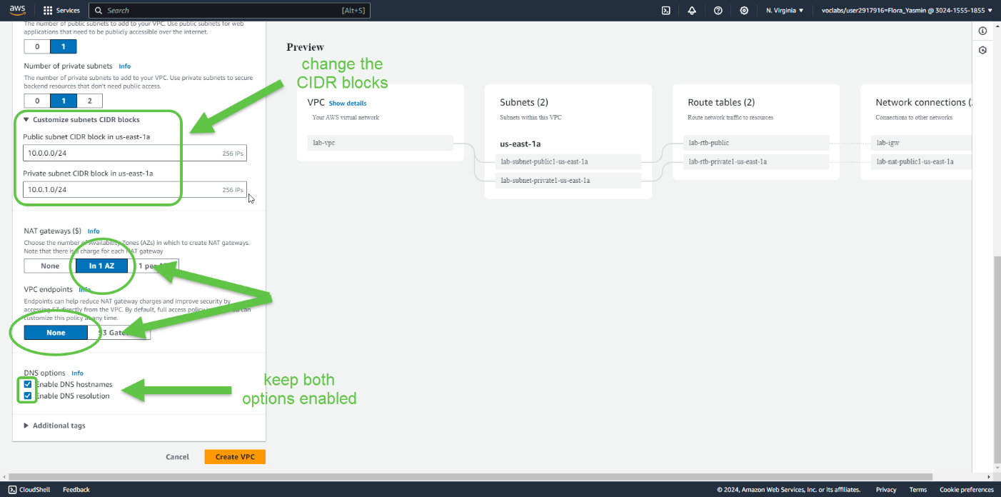

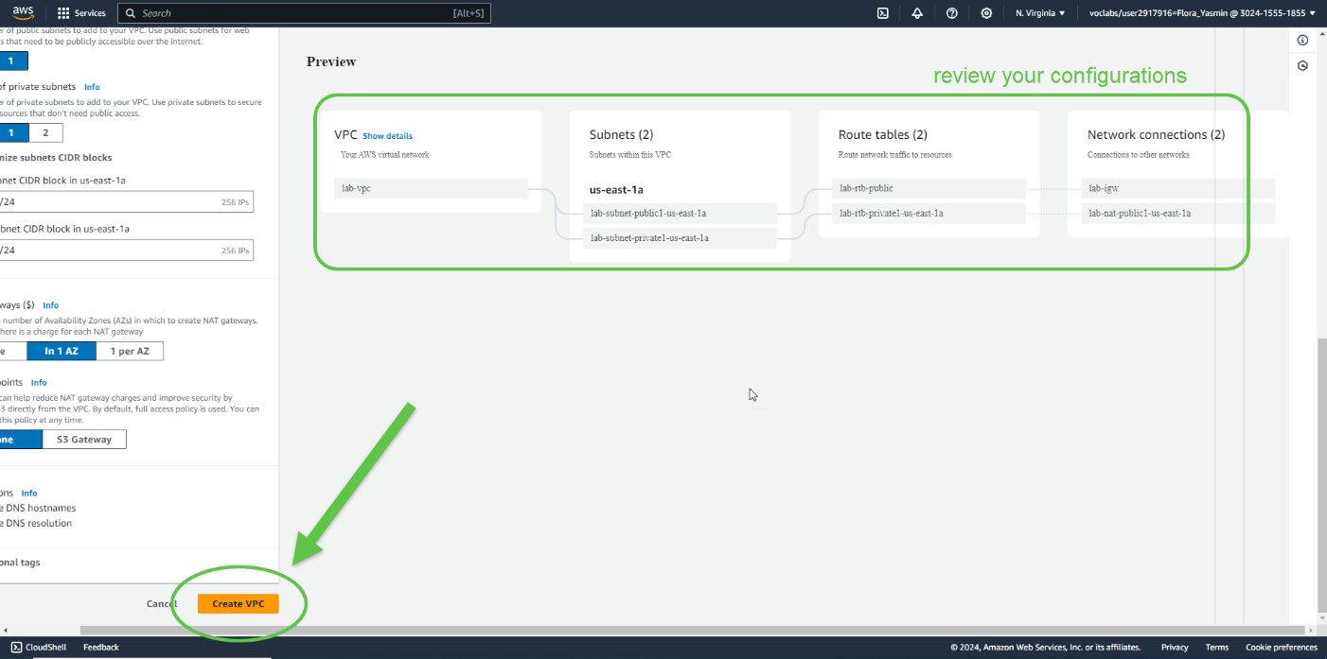

Here we have a VPC with both a public and private subnet assembled in one Availability Zone with route tables created for each subnet, as well as an Internet gateway and a NAT gateway.

To view these settings, users can browse through the VPC console, for example by clicking on “Subnets” or “Route tables” to view details of each section.

Task 2: Create Additional Subnets

Configuring subnets across multiple Availability Zones within a VPC will provide *high availability.*

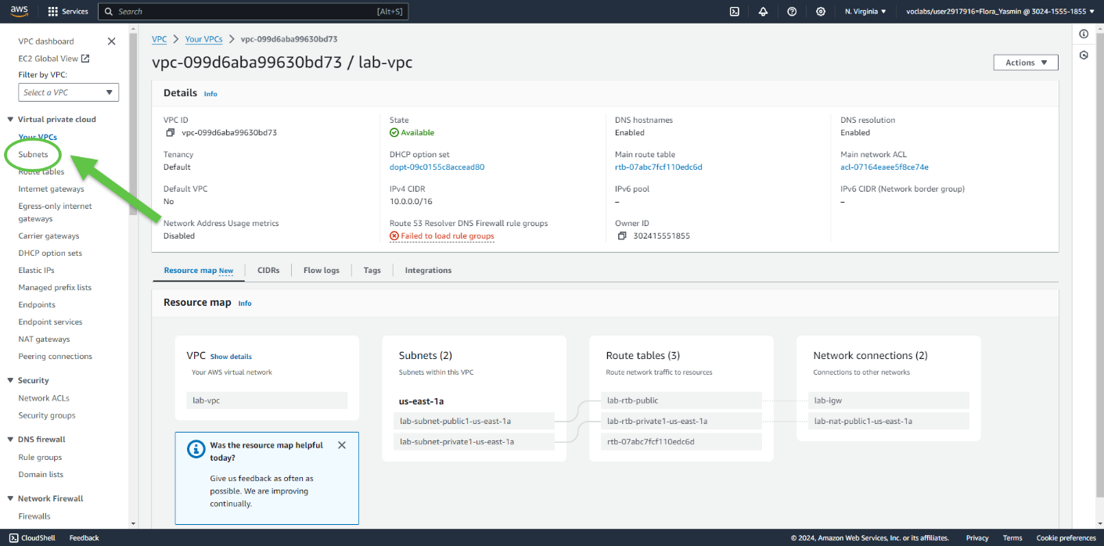

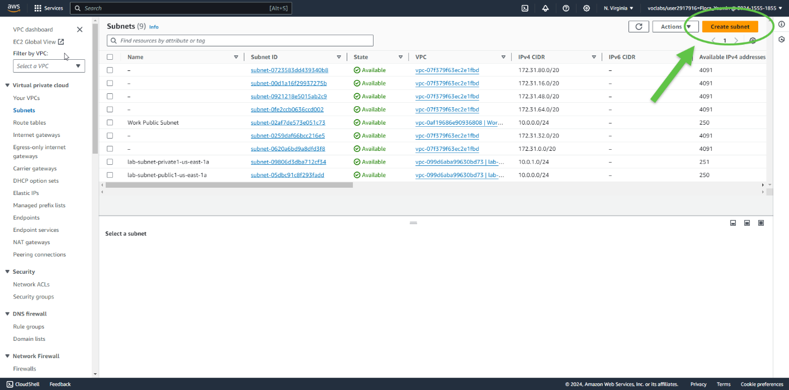

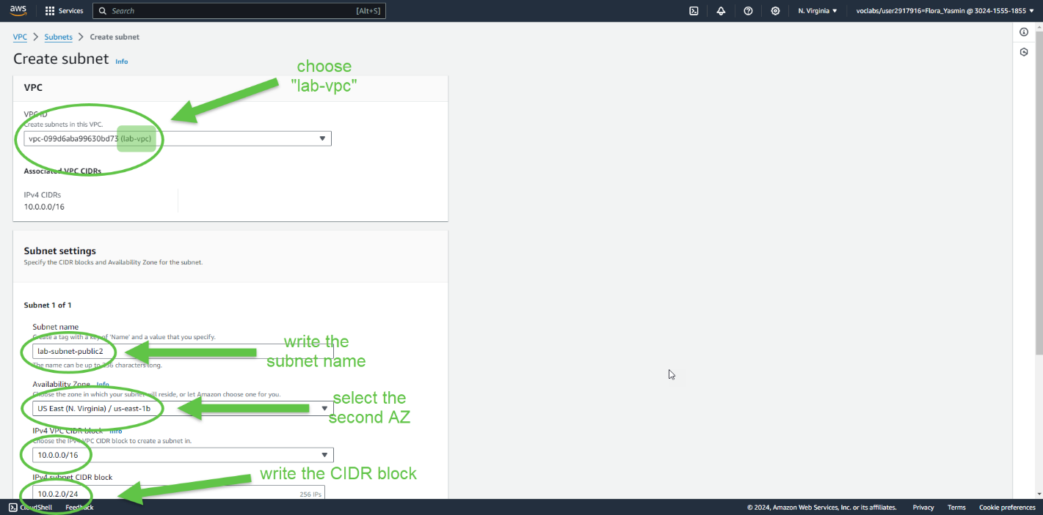

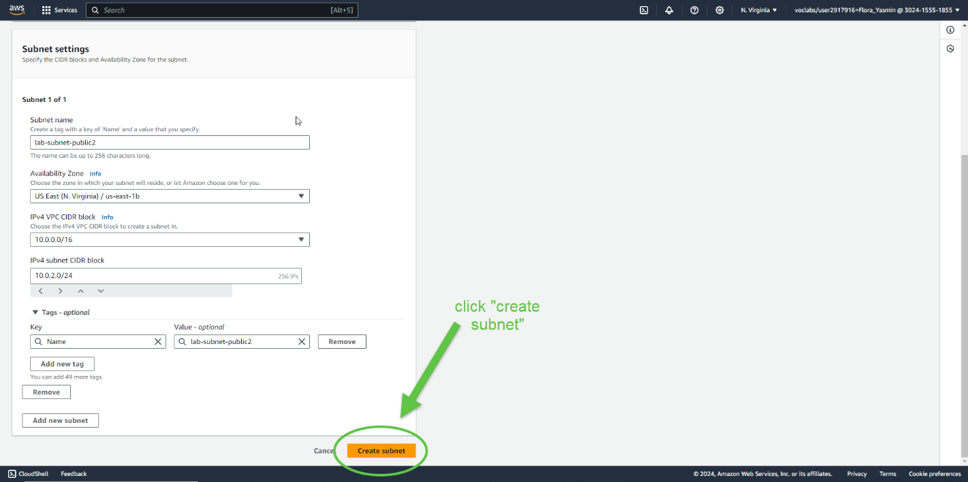

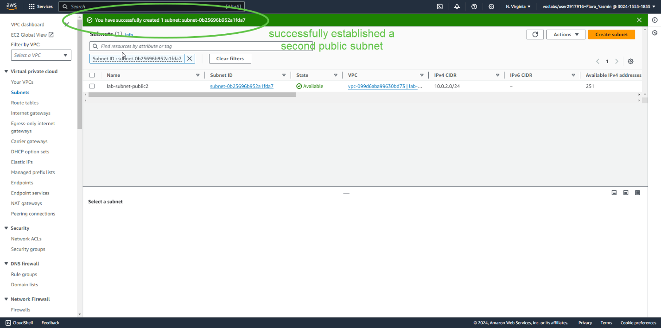

Now you have created a second public subnet.

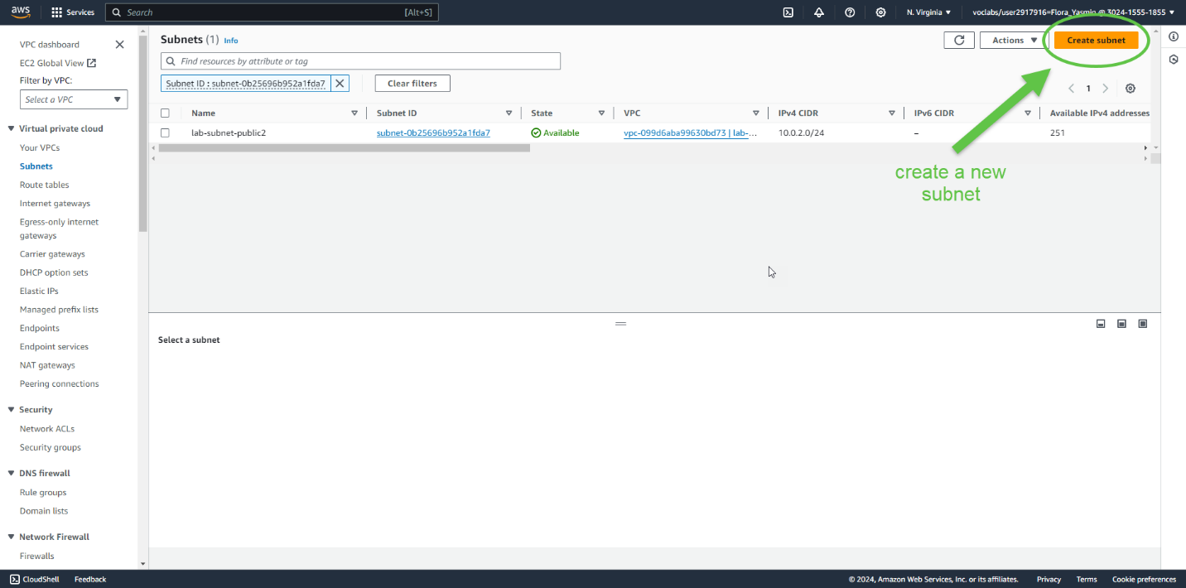

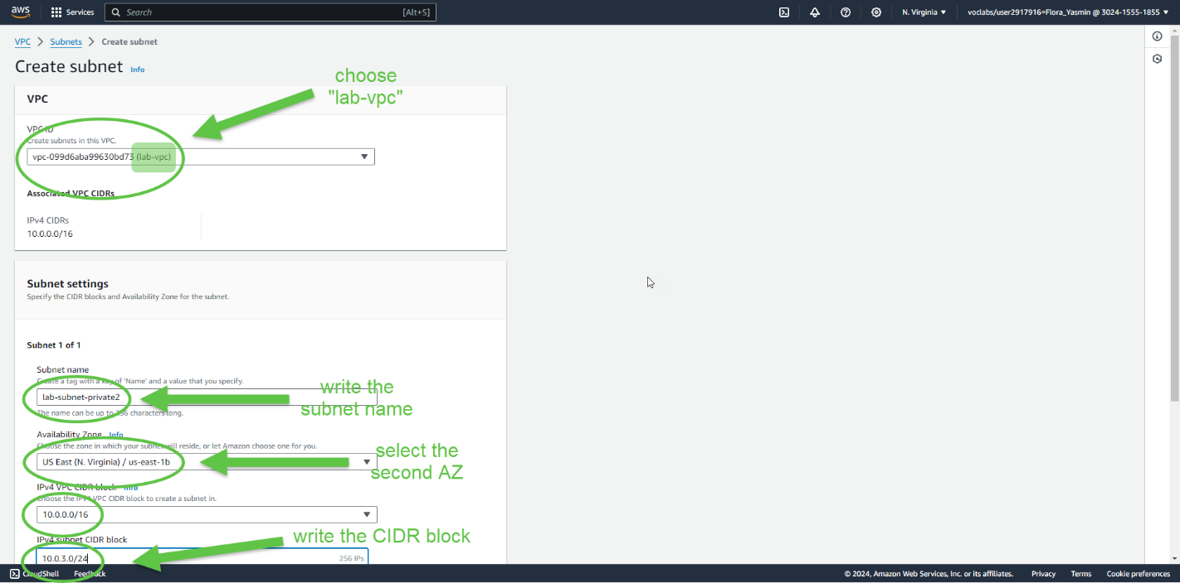

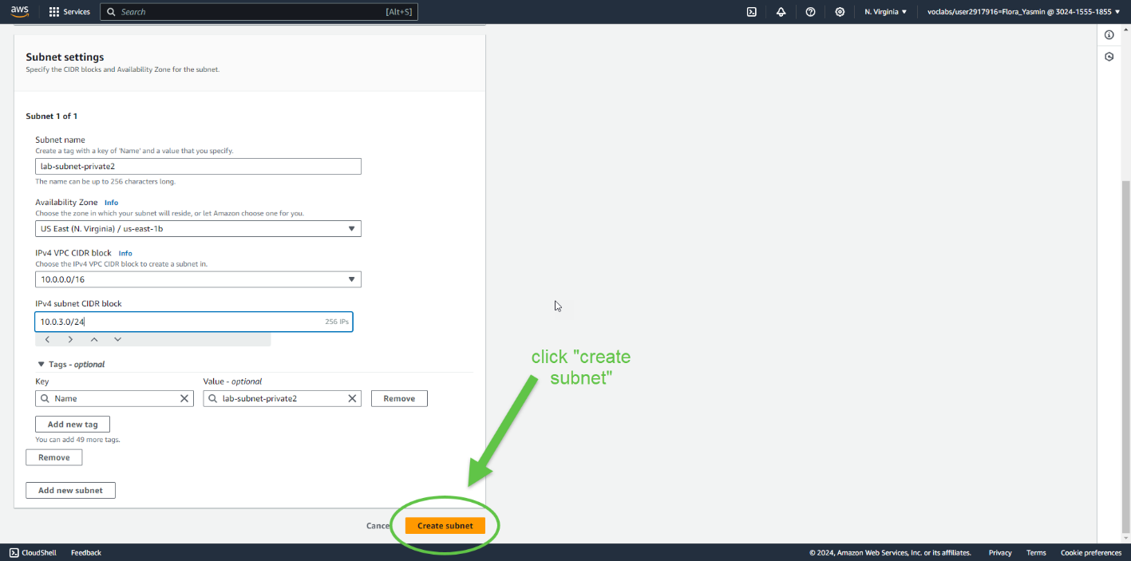

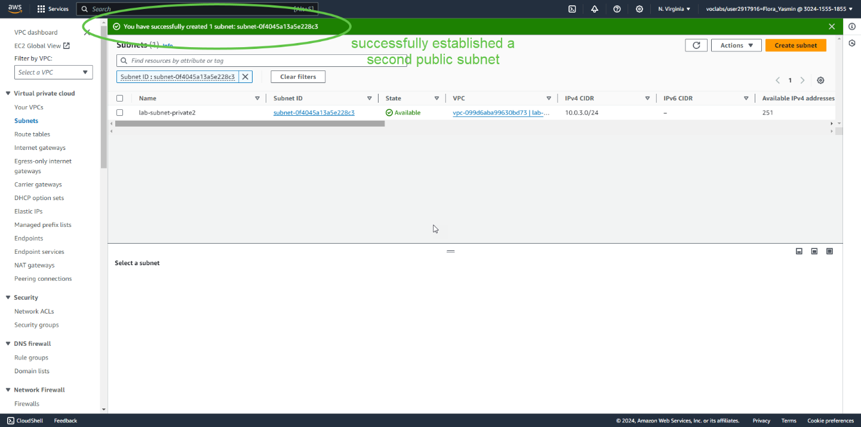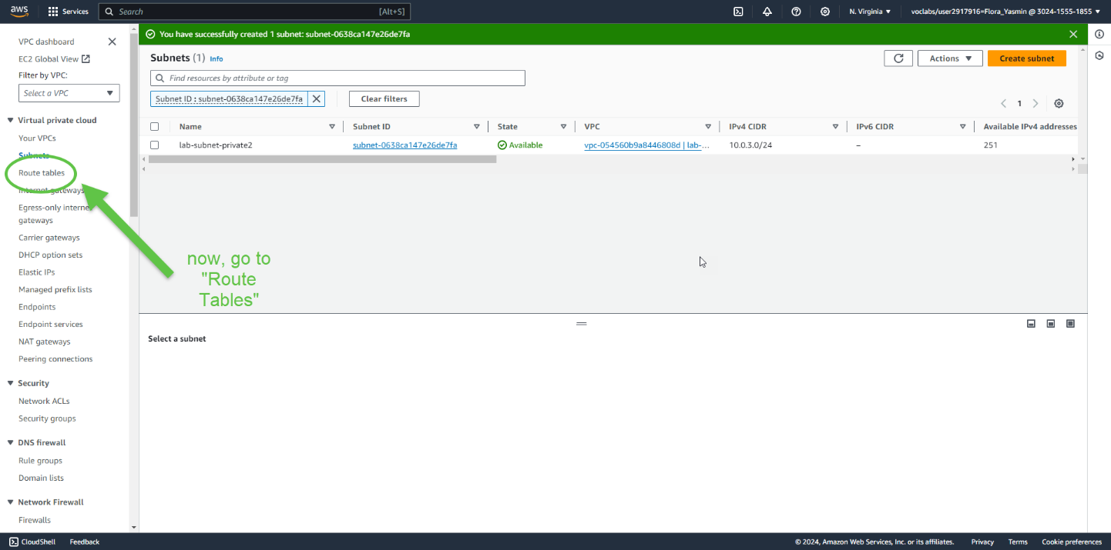

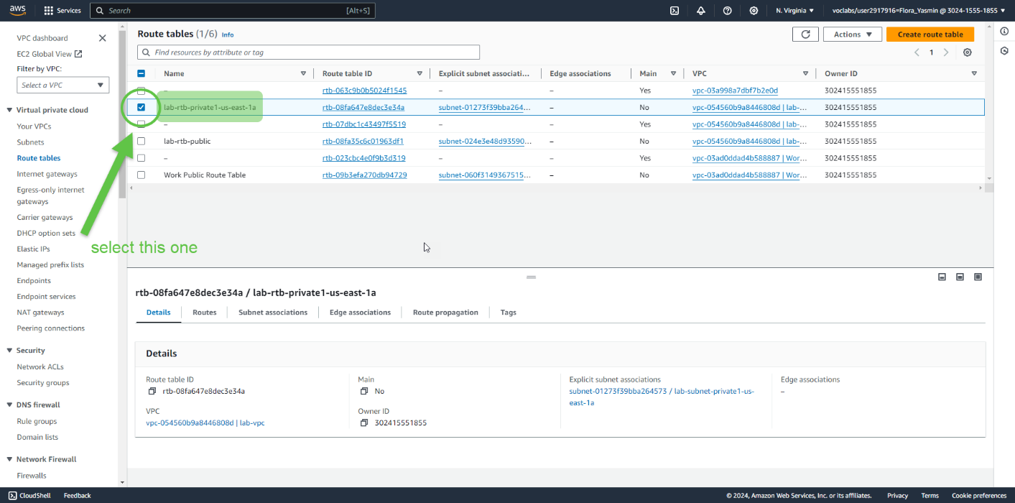

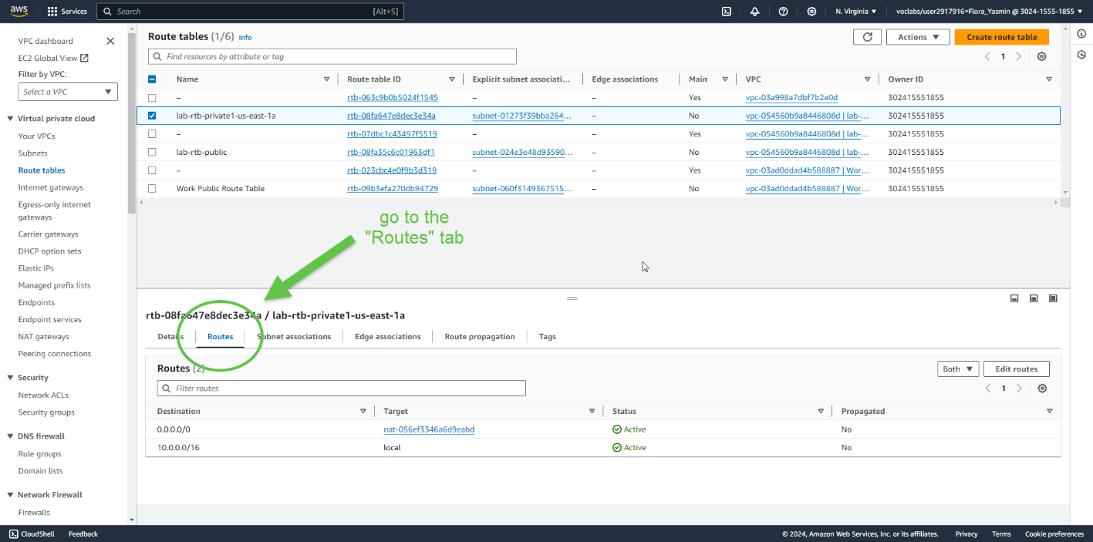

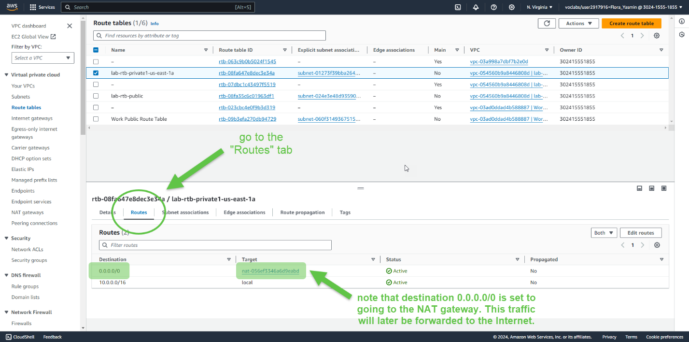

This route table is therefore routing traffic from private subnets, since it is not directly connected to the internet.

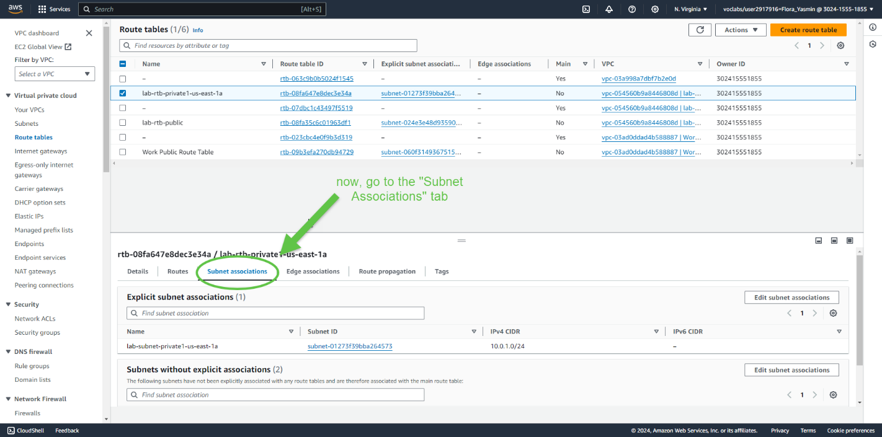

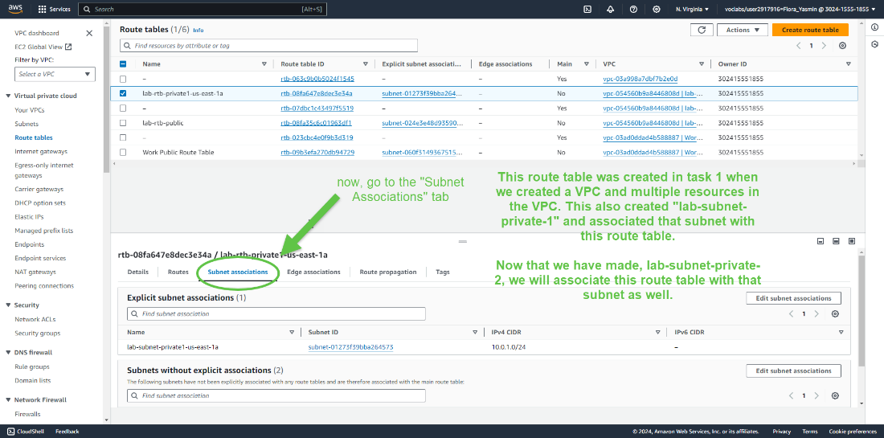

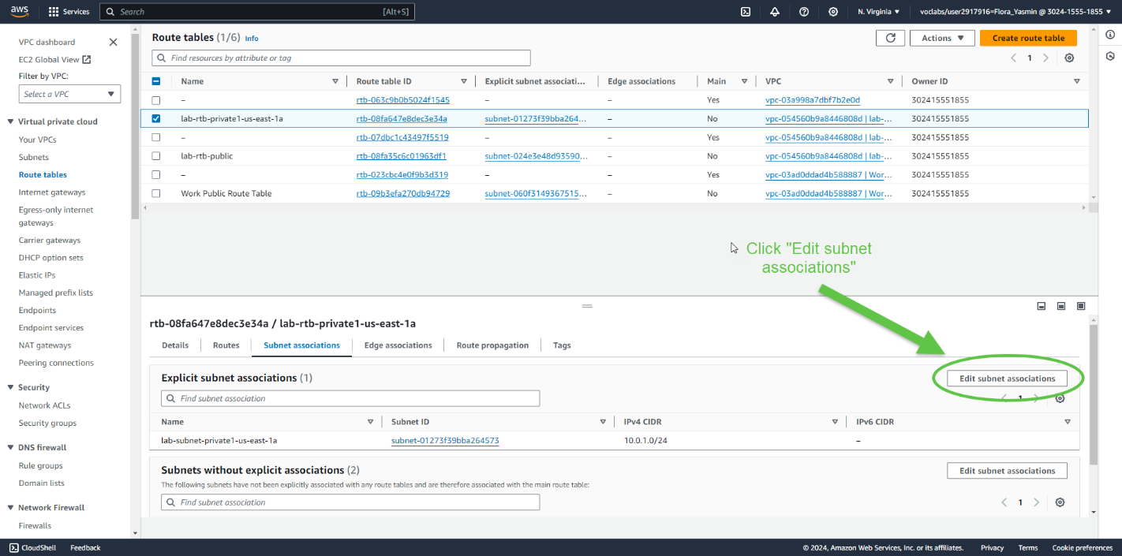

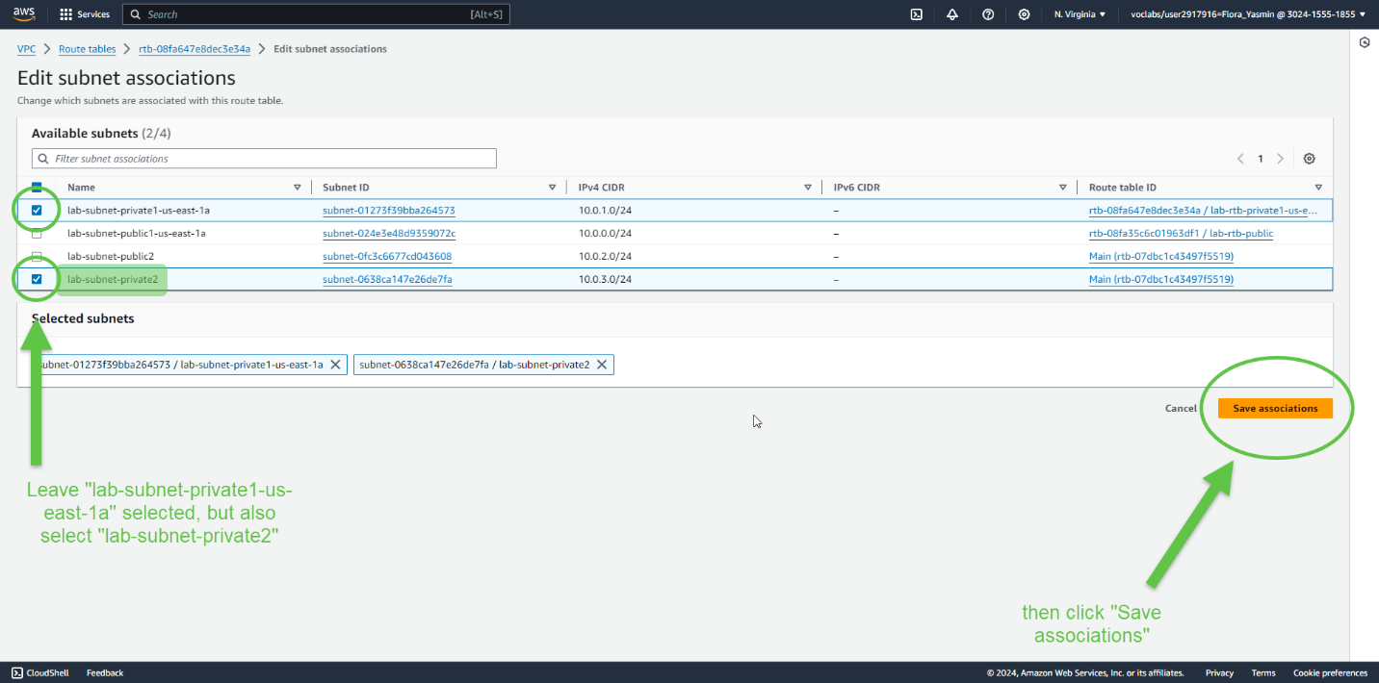  
We just configured the route table used by private subnets. Now, we will configure the route table used by public subnets.

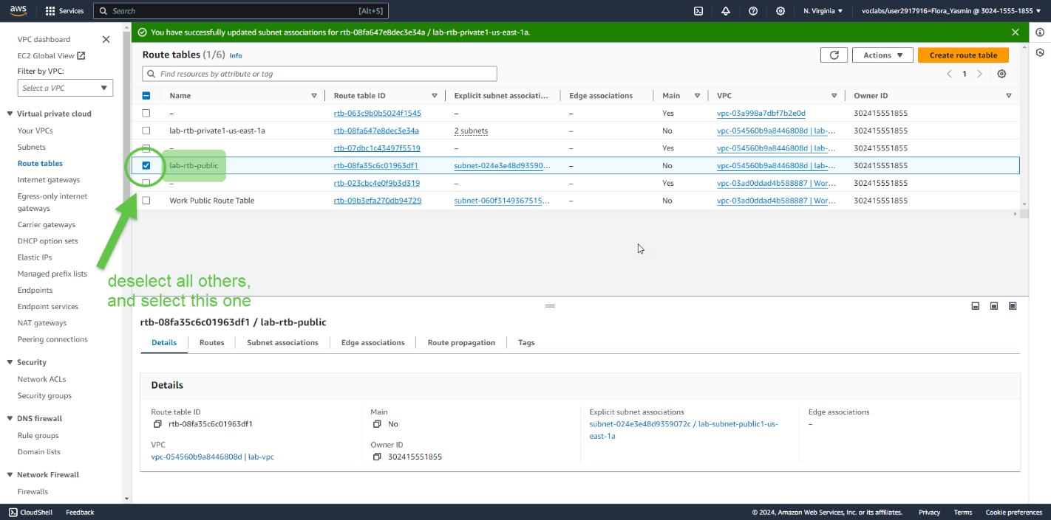

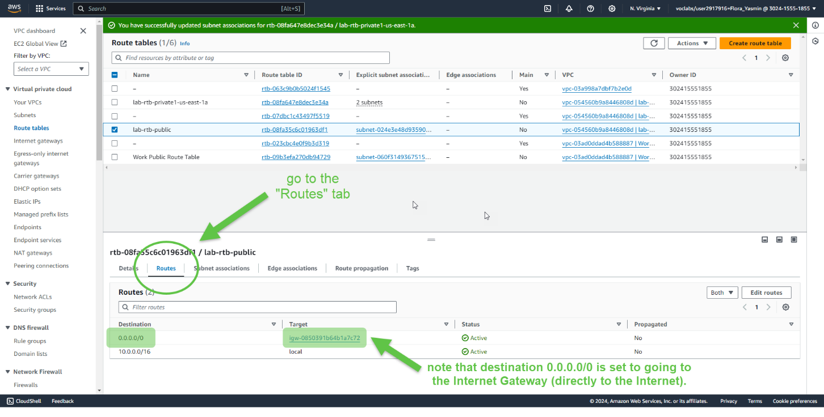

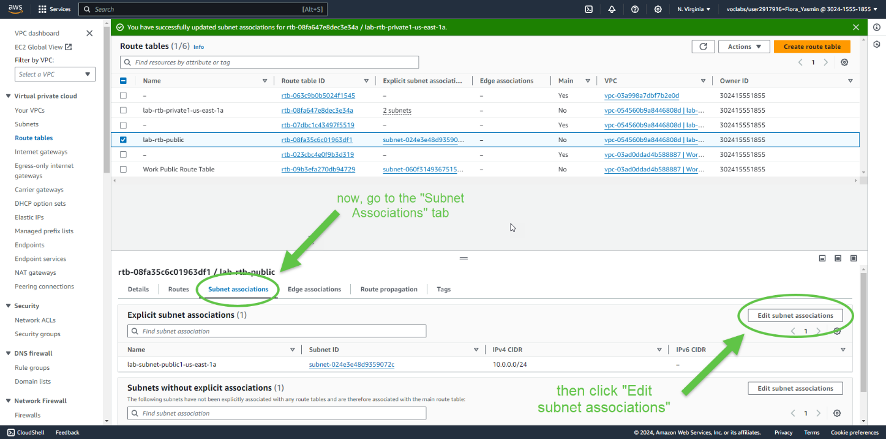

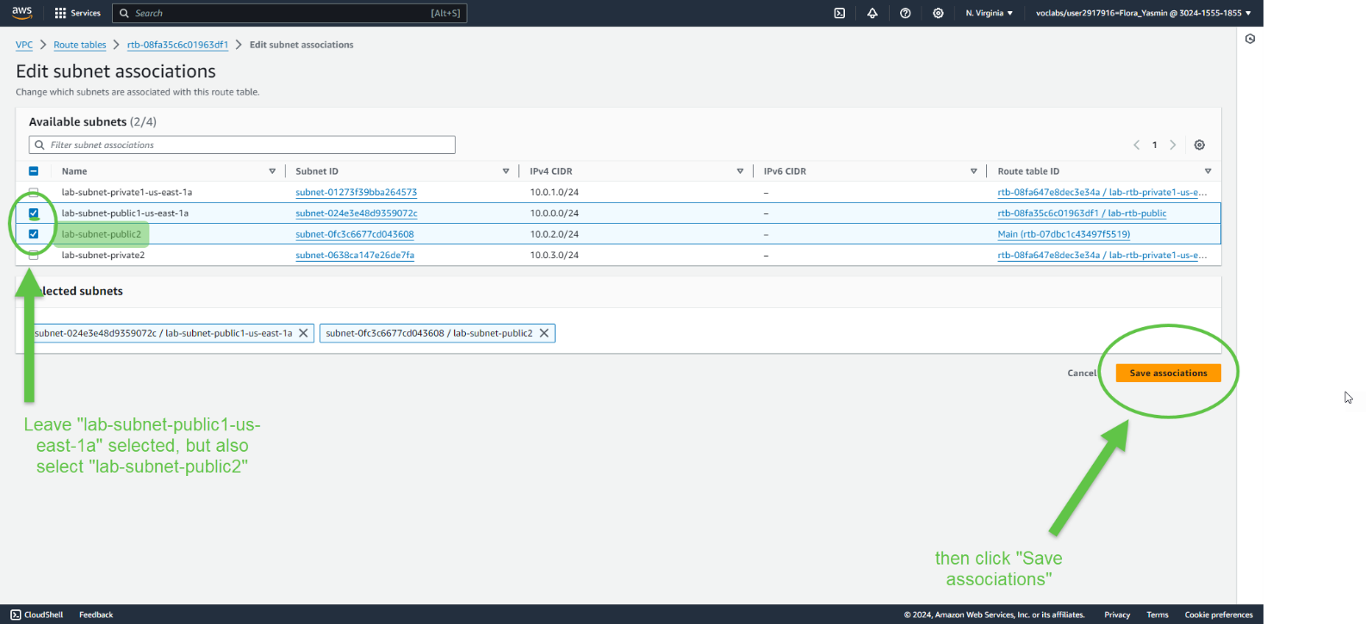  
Now the VPC has public and private subnets configured in two Availability Zones. The route tables from task 1 have also been updated to route traffic from the new subnets.

Task 3: Create a VPC Security Group

This task demonstrates how to create a VPC security group, which is similar to a virtual firewall. When an instance is launched, it is associated with one or more of these security groups. The security groups can be configured with rules that allow or deny traffic traveling from other instances.

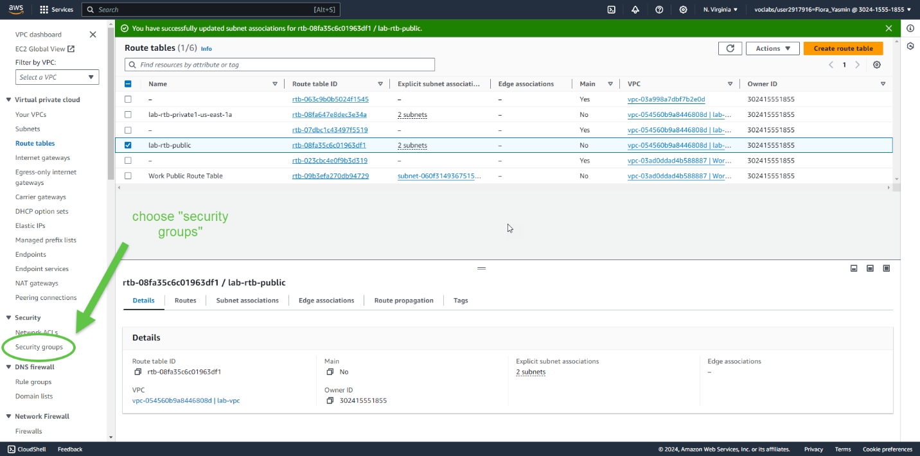

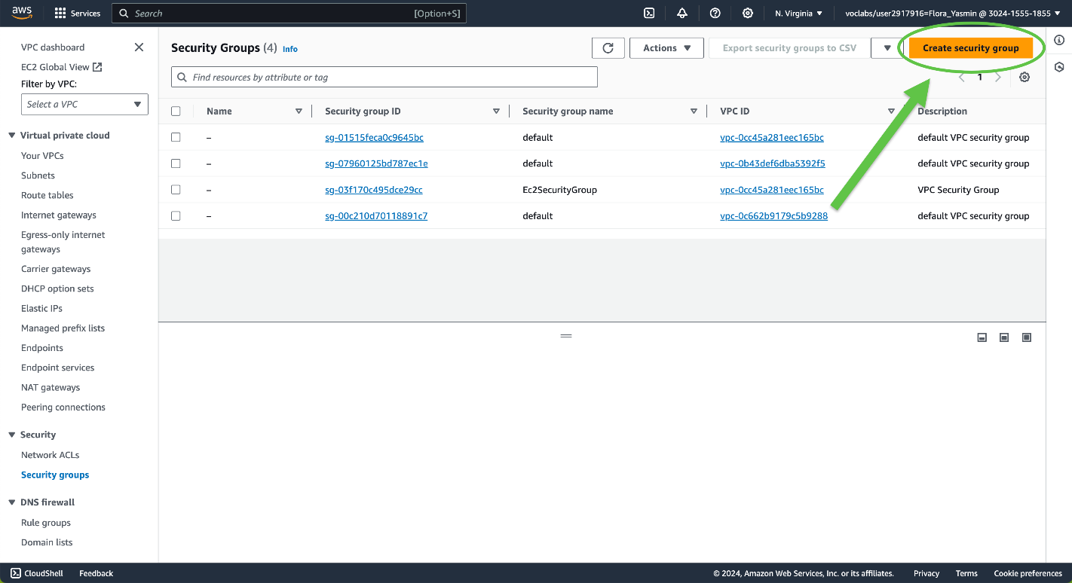

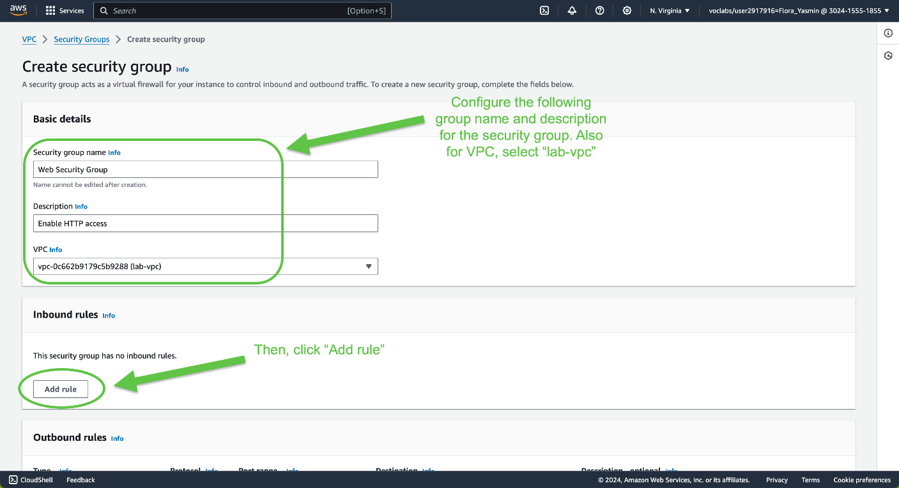

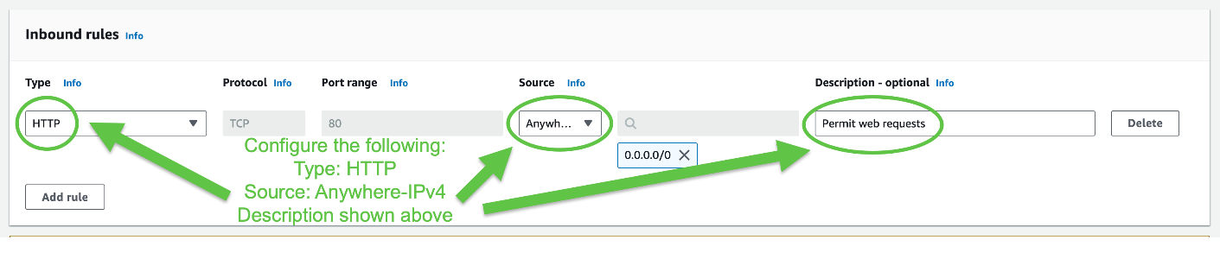

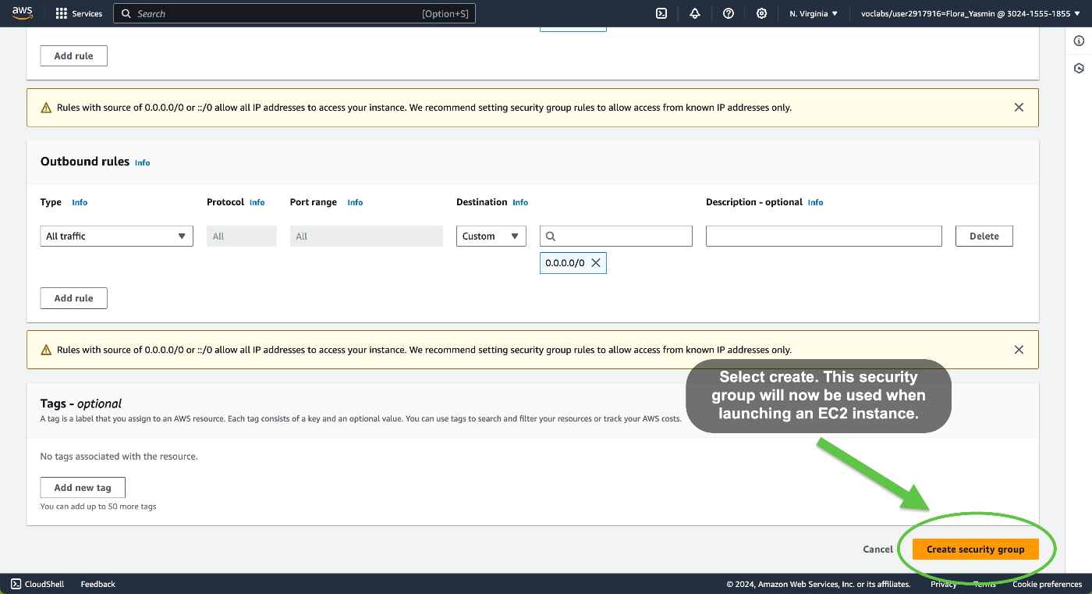

Task 4: Launch a Web Server Instance

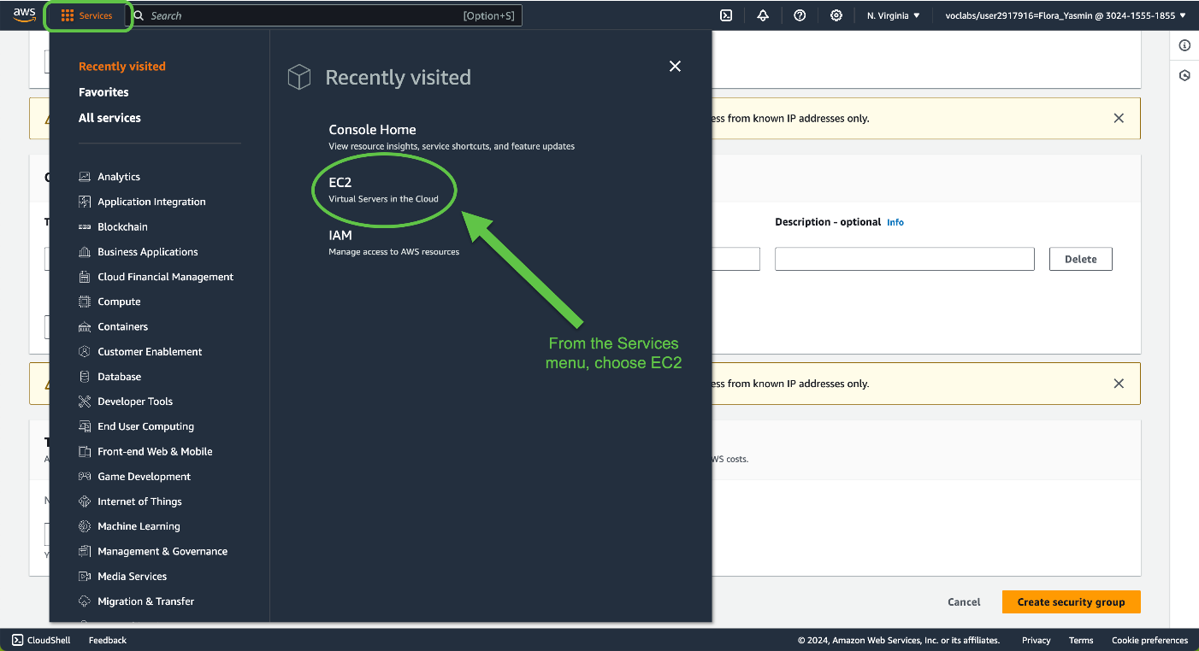

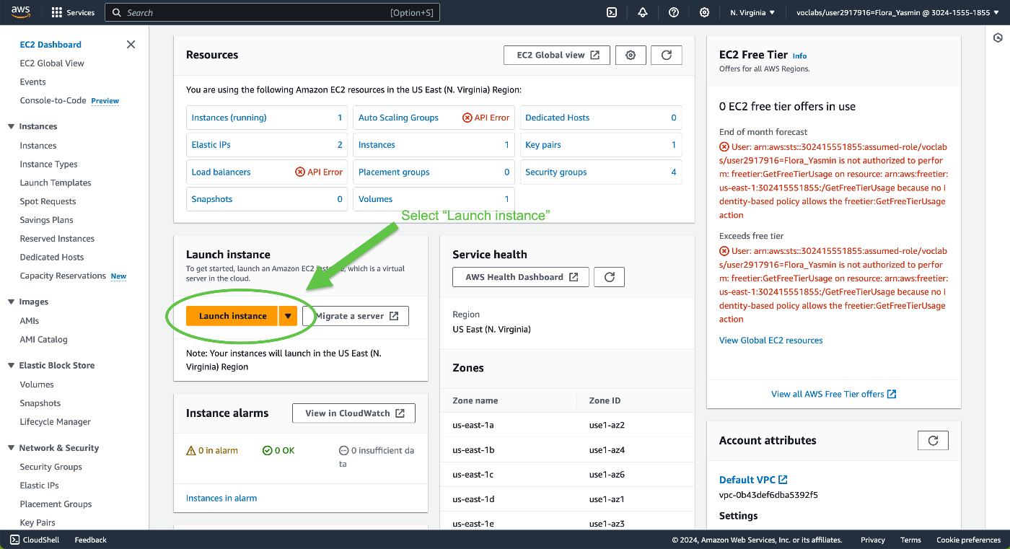

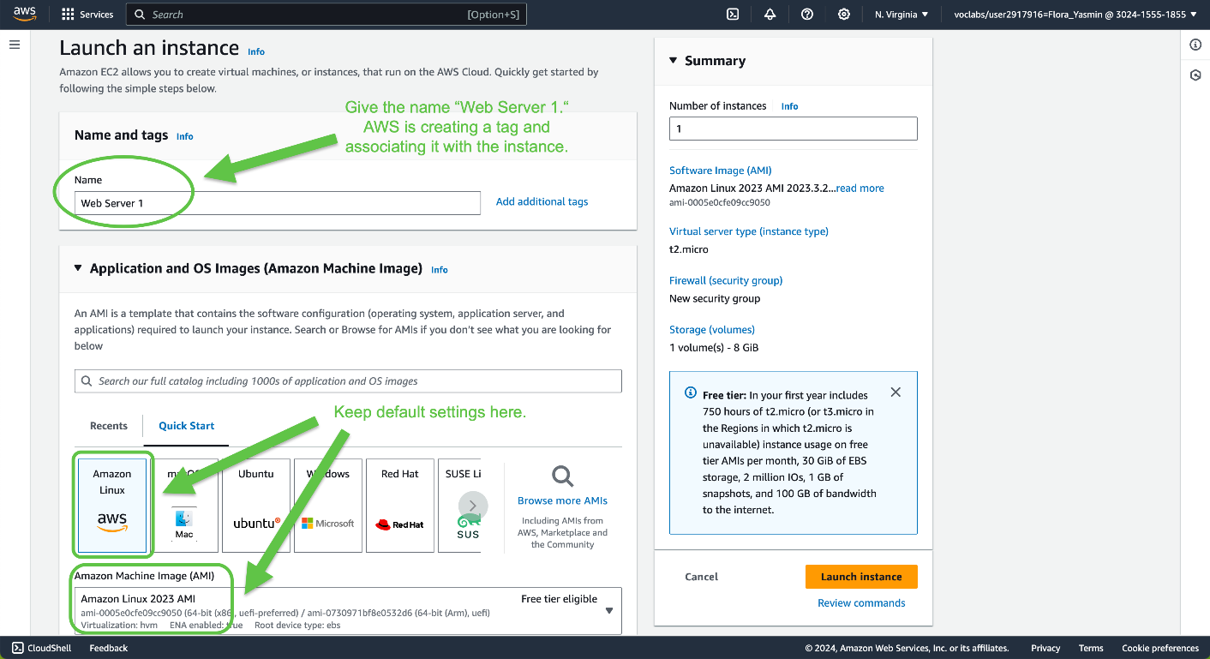

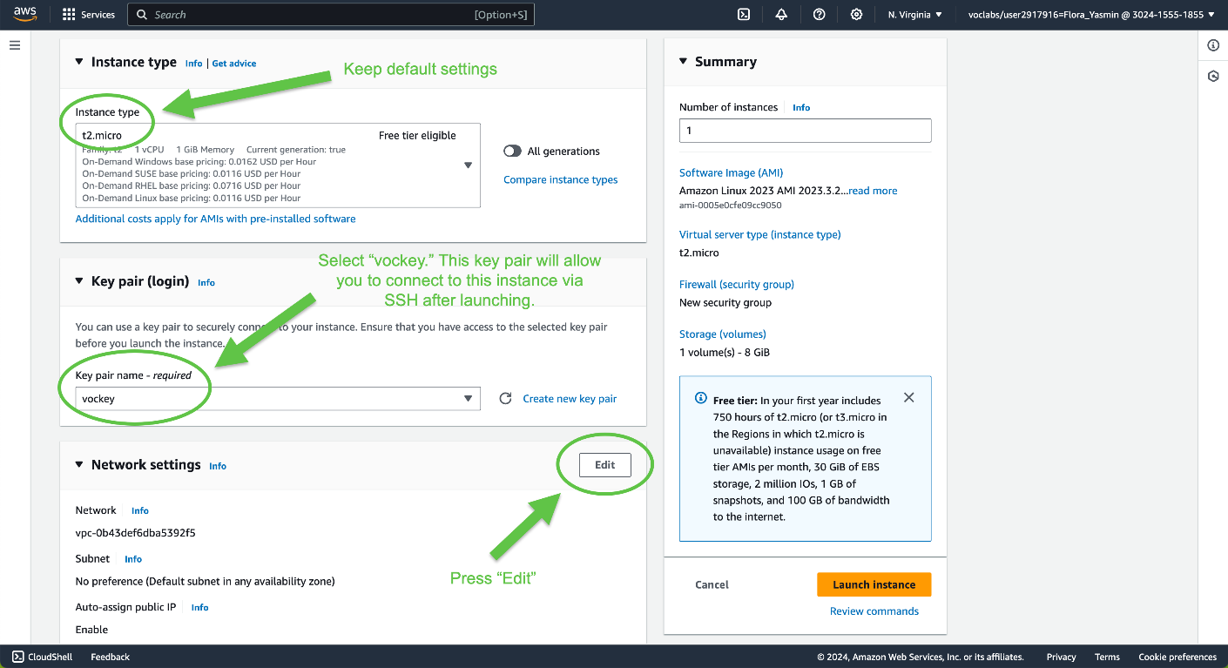

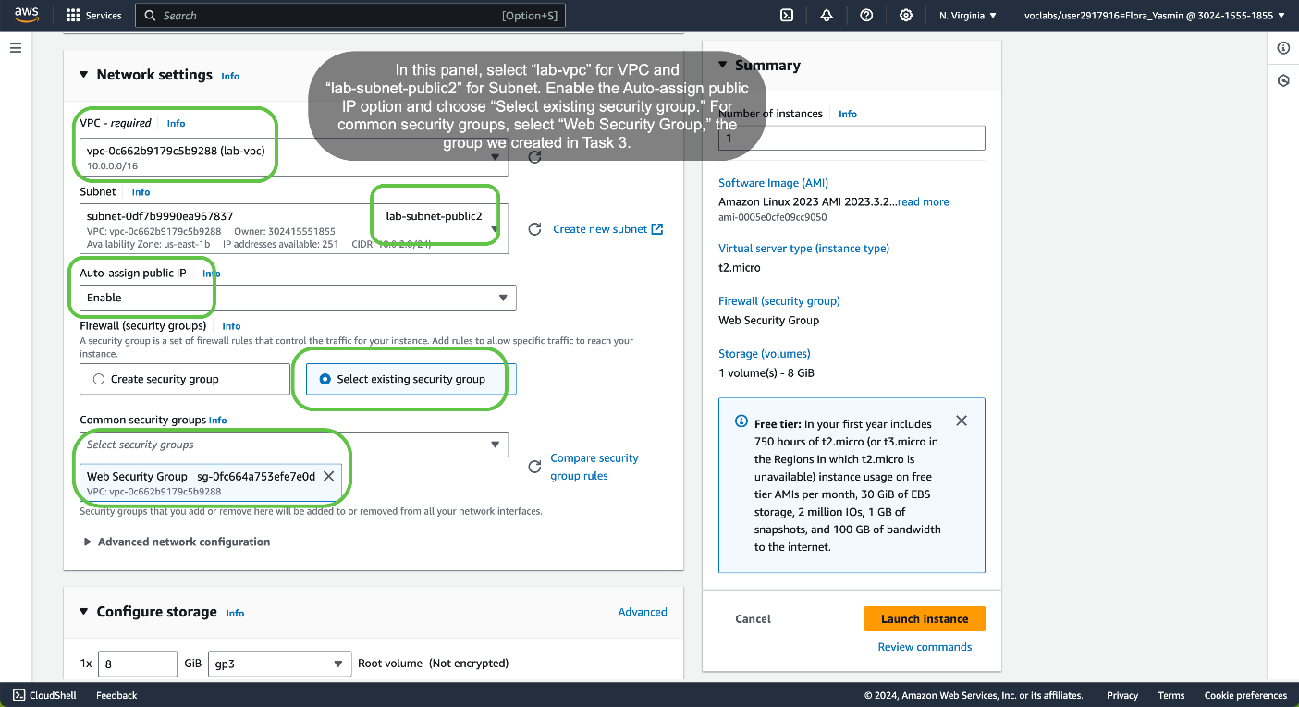

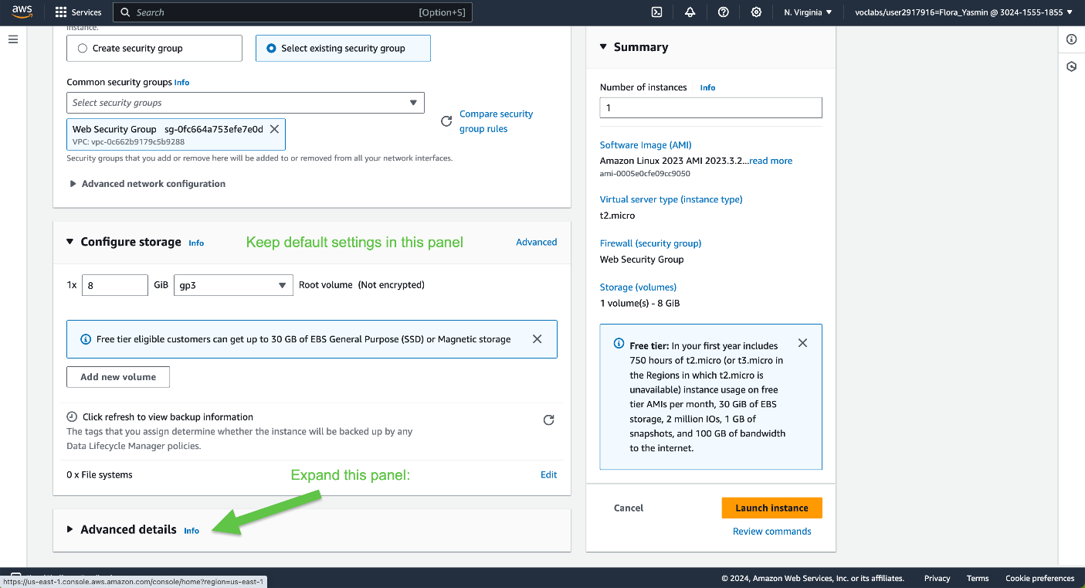

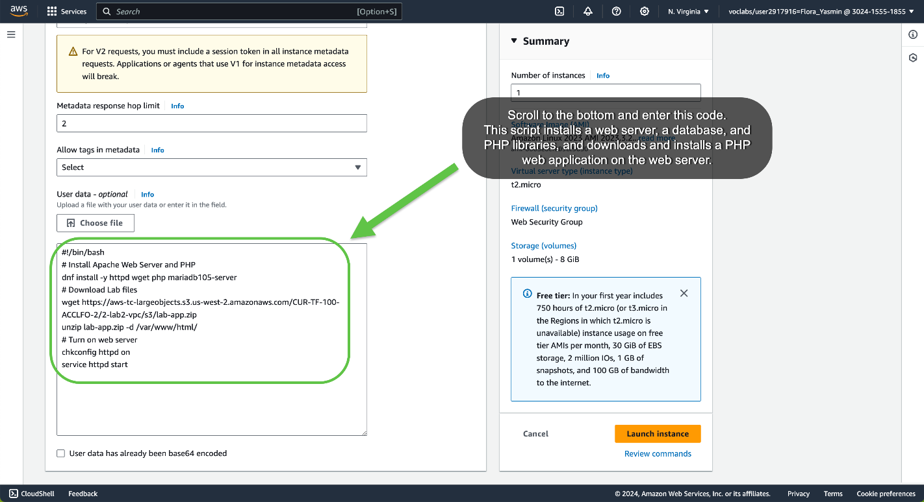

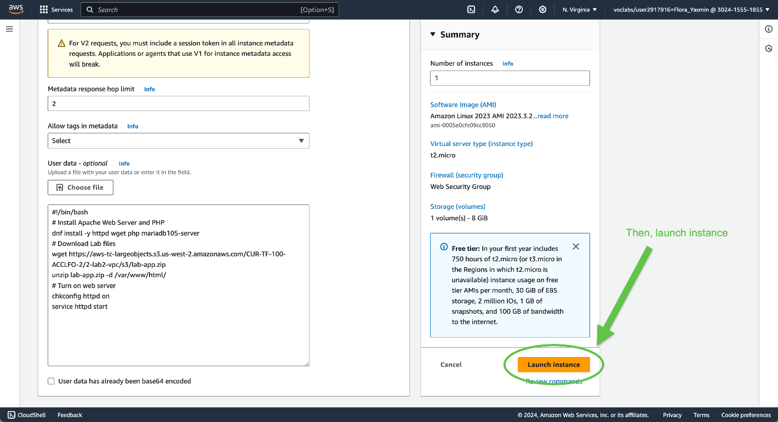

You’ll receive a success message:



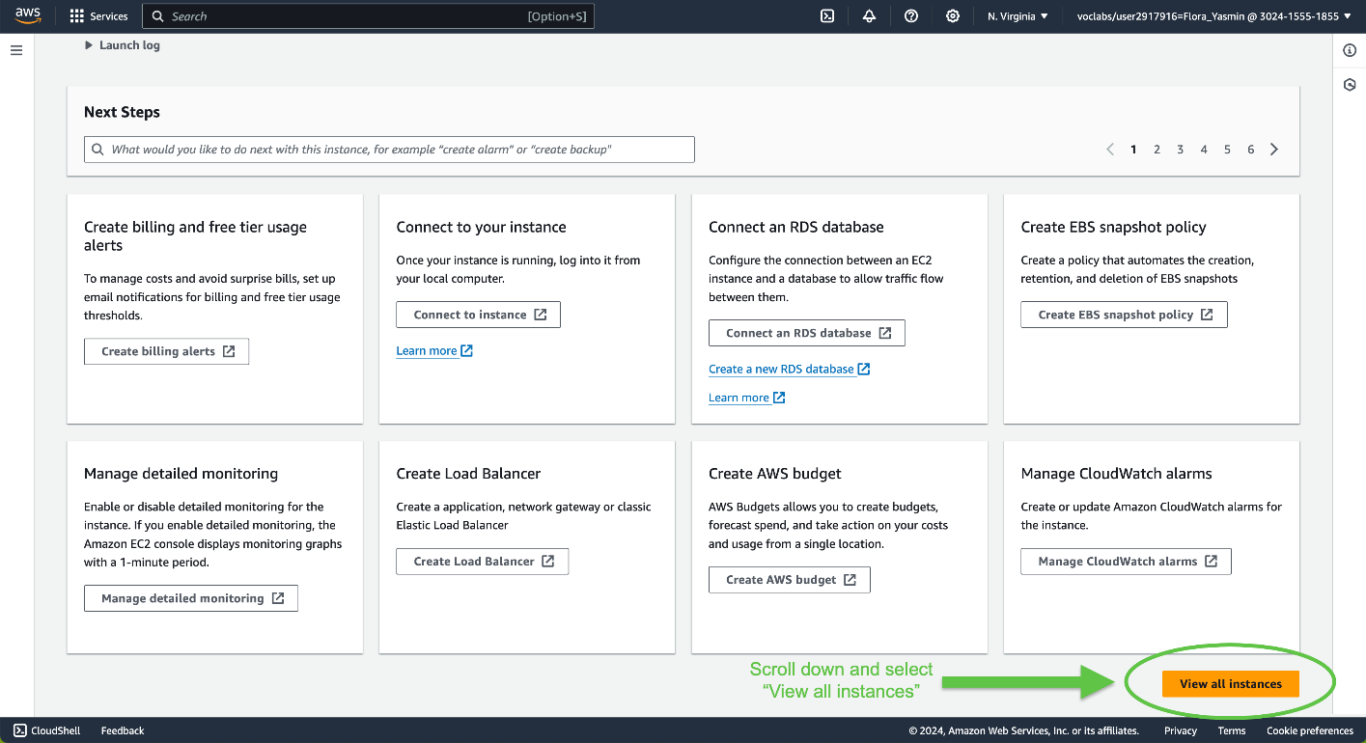

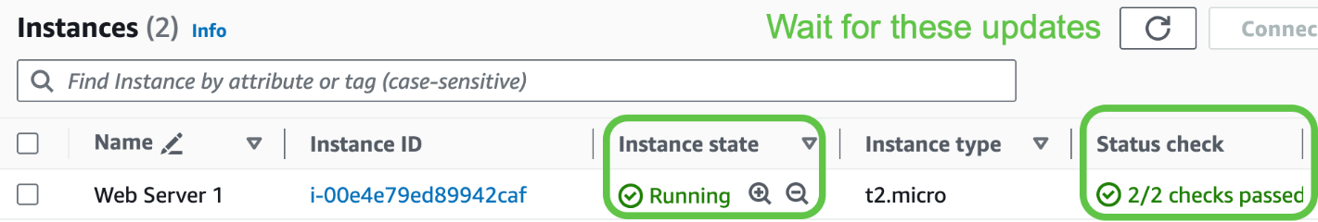

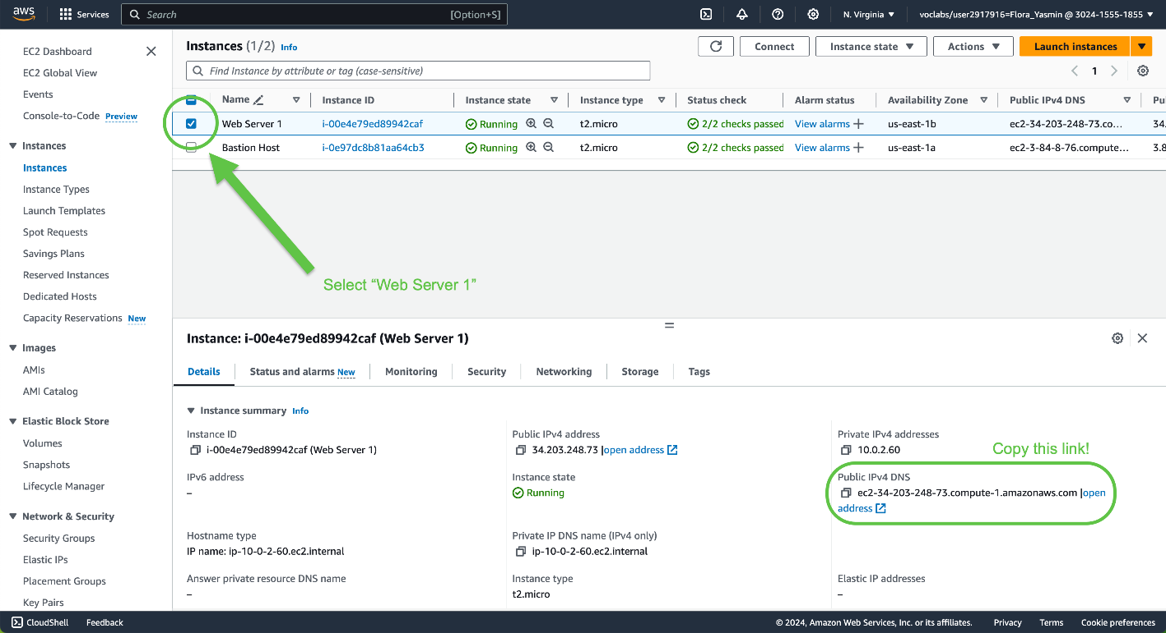

Paste the Public DNS value into a Web Browser:

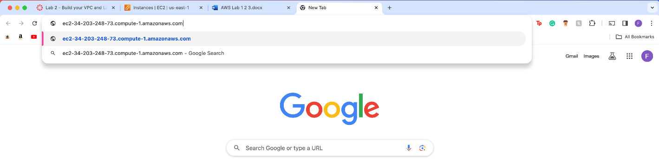

You should be directed to a website looking like this:

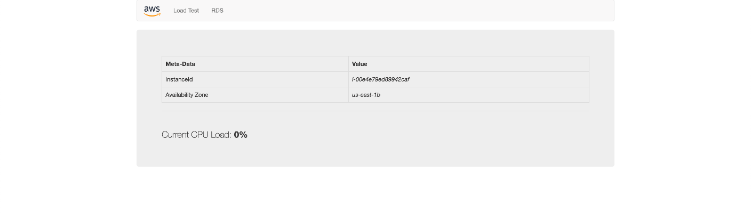

**Problems**

While completing the writeup corresponding to this lab, it took more than the allotted time to do the lab, so I was signed out numerous times and prompted to redo the lab steps.

The Security Group in Task 3 did not fully upload, causing problems in Task 4. To resolve the issue of the Web Security Group not appearing in the menu, I went back and followed the steps from Task 3 to re-create the security group correctly.

**Conclusion**

This lab showed how to create a VPC using AWS and configure subnets and security groups within. It also demonstrated how to launch an EC2 instance into a VPC.

**Lab 3: Introduction to Amazon EC2**

**Purpose**

This lab gives an overview of the basic actions associated with an Amazon EC2 instance—including launching, resizing, managing, and monitoring the instance.

**Background Information**

Amazon Elastic Compute Cloud (EC2) is an Amazon web service that allows users to rent virtual servers, also known as instances. An Amazon EC2 instance can be supported with many operating systems, including Linux, Microsoft Windows, Ubuntu, Amazon Linux, and more.

EC2 provides AWS users with scalability, giving them the option to scale up or down based on workloads and requirements. Amazon EC2 also offers great security to securely compute applications. Security is built into the foundation of EC2.

Amazon’s EC2 service offers the broadest compute platform with over 750 instances and choices of processor, storage, networking, and operating system, to help best match users’ needs and workload.

Some of EC2’s use cases involve, running cloud-native and enterprise applications, scalability for high performance applications, developing for Apple macOS platforms, and training and deploying machine learning applications.

Amazon EC2 also uses a payment method that allows users to pay only for the capacity they only use. Amazon EC2 overall provides developers with tools to build fail-safe applications and prevent numerous possible failure scenarios. This helps optimize cost, along with performance.

**Lab Procedures**

Task 1: Launch Your Amazon EC2 Instance

This task involves launching an EC2 instance with termination protection, which prevents users from accidentally terminating an EC2 instance.

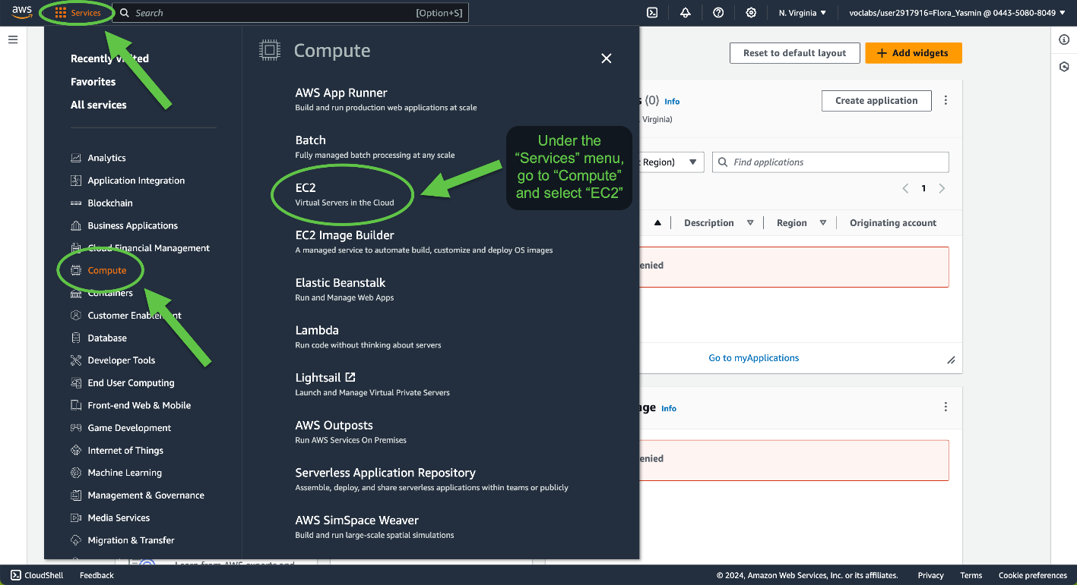

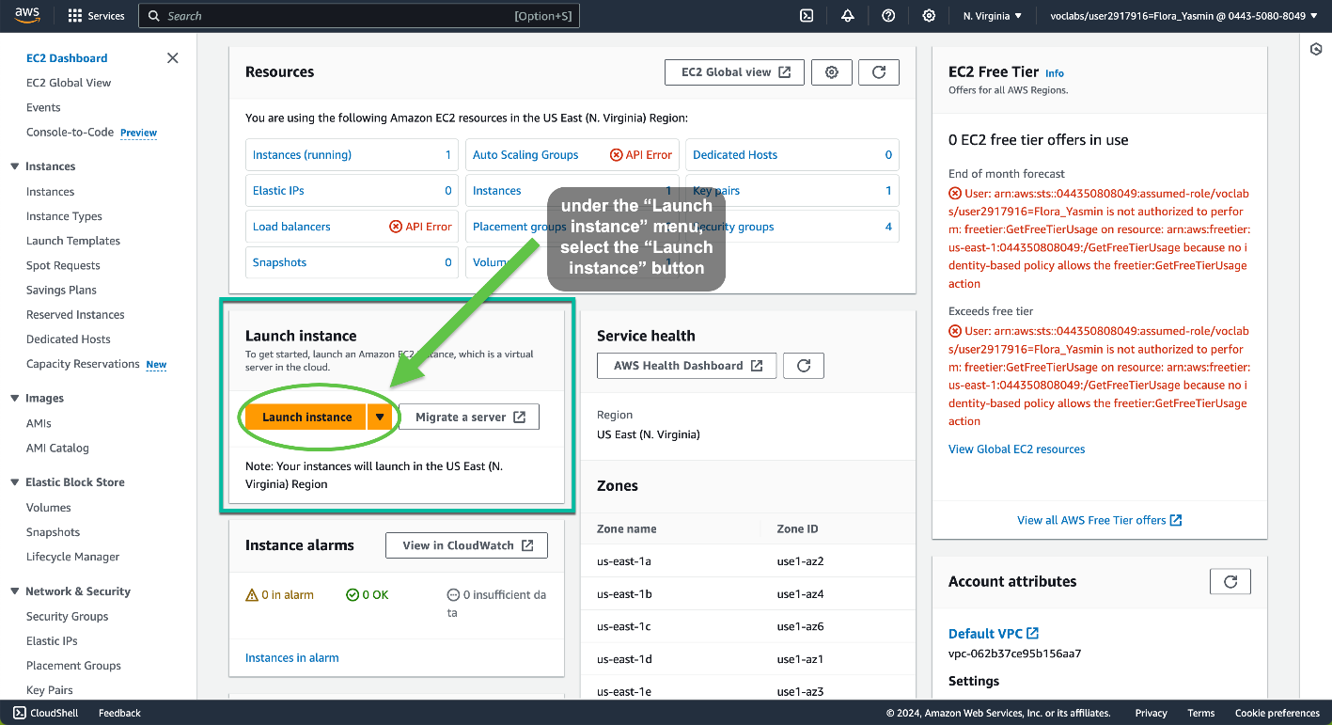

Step 1: Name and Tags

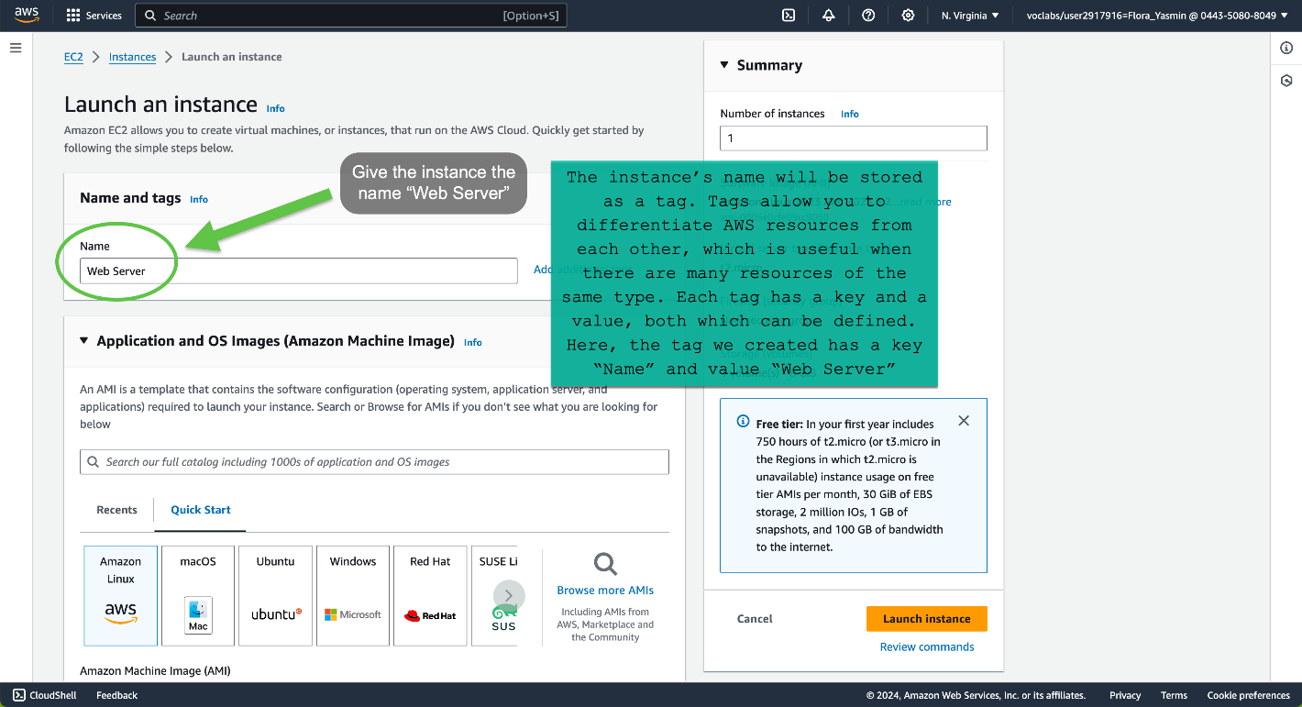

Step 2: Application and OS Images (Amazon Machine Image)

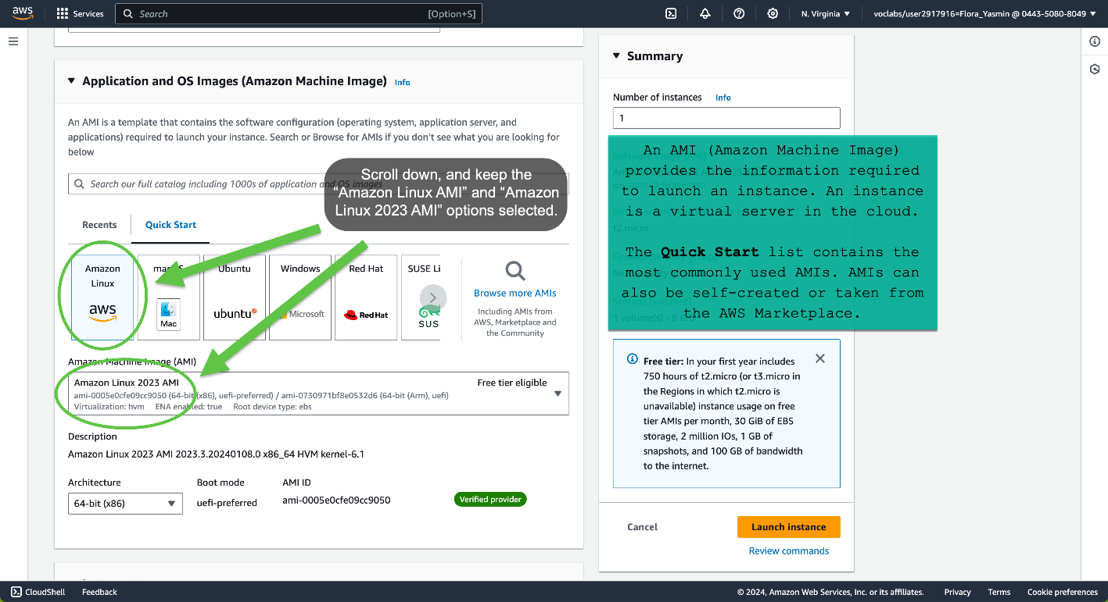

Step 3: Instance Type

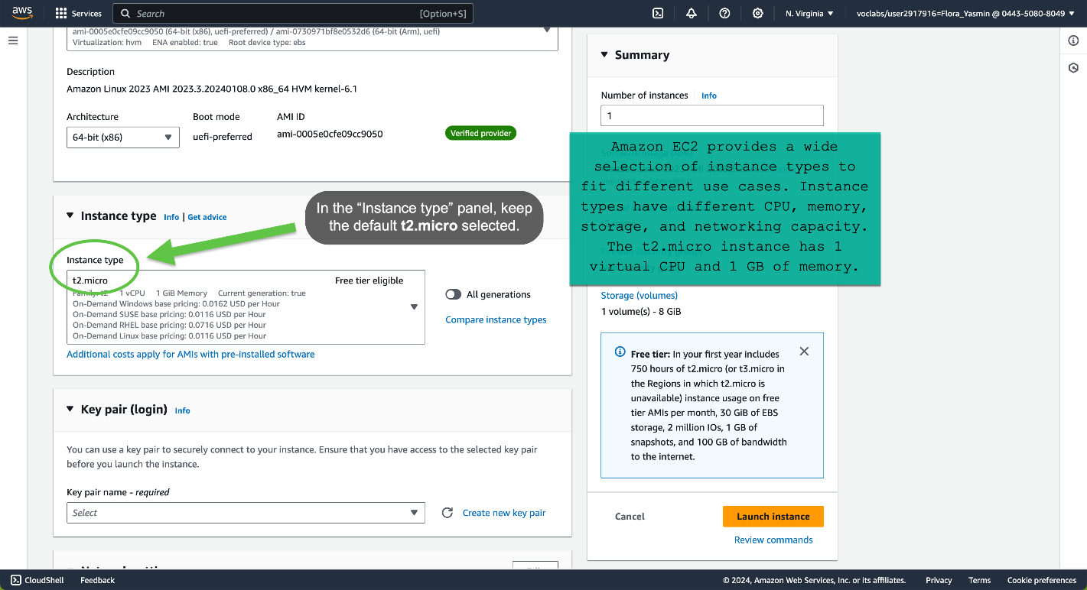

Step 4: Key Pair (Login)

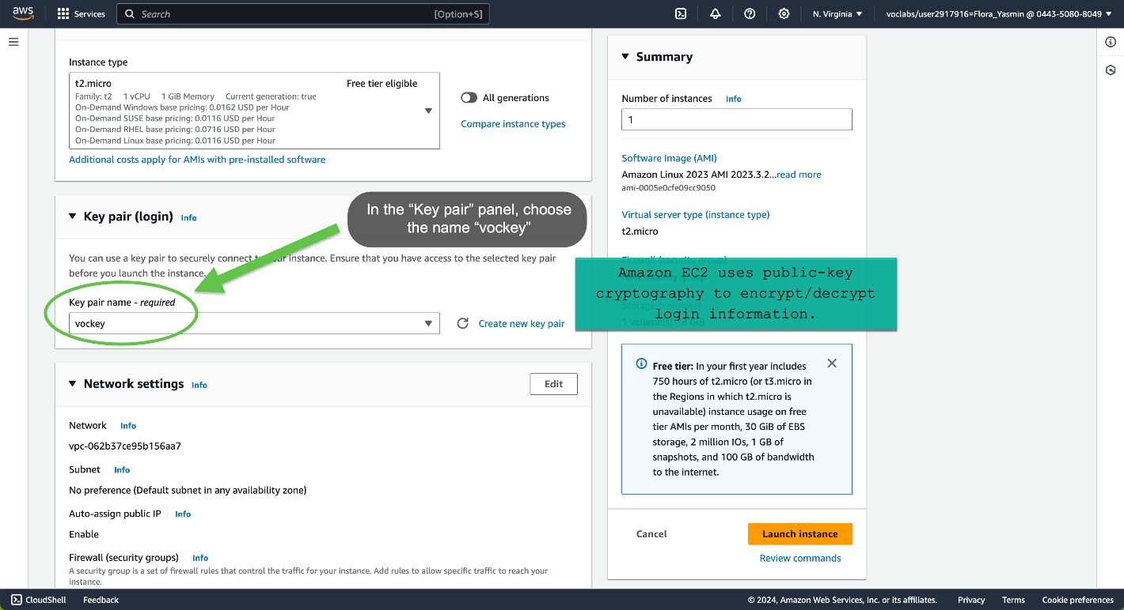

Step 5: Network Settings

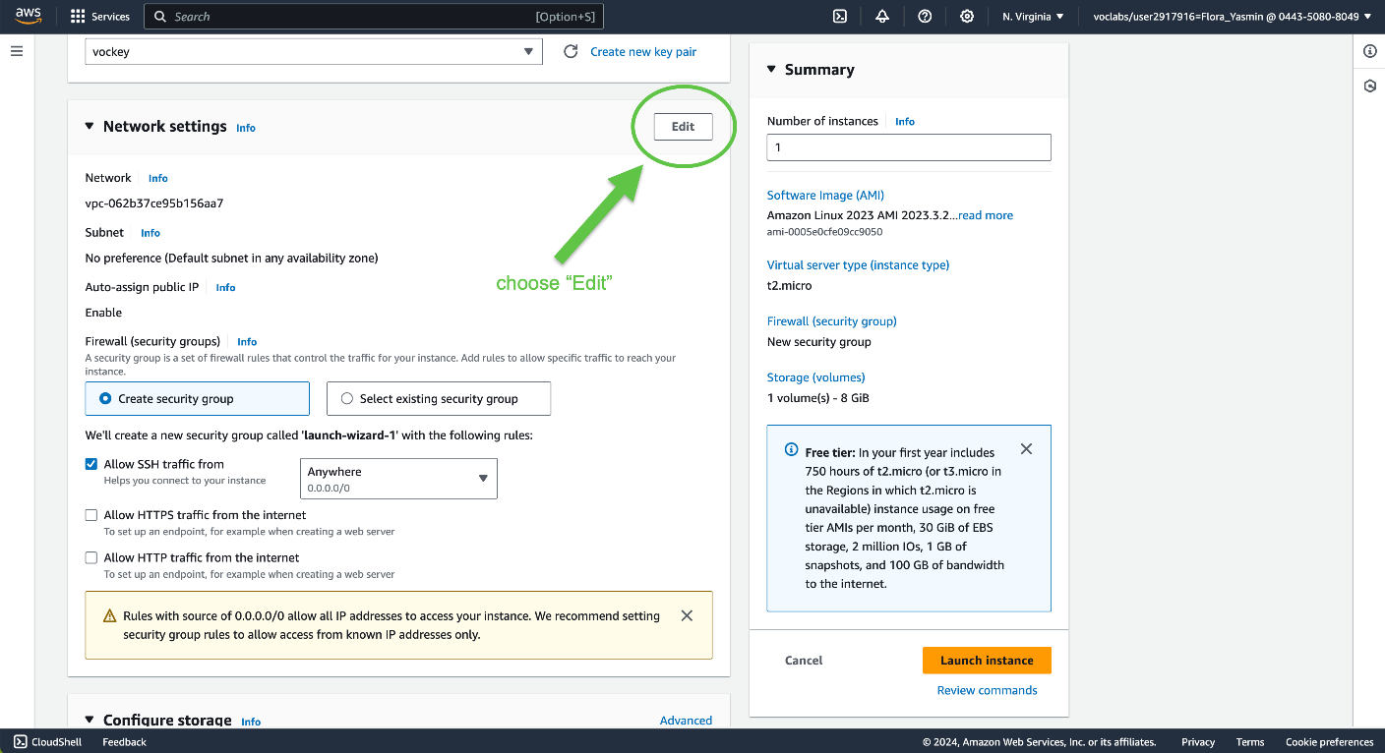

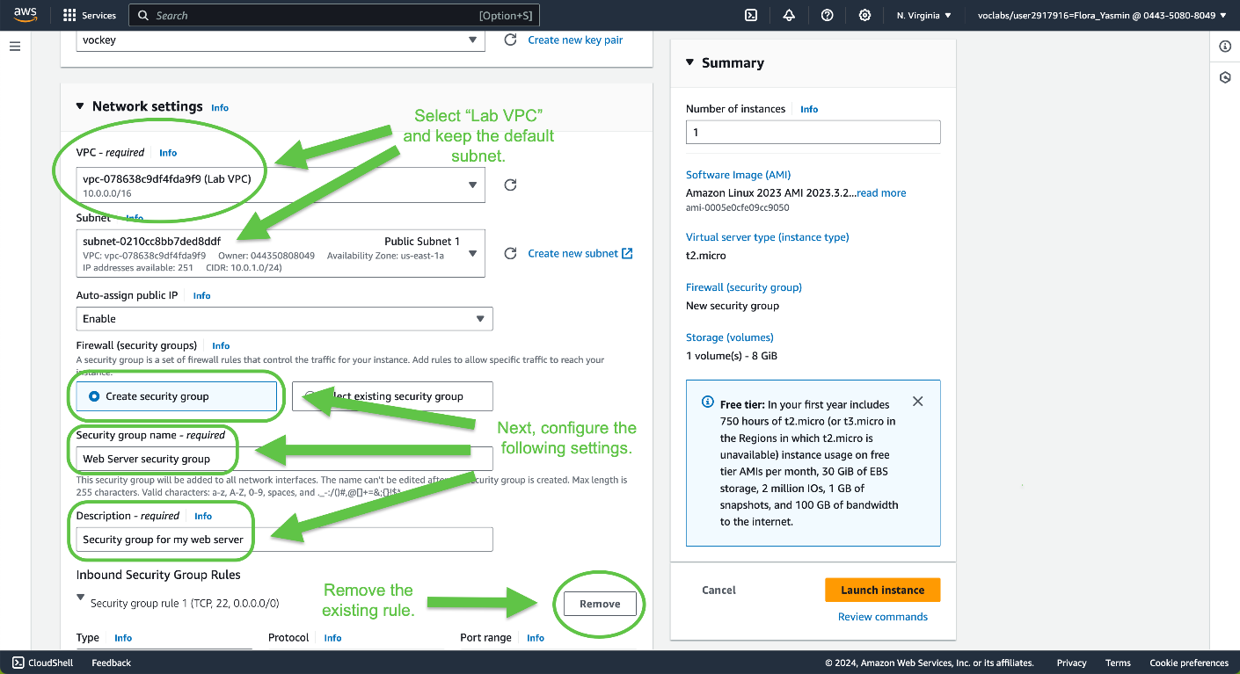

Step 6: Configure Storage

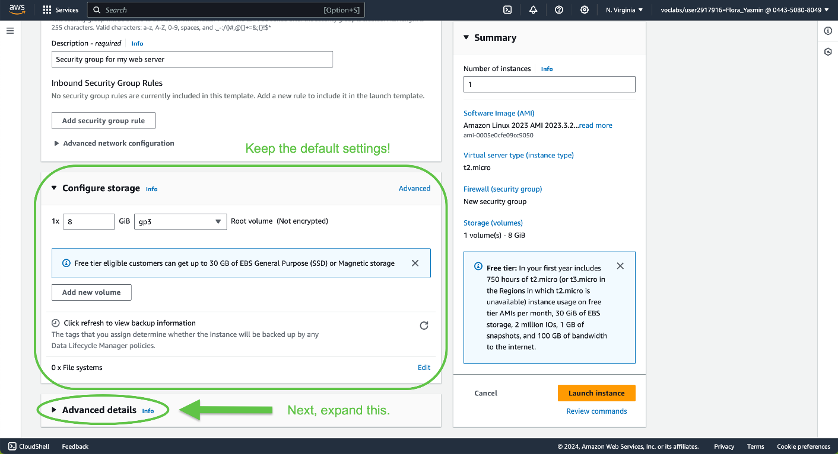

Step 7: Advanced Details

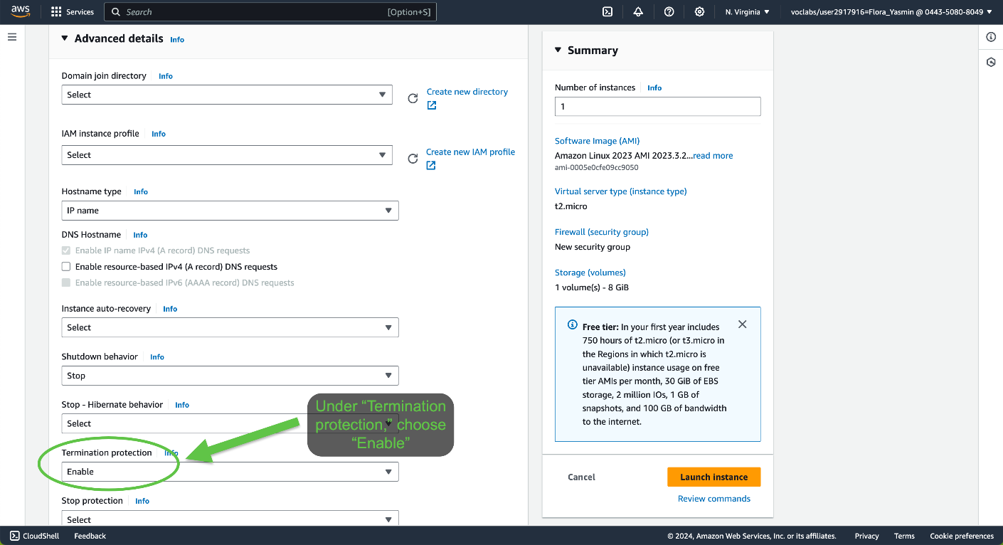

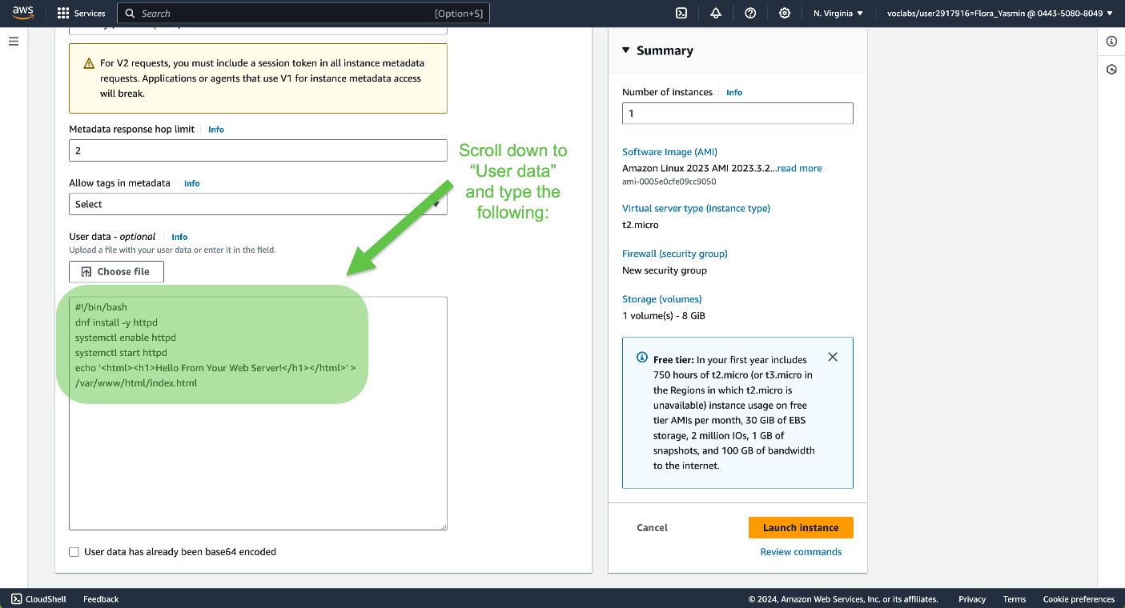

Step 8: Launch the Instance

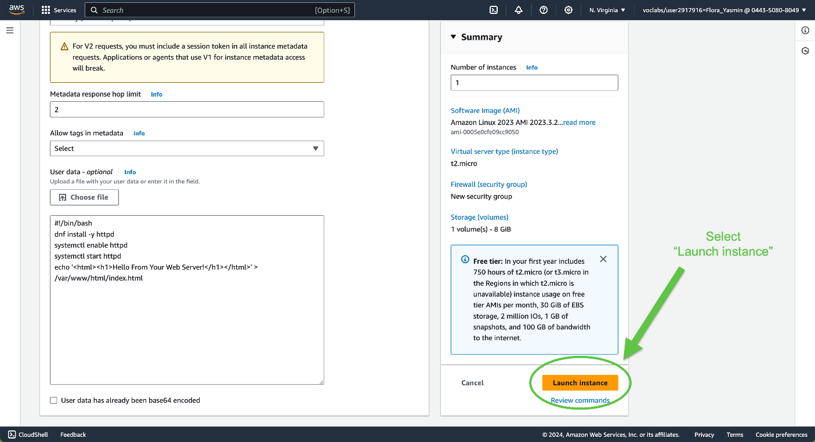

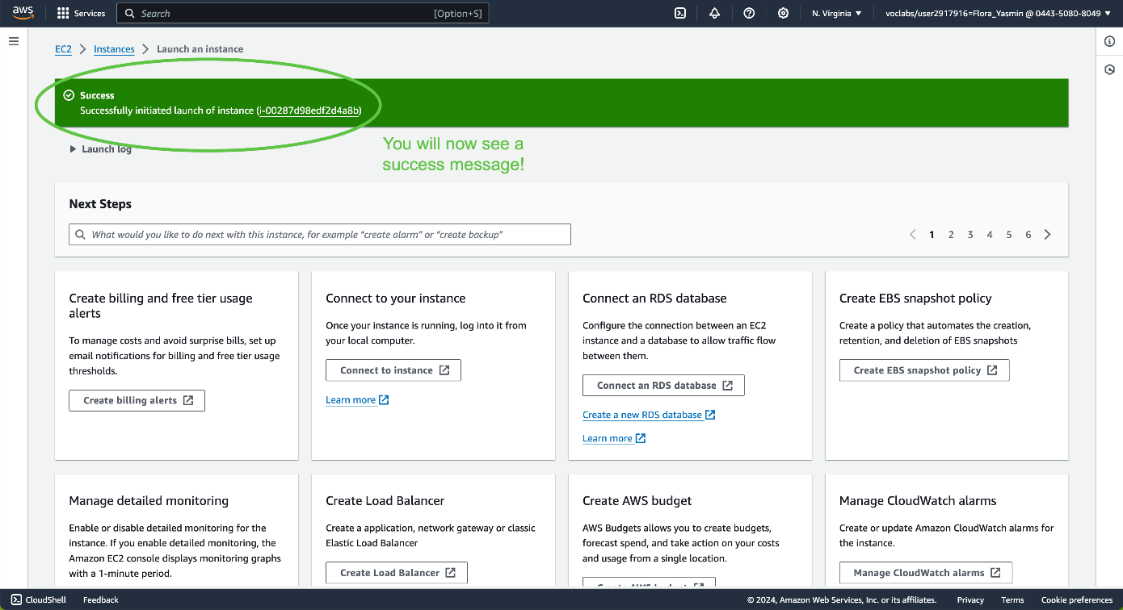

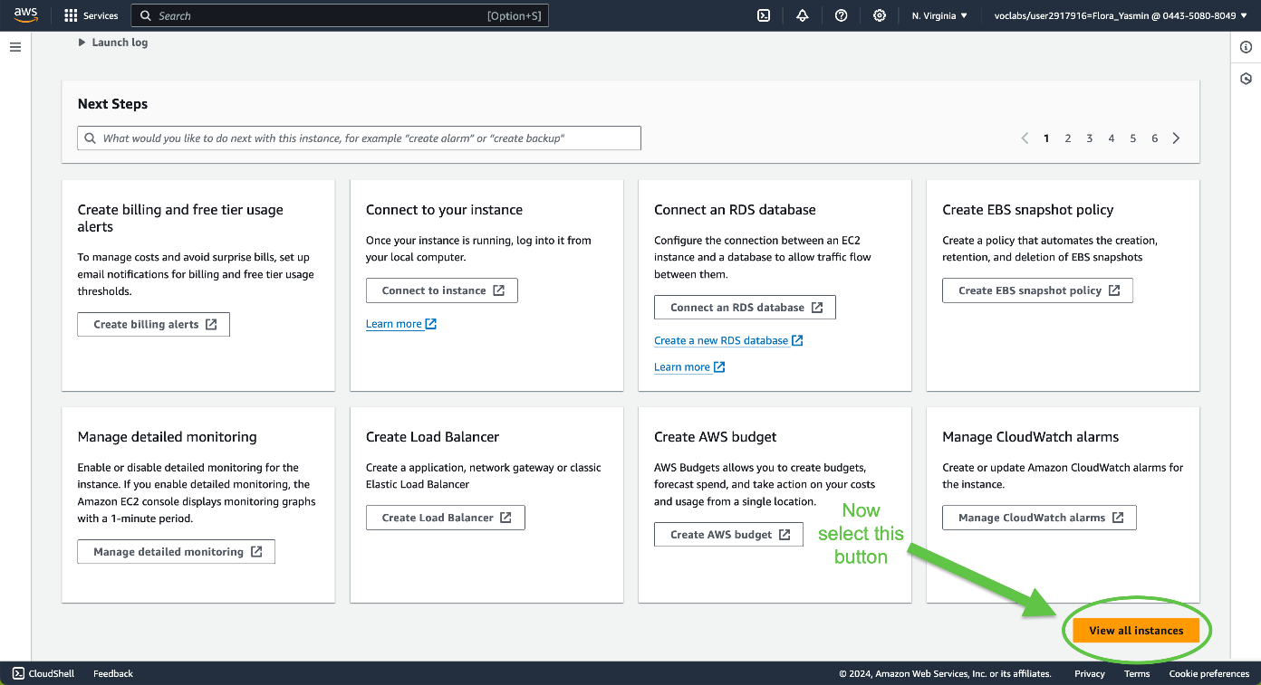

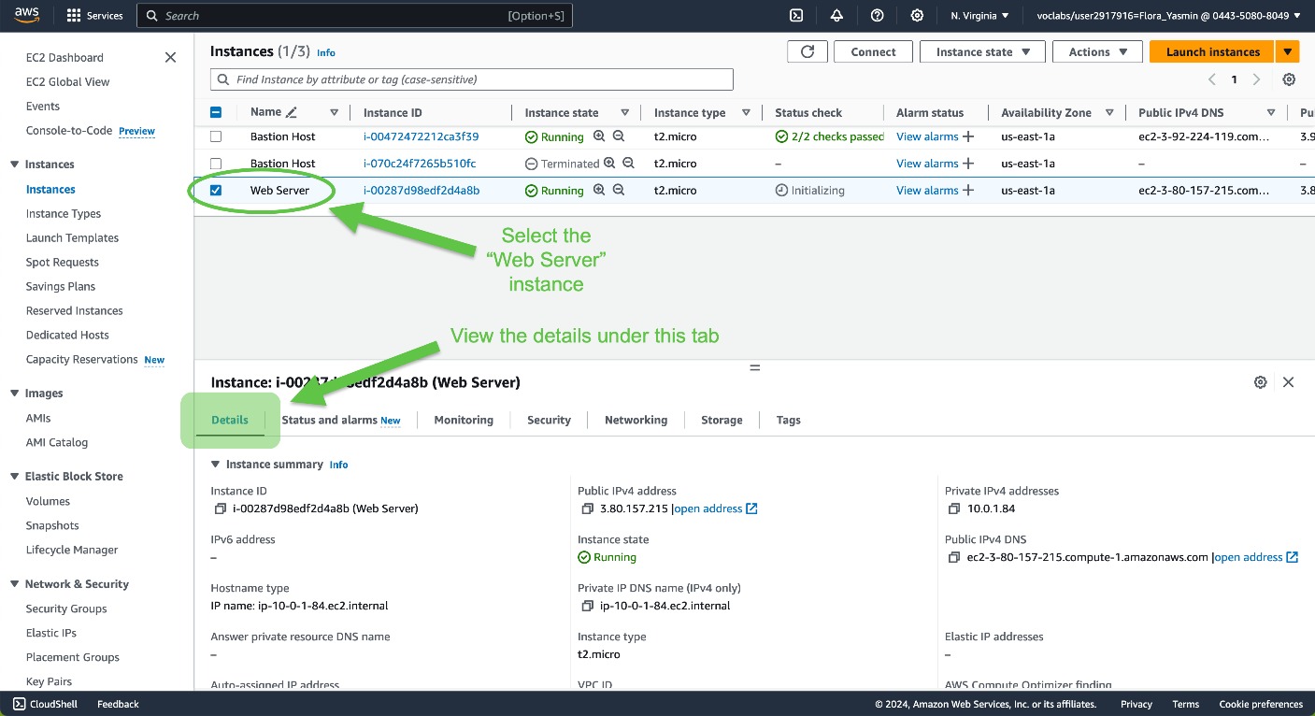

Wait for the “Web Server” instance to display a *Running* instance state and a *2/2 checks passed* status check:

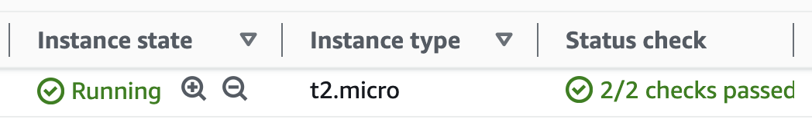

Task 2: Monitor Your Instance

Monitoring is important to maintain the reliability, availability, and performance of EC2 instances and AWS solutions.

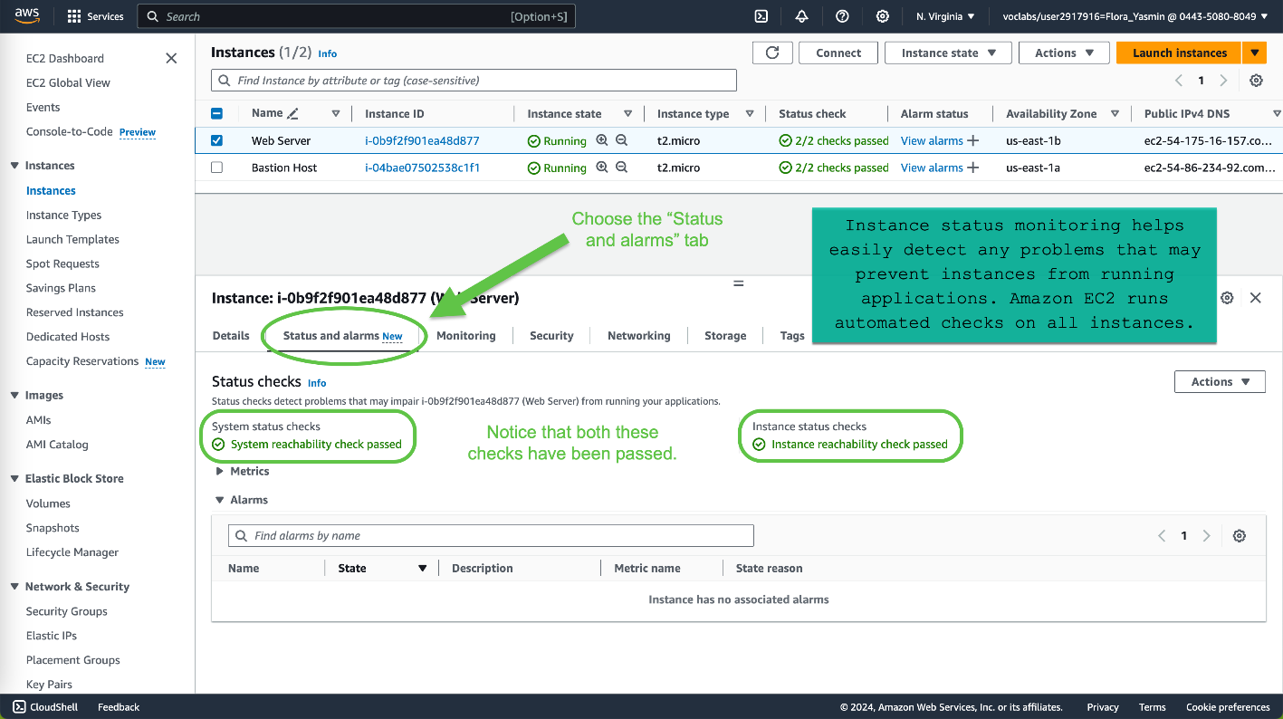

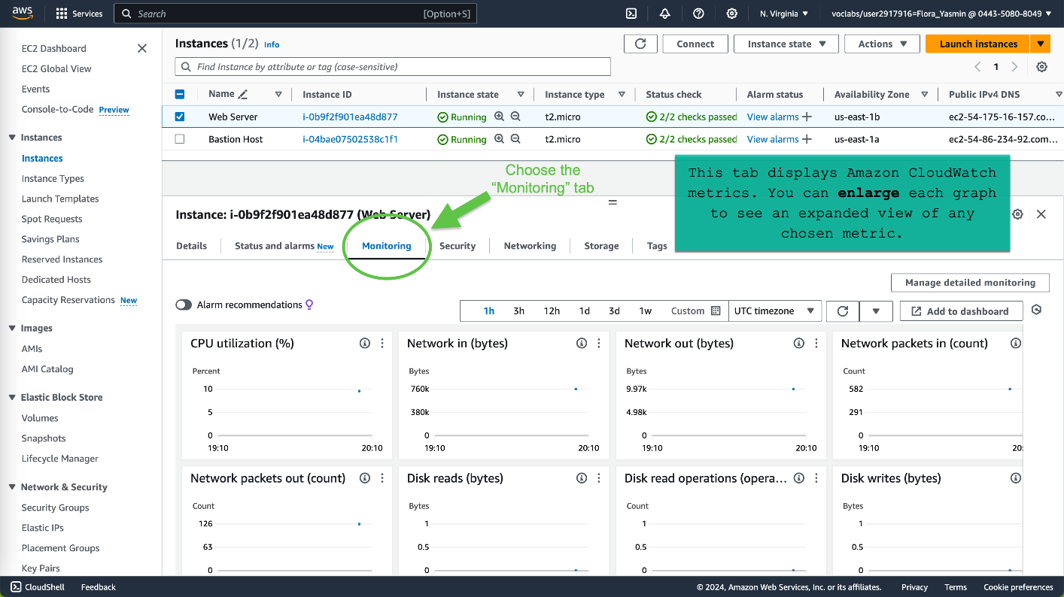

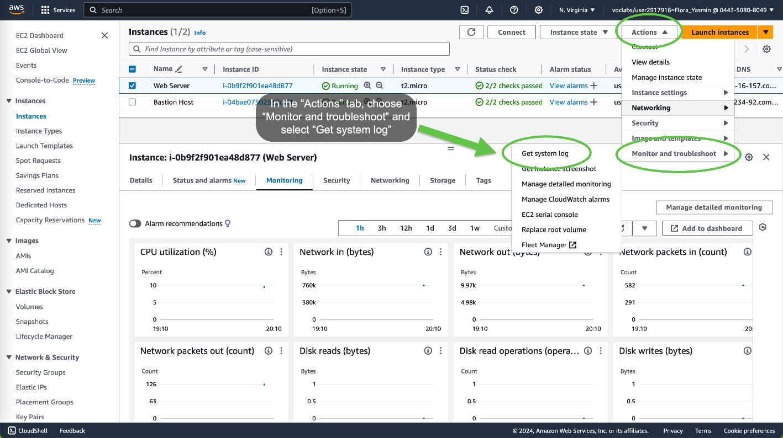

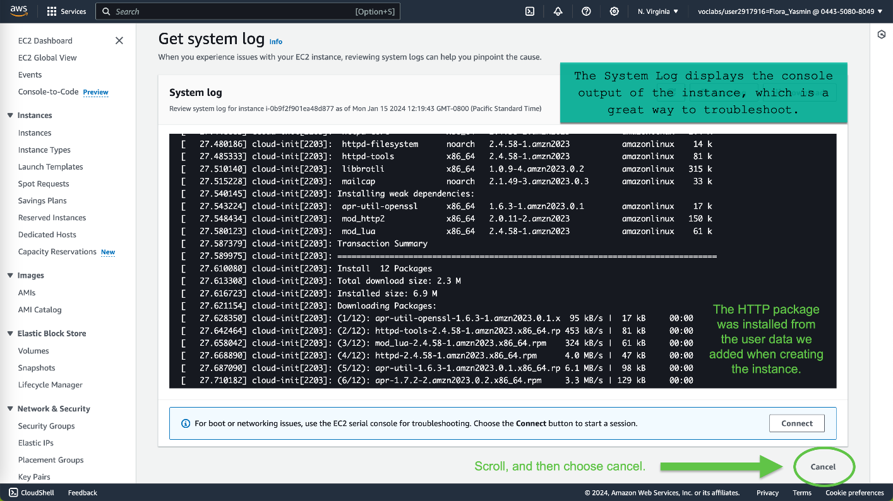

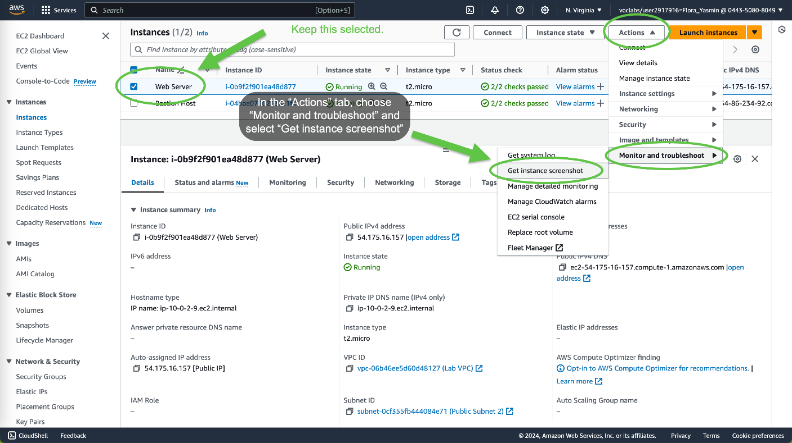

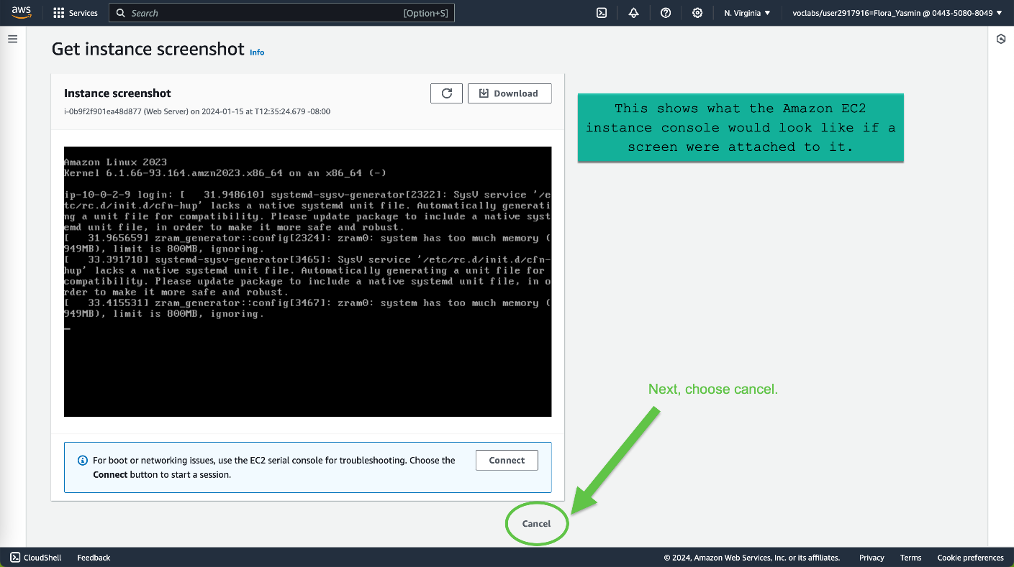

Task 3: Update Your Security Group and Access the Web Server

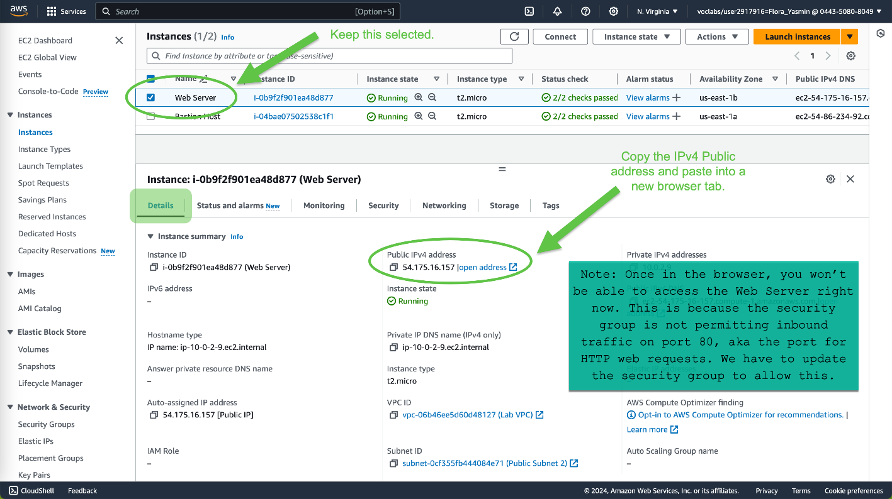

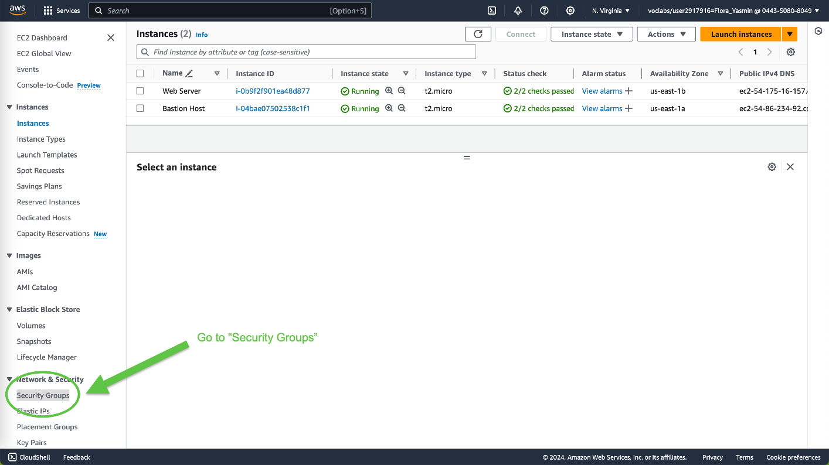

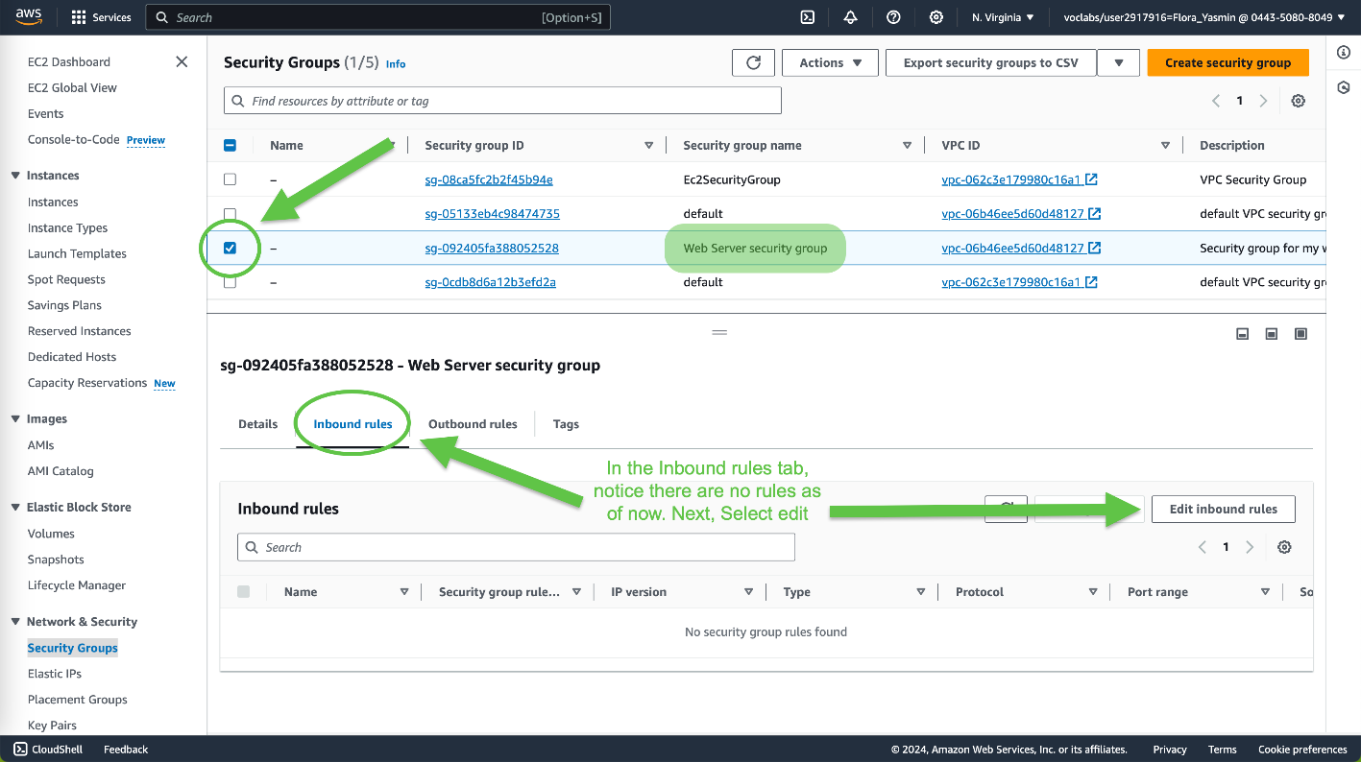

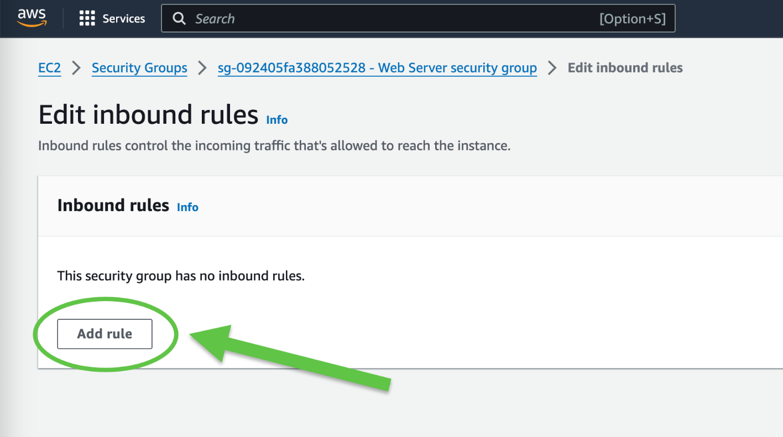

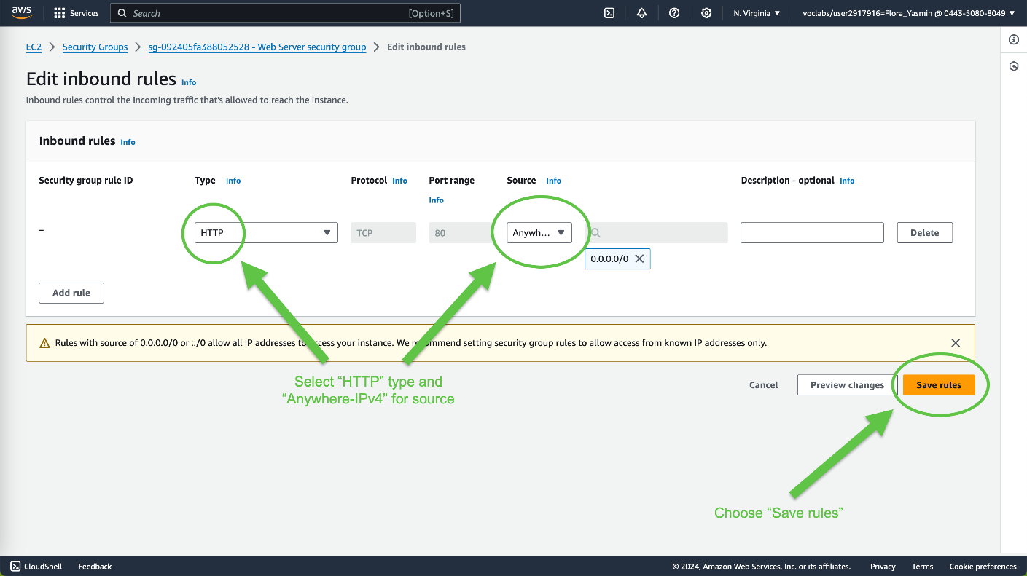

Now, go back to the browser tab and paste the IPv4 Public address again.

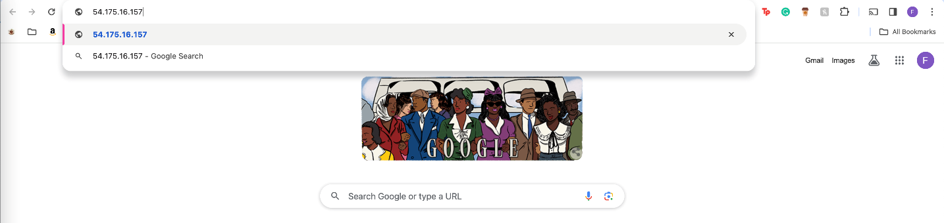

You should see the following message from your webpage:



Task 4: Resize Your Instance: Instance Type and EBS Volume

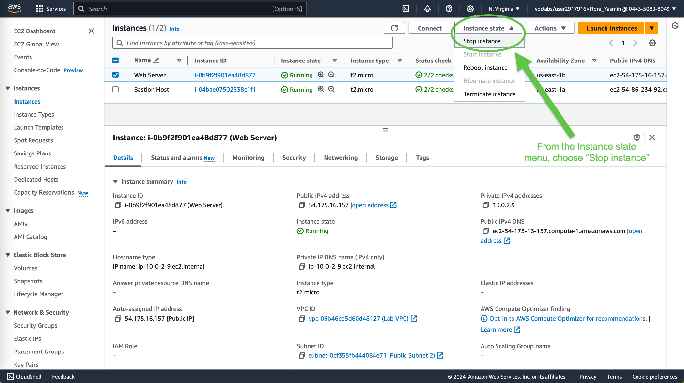

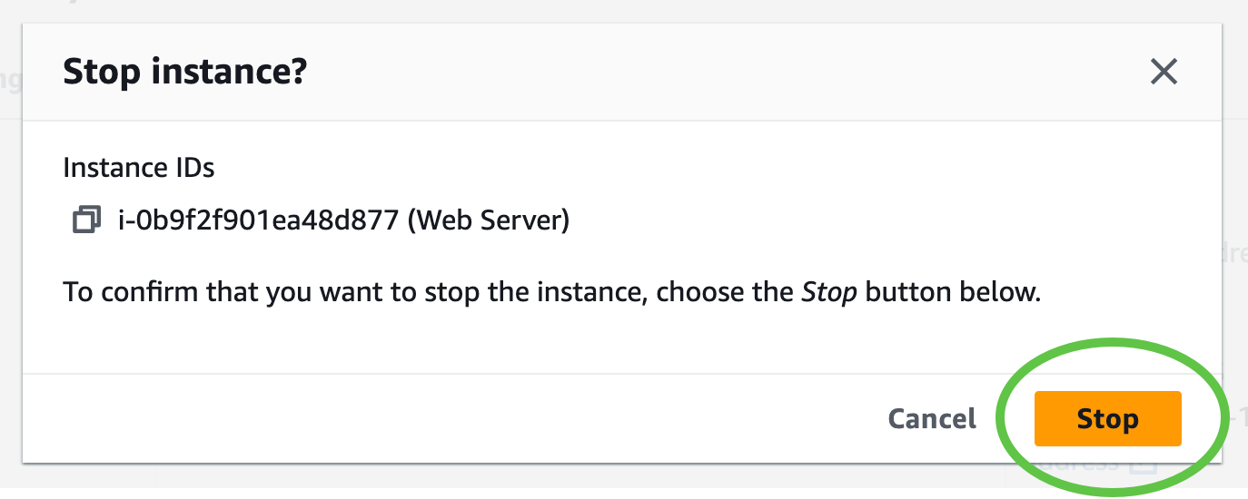

Wait for the instance to be fully stopped:

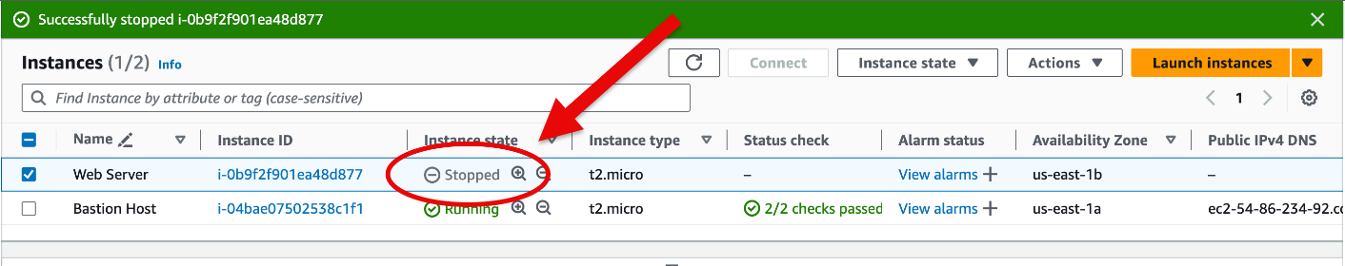

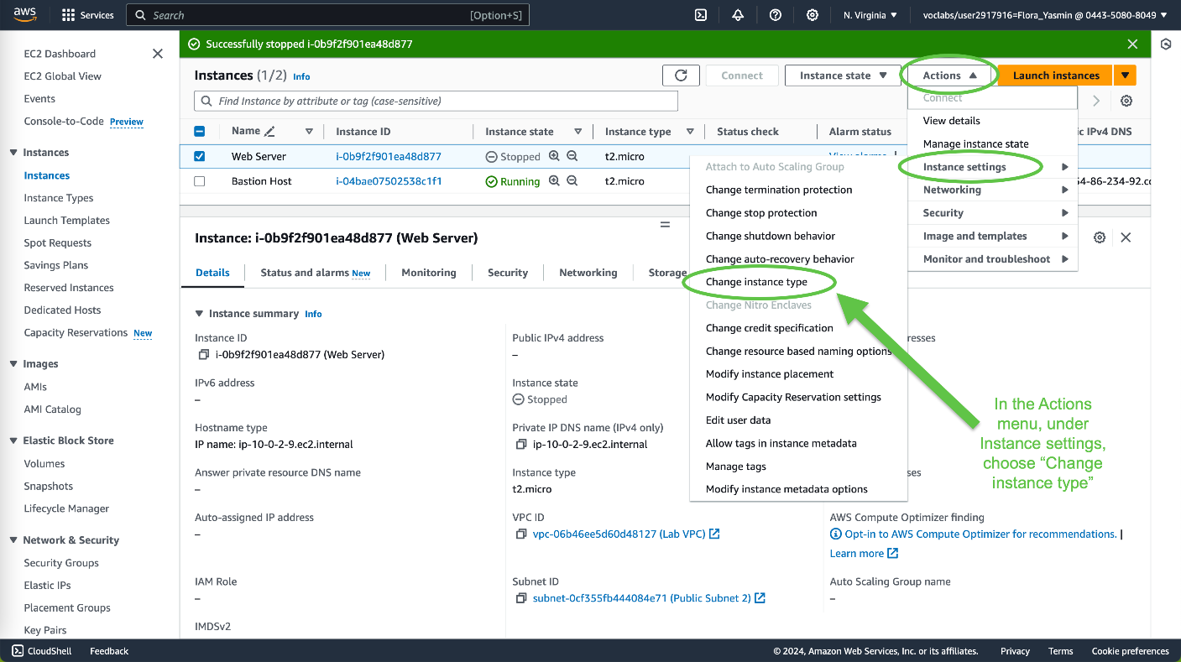

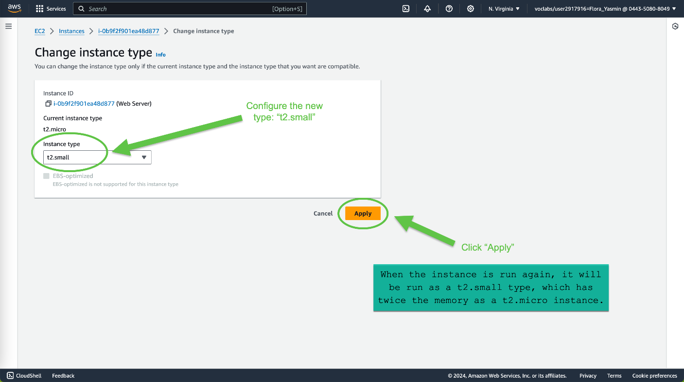

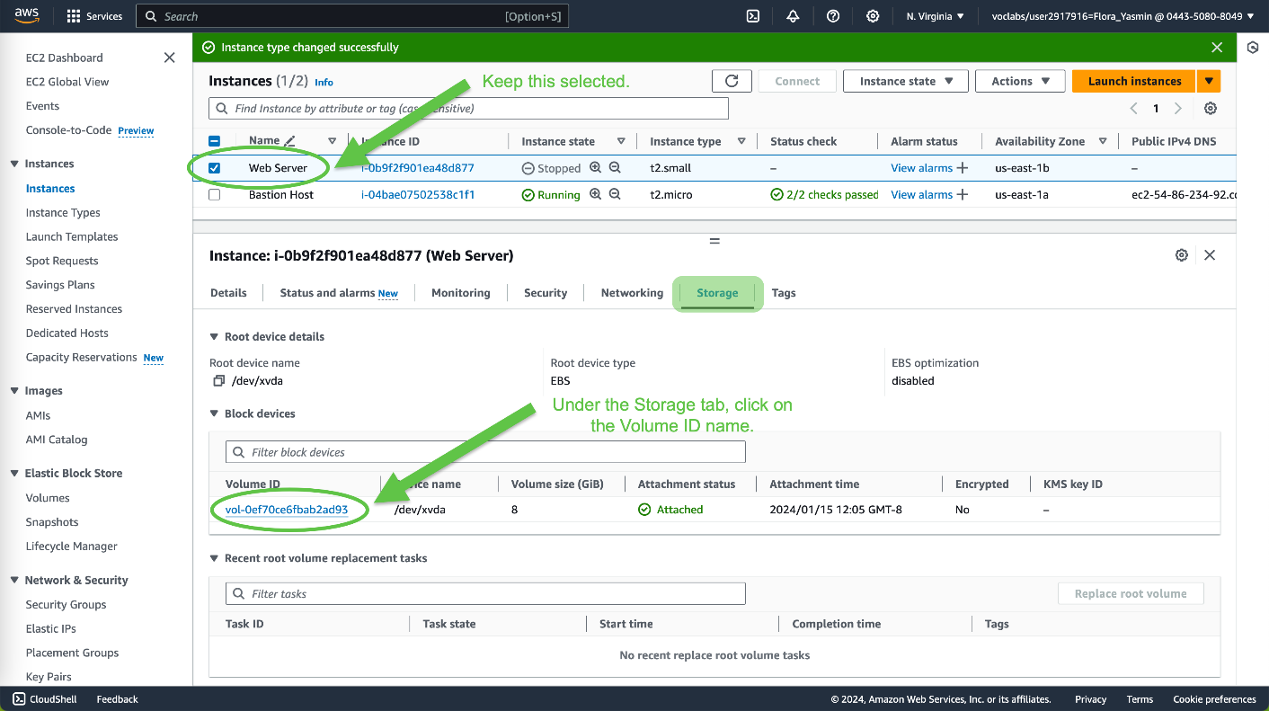

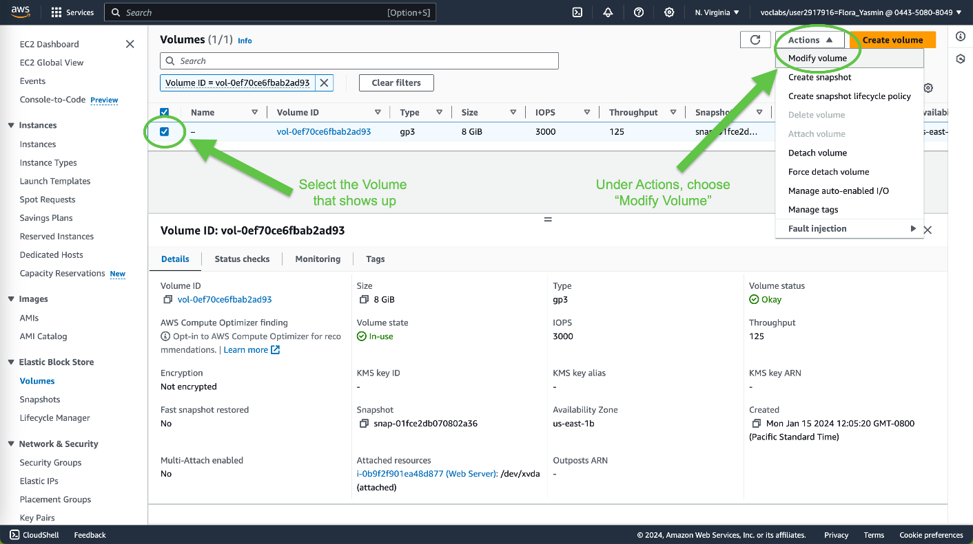

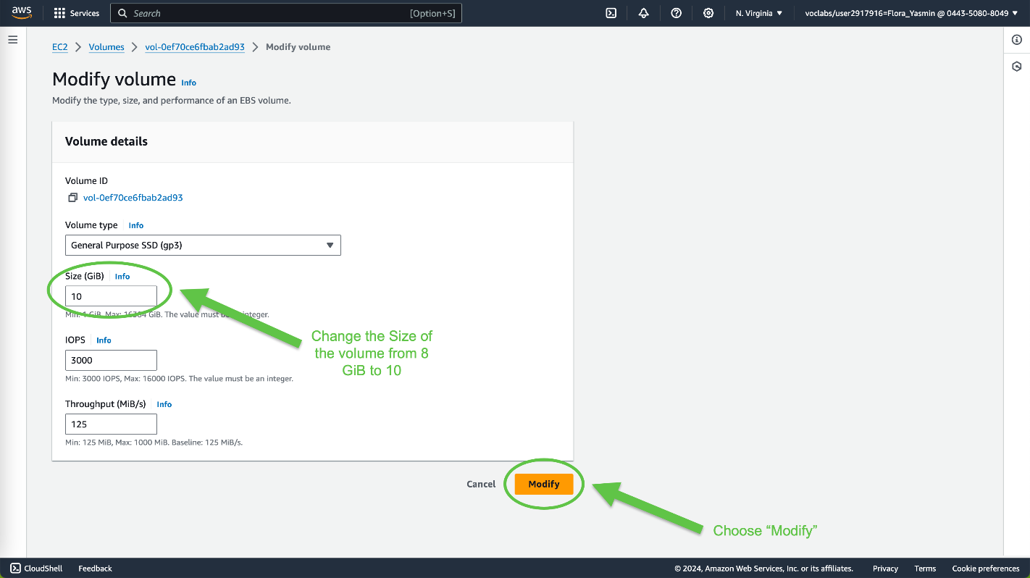

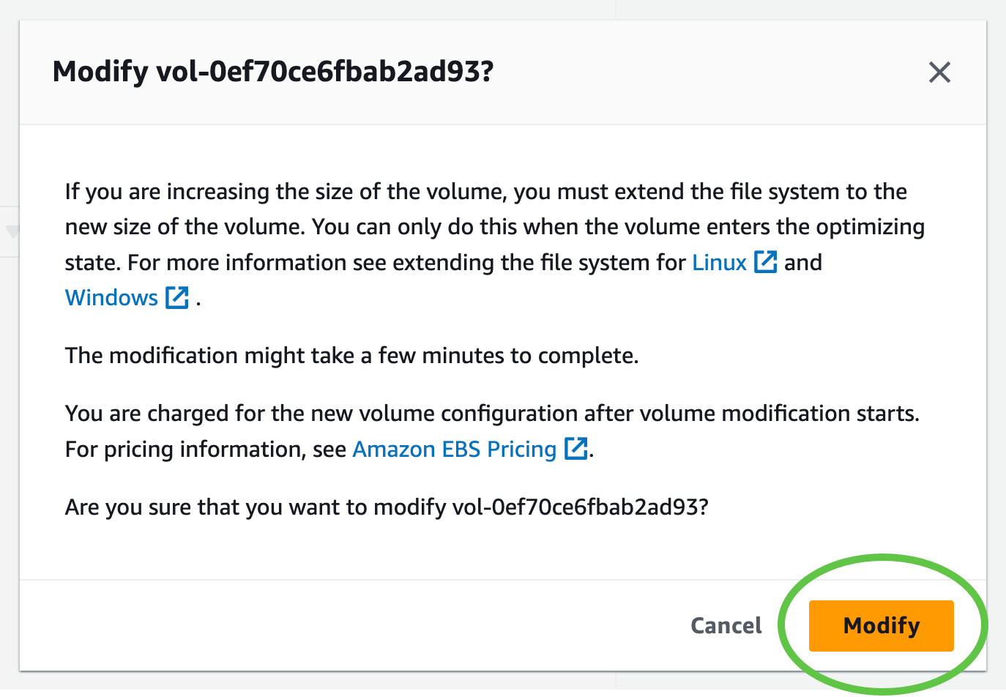

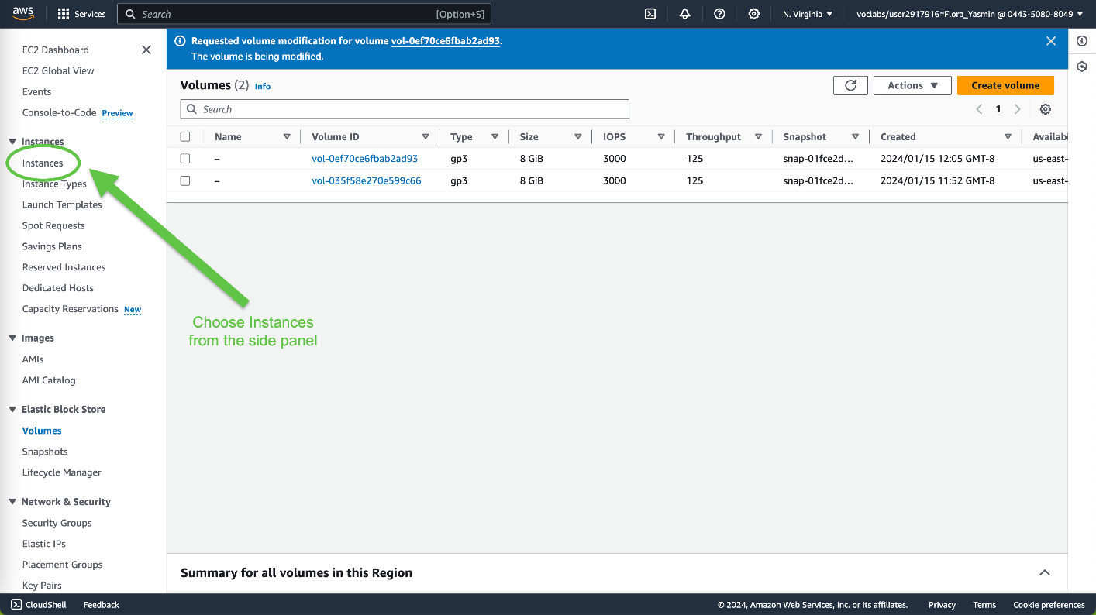

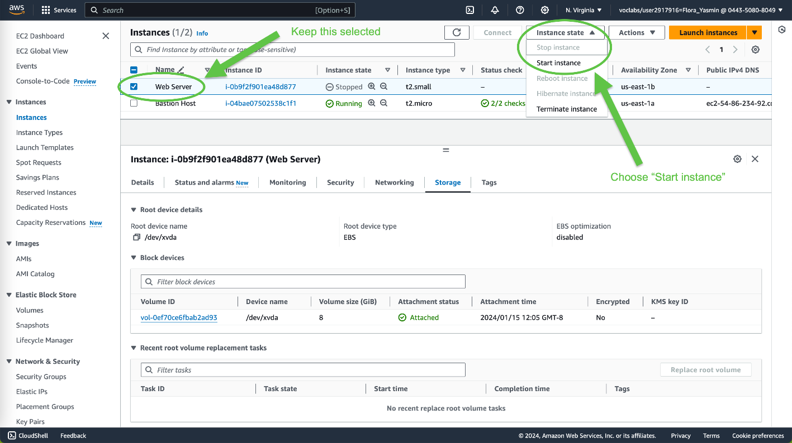



Task 5: Explore EC2 Limits

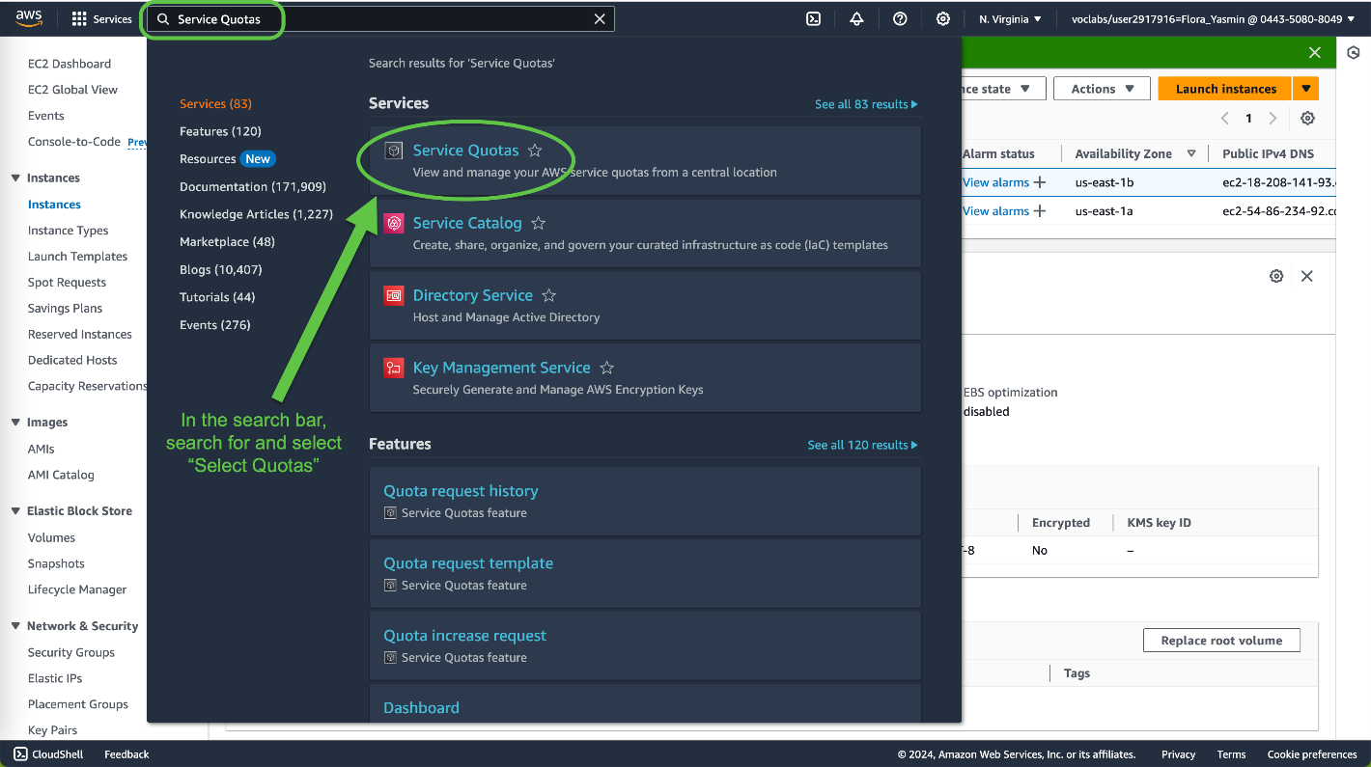

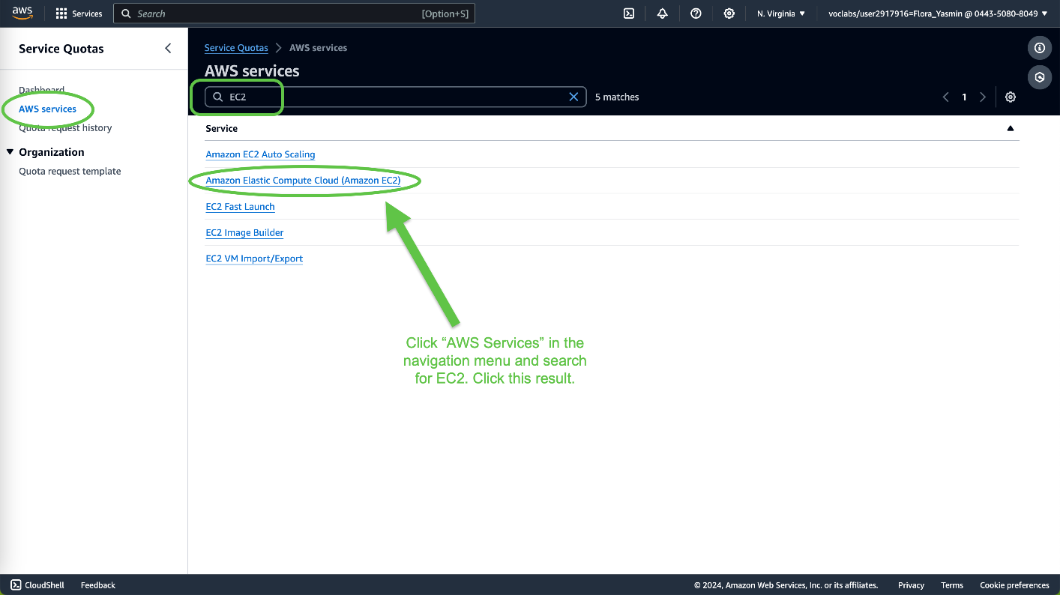

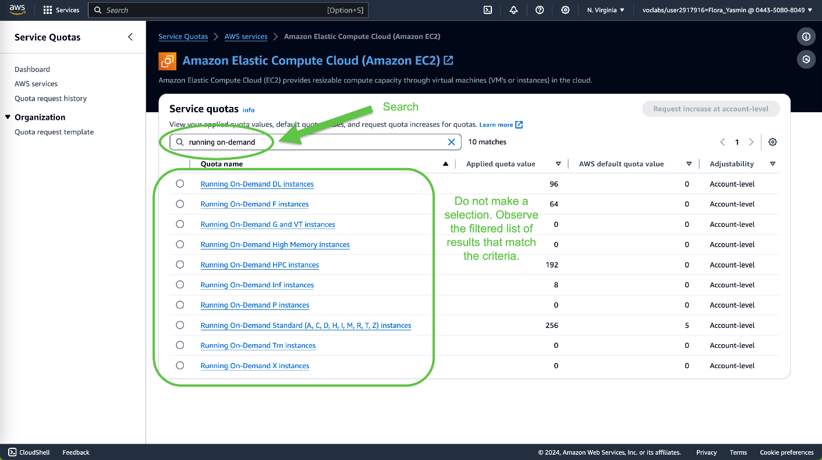

Task 6: Test Termination Protection

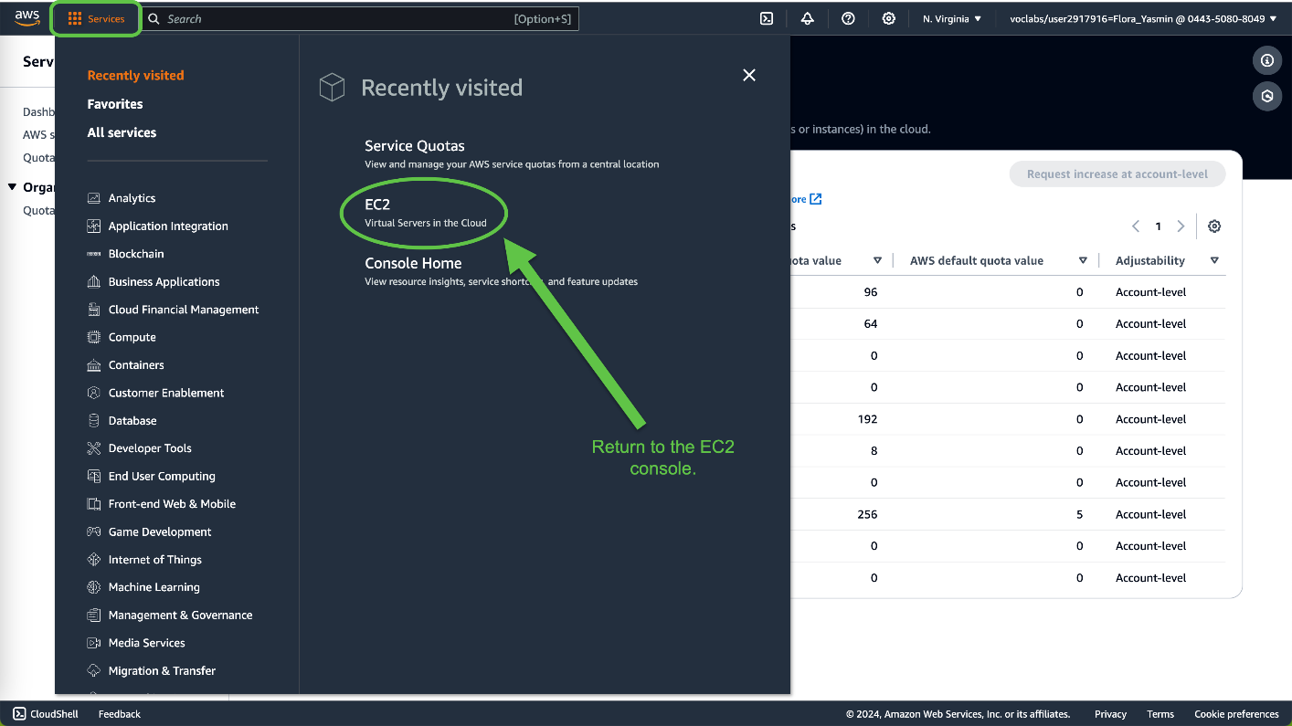

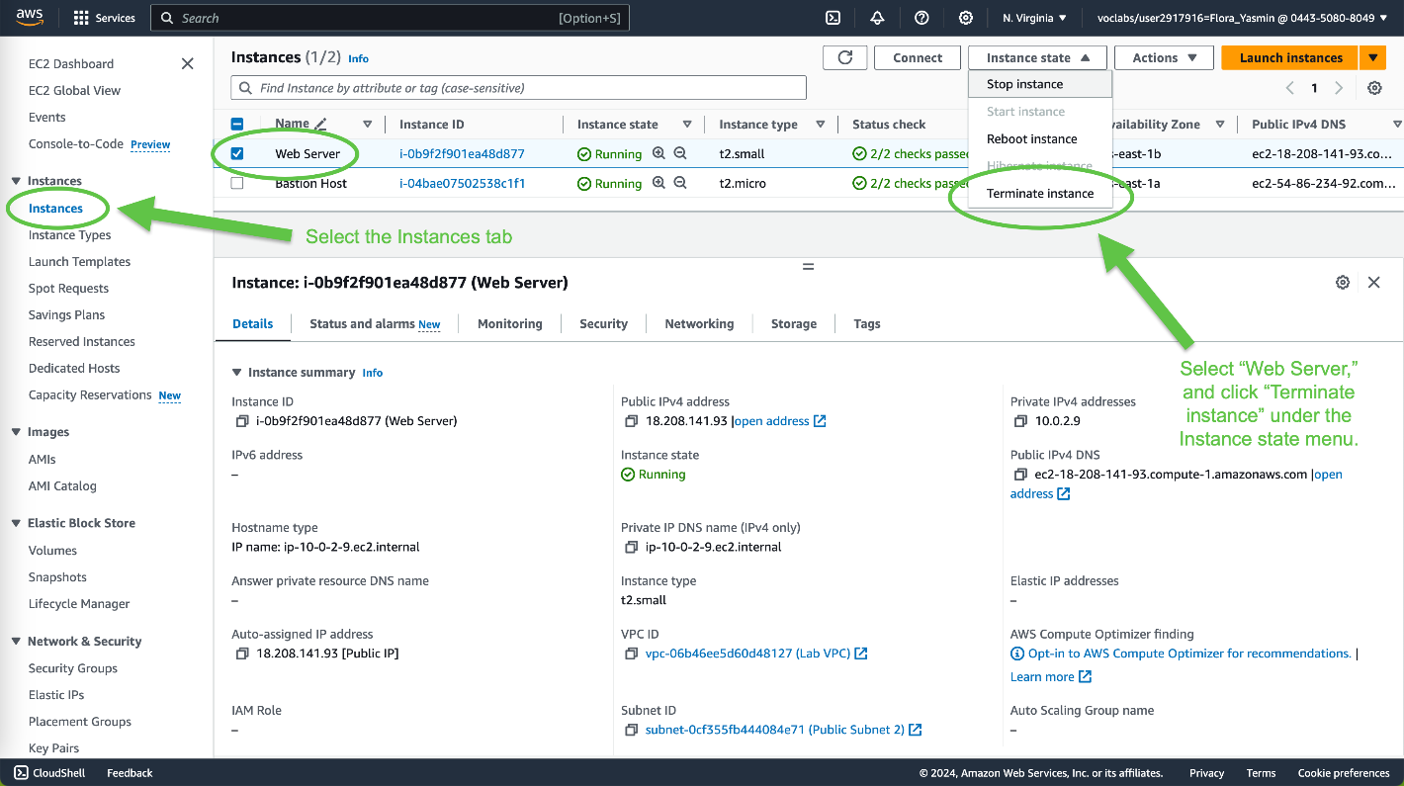

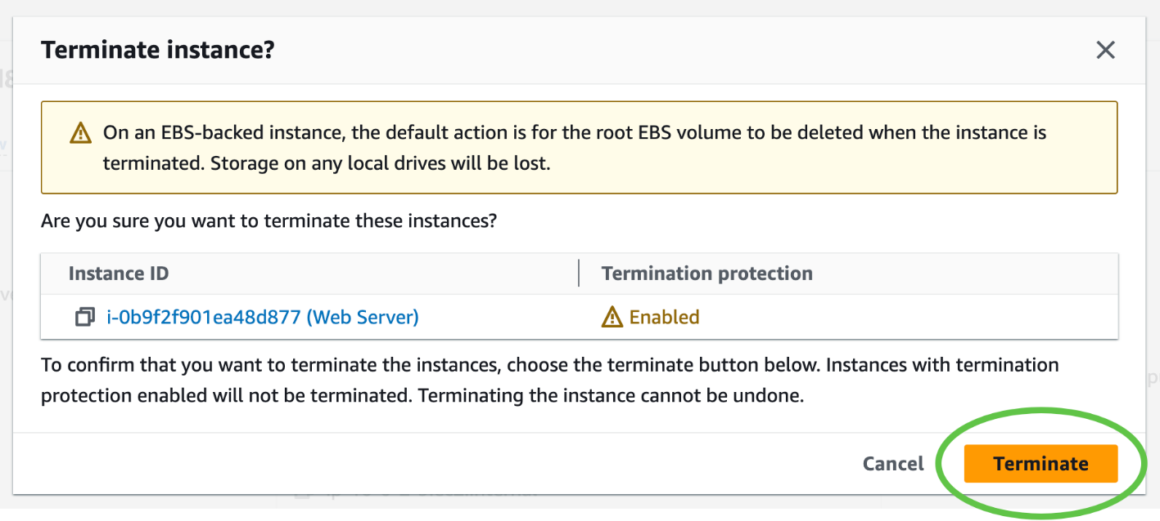

There is a failure message. This is a safeguard to prevent the accidental termination of an instance. To fully terminate the instance, we need to disable the termination protection setting we configured.



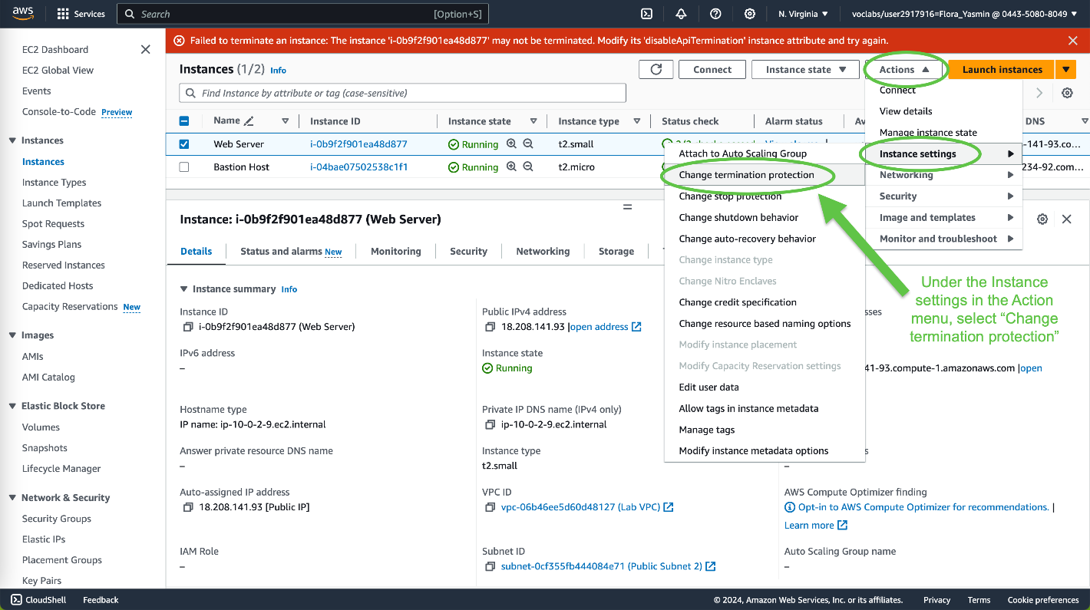

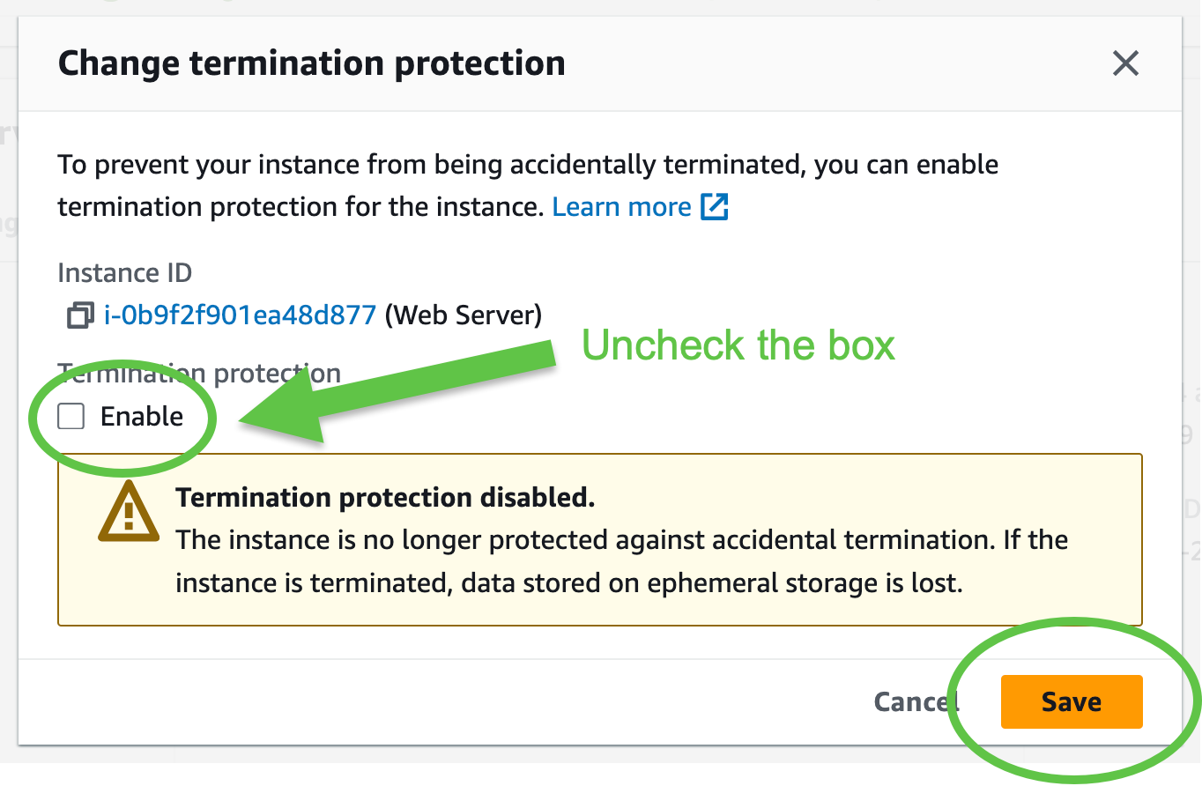

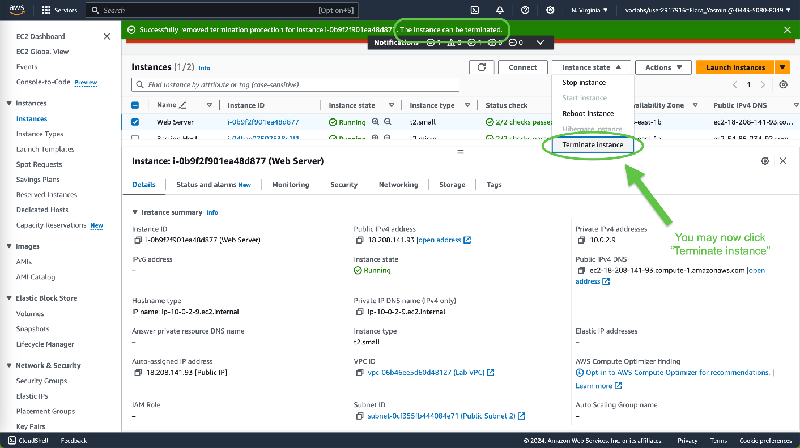

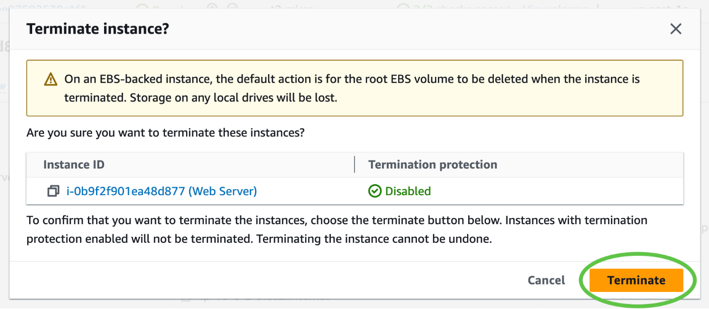



**Problems**

After completing set up in Task 1, I ran into a message saying that my session has expired and that I've been logged out when attempting to launch my instance. To solve this problem, I had to close and reopen the lab link and redo all steps.

Getting to a passed status check took a while, which required me to restart the Web Server instance.

**Conclusion**

Completing this lab helps learn how to launch a web server with termination protection and correctly monitor an EC2 instance. It explores how EC2 instances can be resized, the limits upon instances, and the termination of one. The lab walks also through modifying a security group to have HTTP access through the web server and testing termination protection. Overall, the lab provides many AWS skills needed for companies in the real world.